**RELATIVITY**

**Exercises**

**Section 33.2 Matter, Motion, and Ether**

**13. Interpret** In this problem we are asked to take wind speed into consideration to calculate the travel time of an airplane. Because the speeds involved are much, much less than c, we can use nonrelativistic physics.

**Develop** Since the velocities are small compared to *c*, Equation 33.5a takes the form

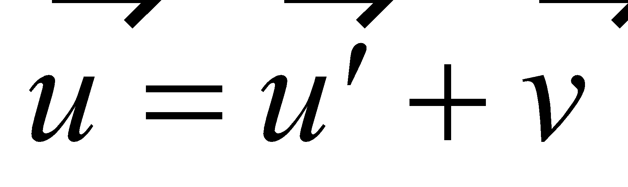

This is the nonrelativistic Galilean transformation of velocities as given in Equation 3.7, where  is the airplane’s velocity relative to the ground, 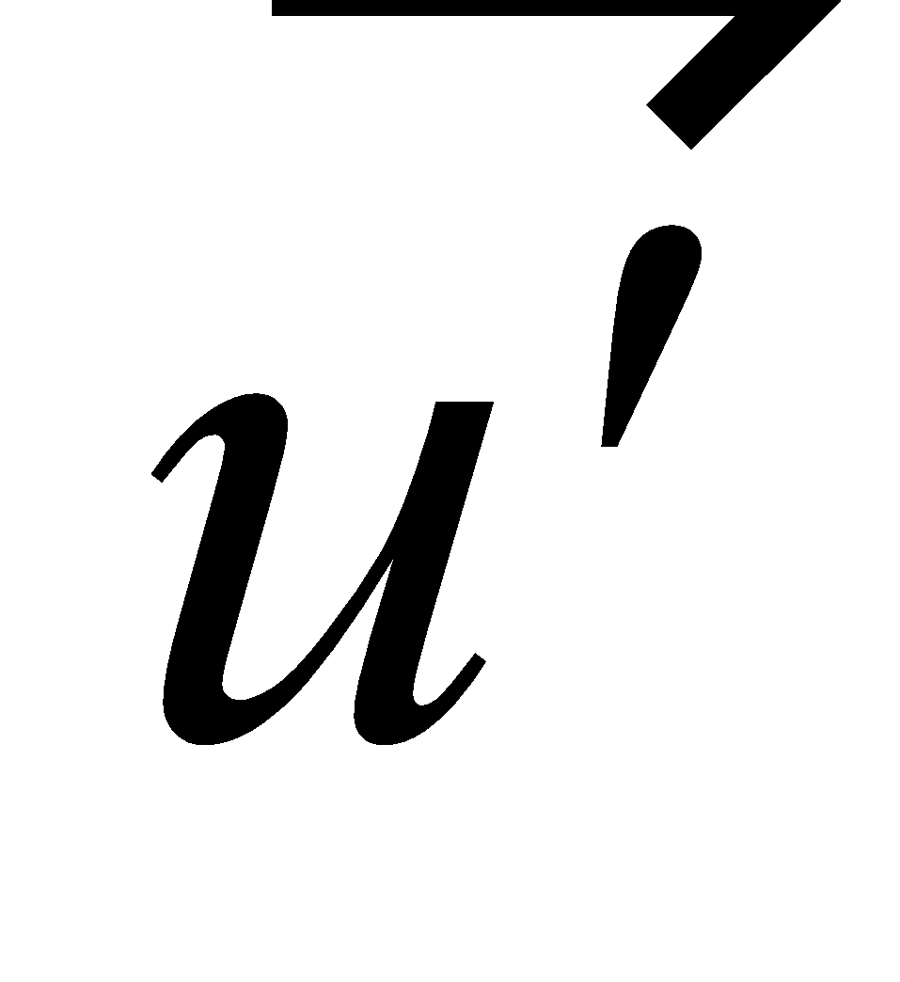 is the velocity of the airplane relative to the air, and 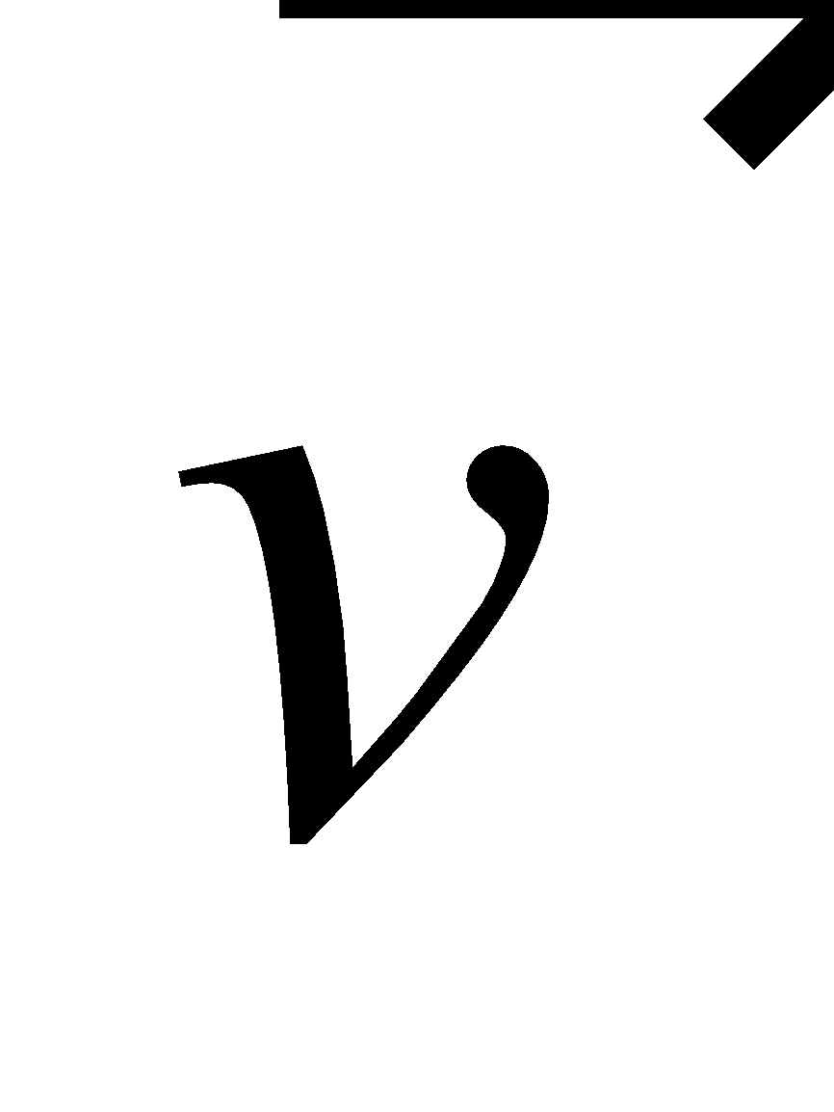 is the velocity of the air relative to the ground (i.e., the wind speed). We can use this expression to find the round-trip time *t*, which is

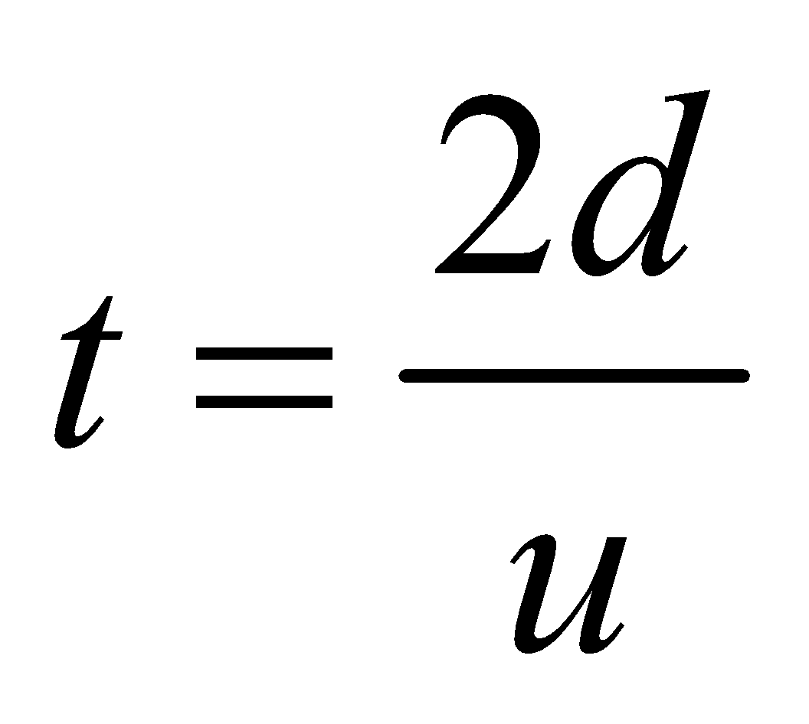

With *d* = 1800 km and *u* = 800 km/h.

**Evaluate** **(a)** If 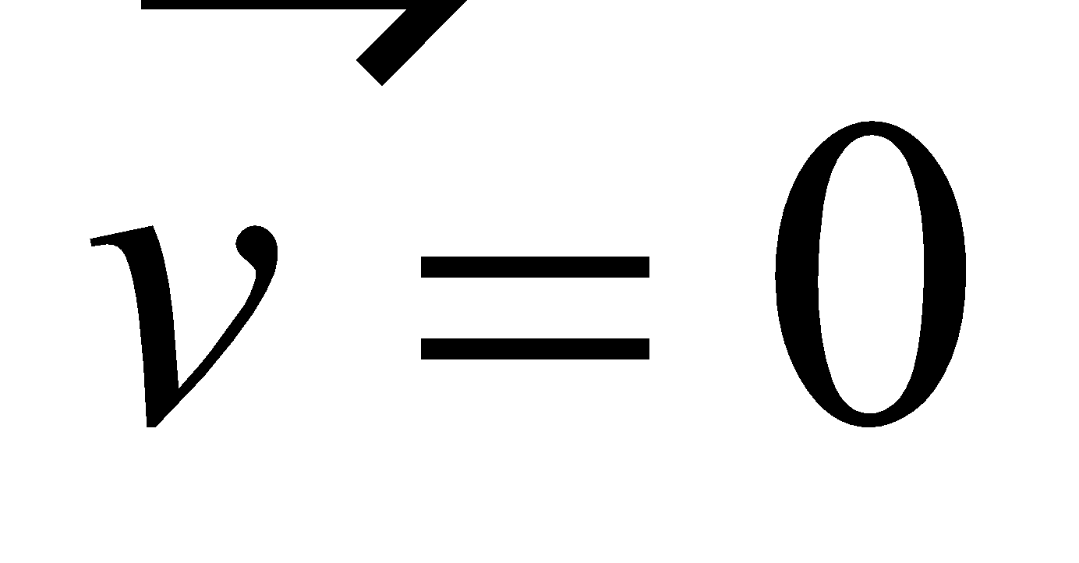 (no wind), then 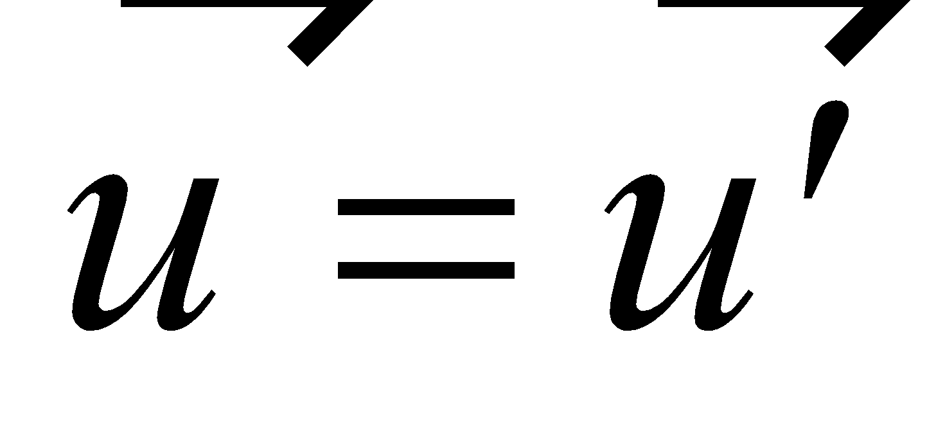 (ground speed equals air speed), and the round-trip travel time is

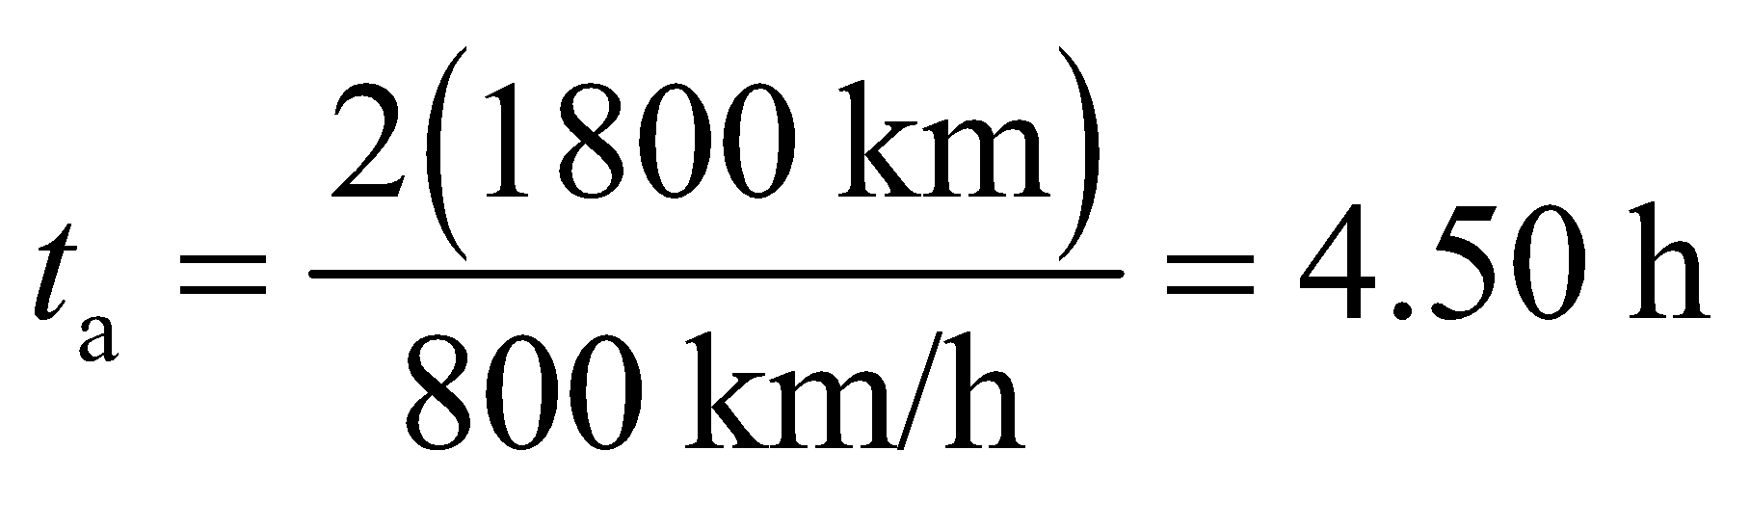

**(b)** If  is perpendicular to , then 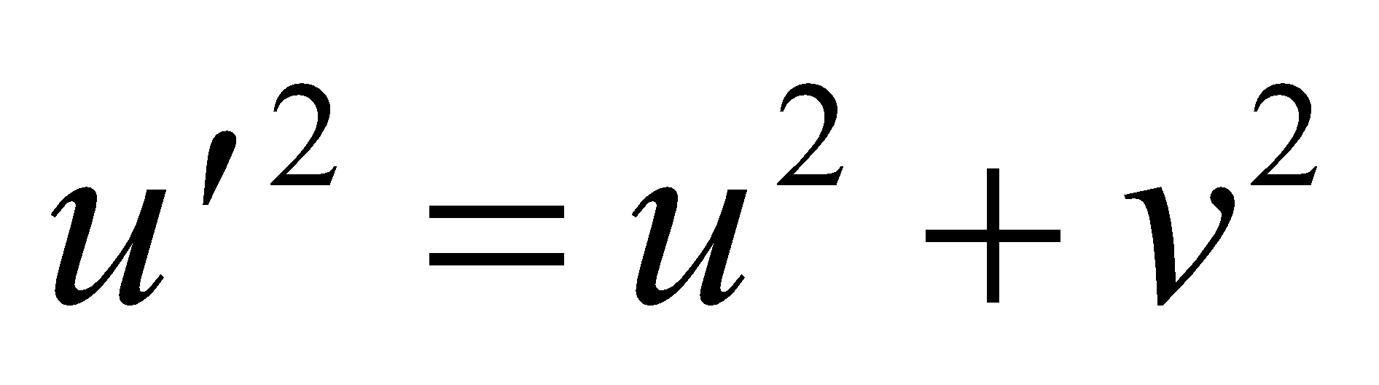, or

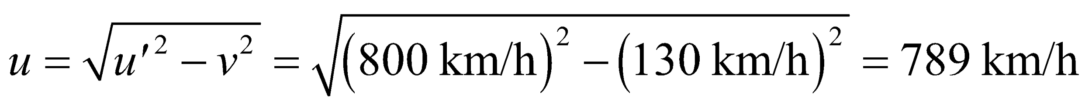

and the round-trip travel time is

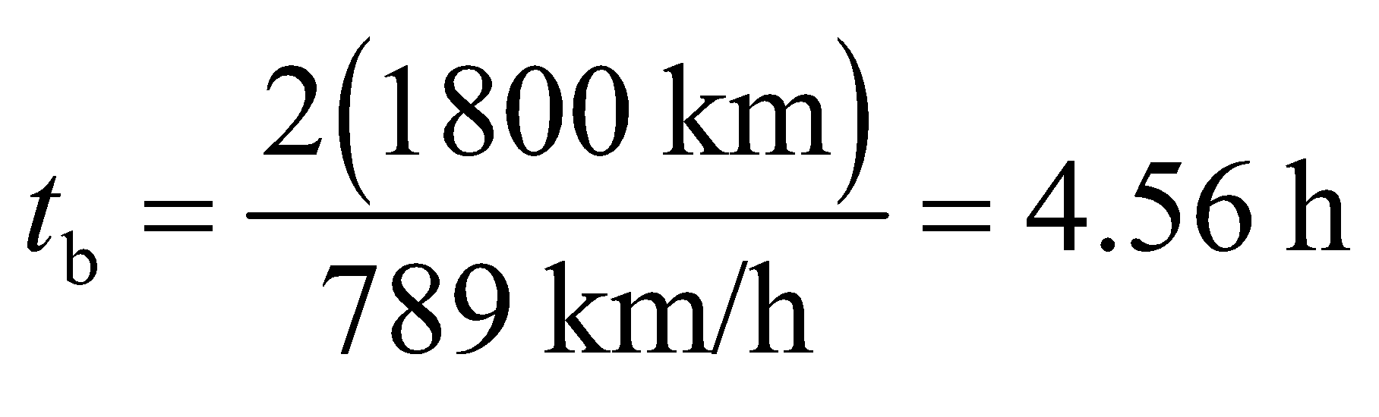

**(c)** If  is parallel or anti-parallel to  on alternate legs of the round trip, then 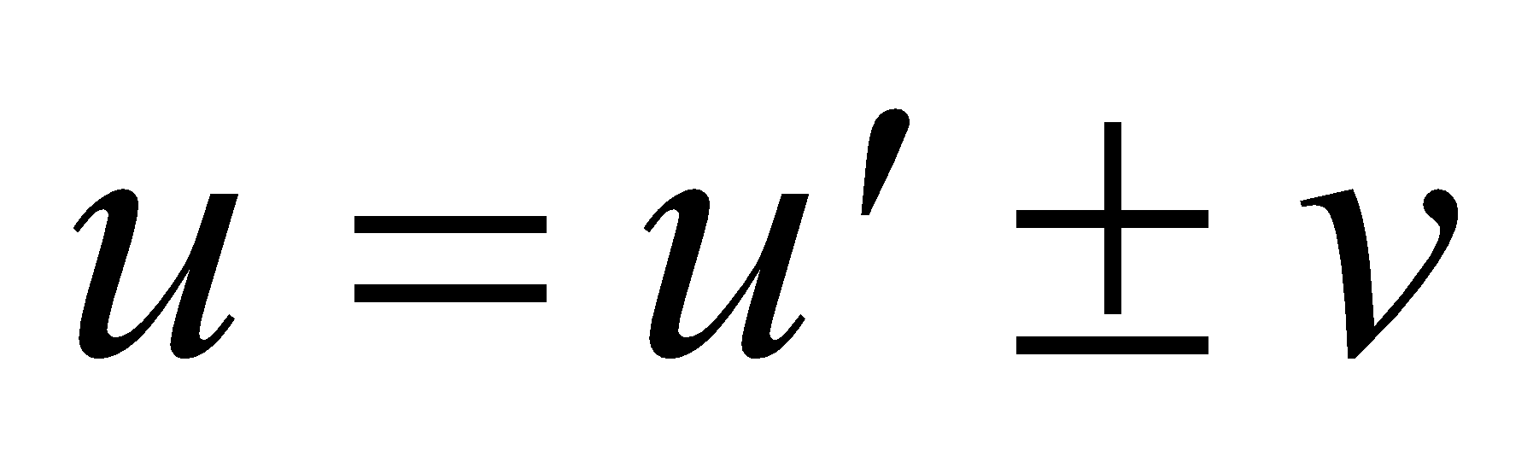 and the travel time is   
(see Equation 33.2, but with *c* replaced by )



**Assess** We find 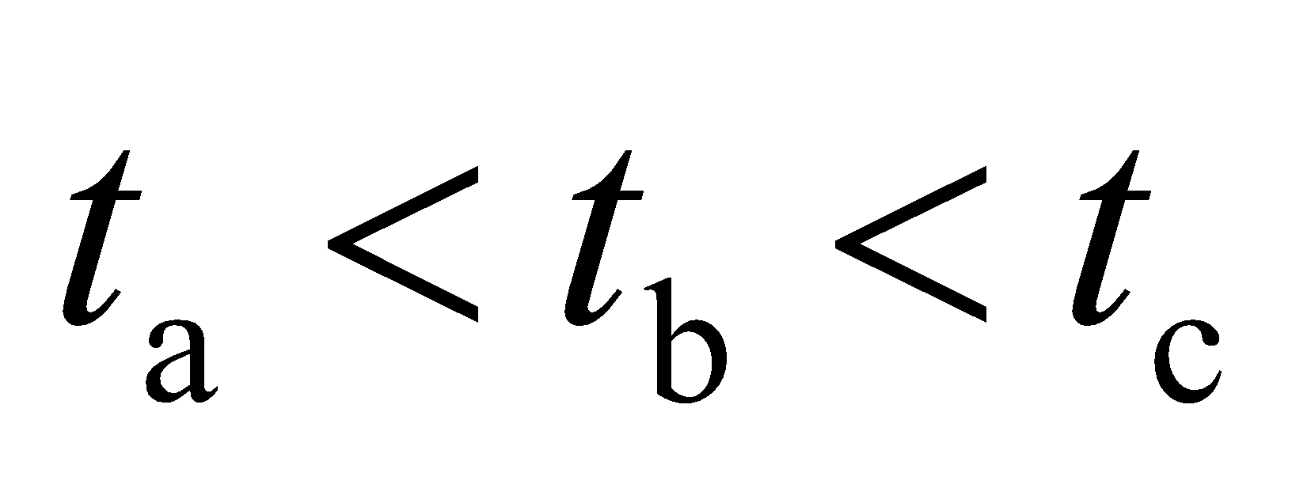, as mentioned in the paragraph following Equation 33.2.

**14.** **Interpret** This problem concerns the Michelson–Morley experiment, which studies the travel time of a wave (i.e., light) that propagates in a moving medium (i.e., the ether). The initial wave is split into two waves, one of which travels parallel to the velocity of the medium and the other of which travels perpendicular to the velocity of the moving medium. We are to find the difference in the travel times for each wave.

**Develop** The round-trip travel time for light in each arm of the Michelson–Morley experiment is given by Equations 33.1 and 33.2. The difference between these times is

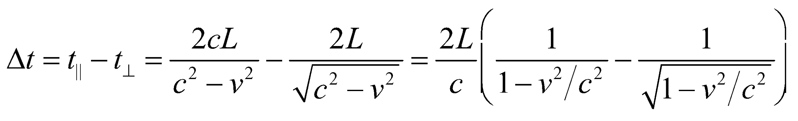

**Evaluate** (**a**) If 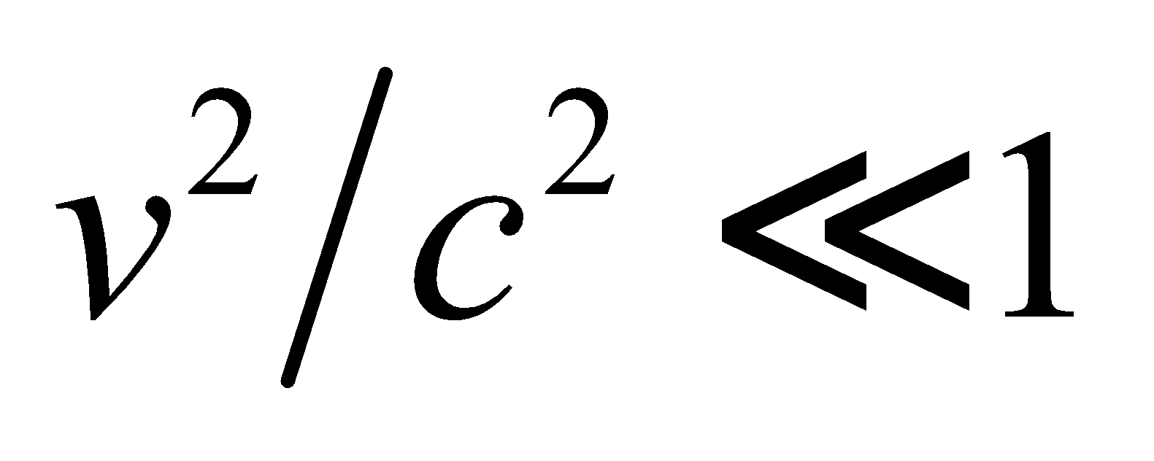 we can expand the denominators (Appendix A) to obtain

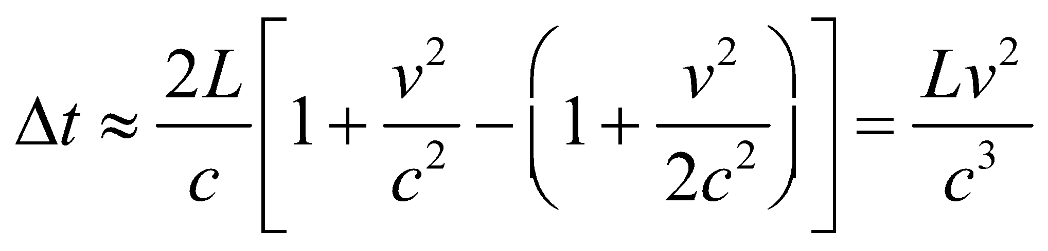

Inserting the given values yields

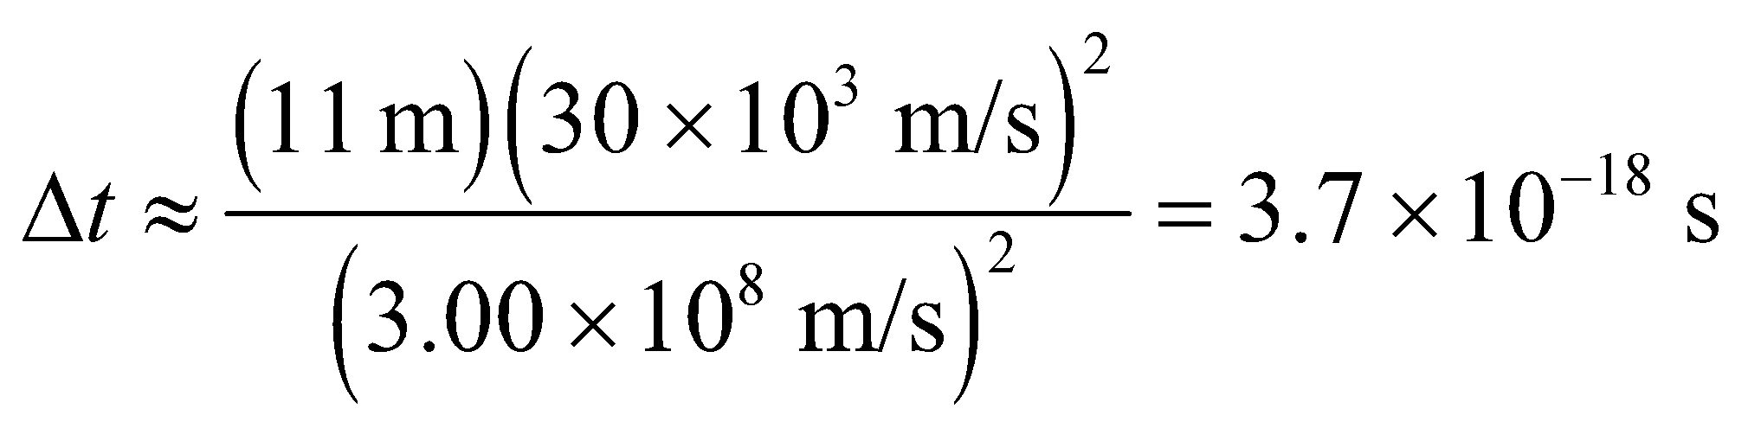

(**b**) For *v* =0.01*c*, we find

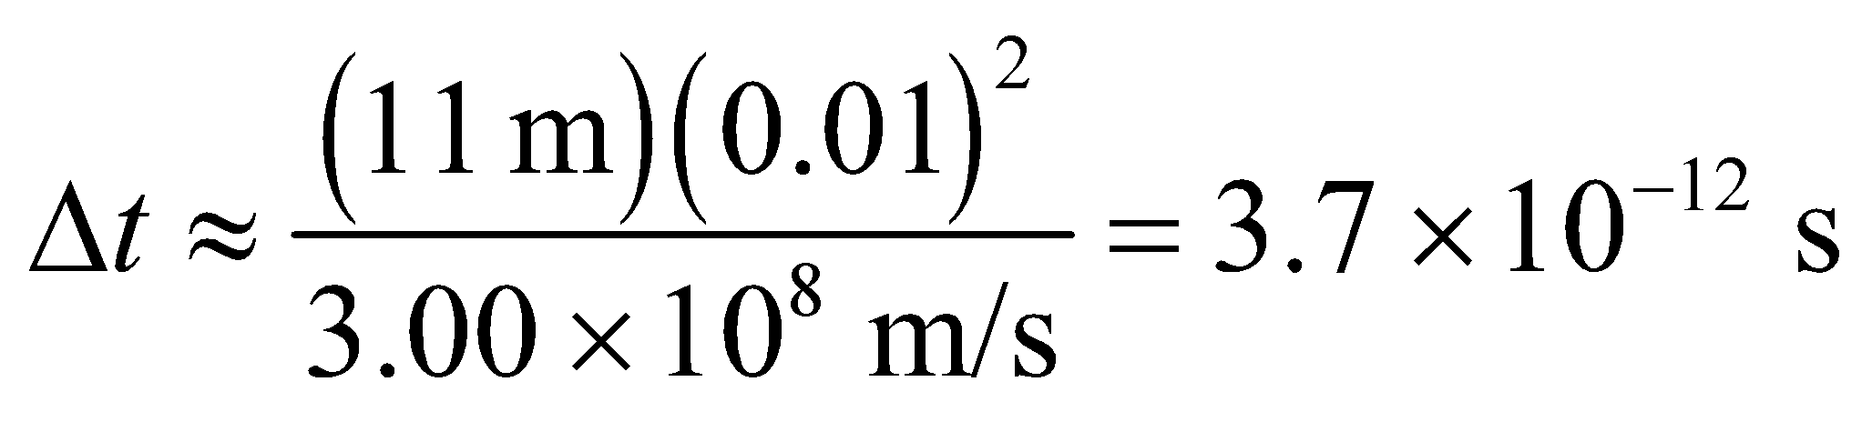

(**c**) For *v* = 0.5*c*, we use the exact expression, which gives

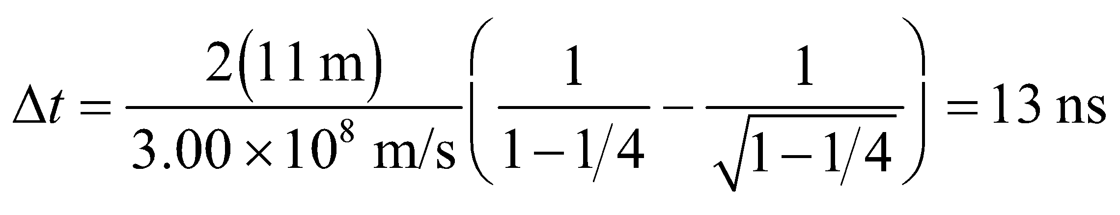

(**d**) For *v* = 0.99*c*, we find

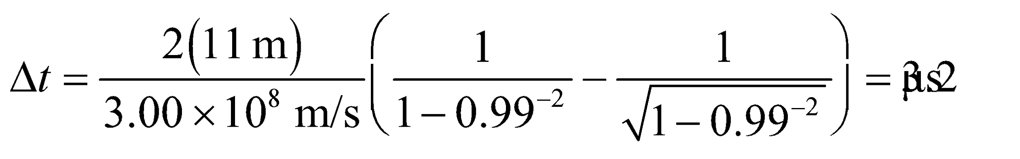

**Assess** The faster the ether wind, the greater is the time difference between the two paths.

**Section 33.4 Space and Time in Relativity**

**15. Interpret** This problem involves measuring a distance in two different frames of reference; the first of which is at rest with respect to the endpoints of the measurement, and the second of which is not.

**Develop** The distance between stars at rest in system *S* appears Lorentz-contracted in the spaceship’s system  according to Equation 33.4:

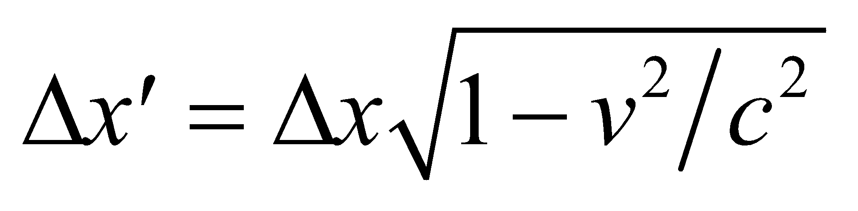

**Evaluate** With 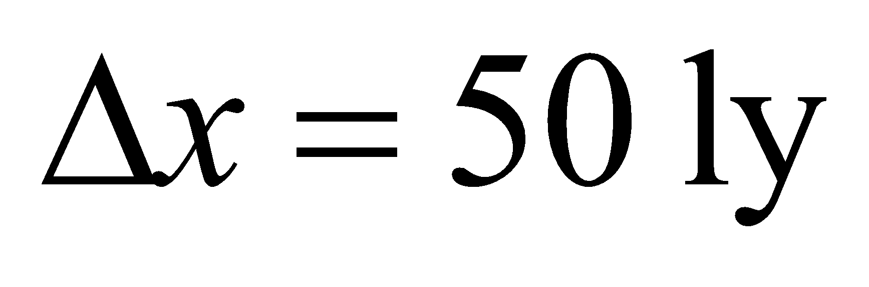and *v* = 0.75*c*, we get

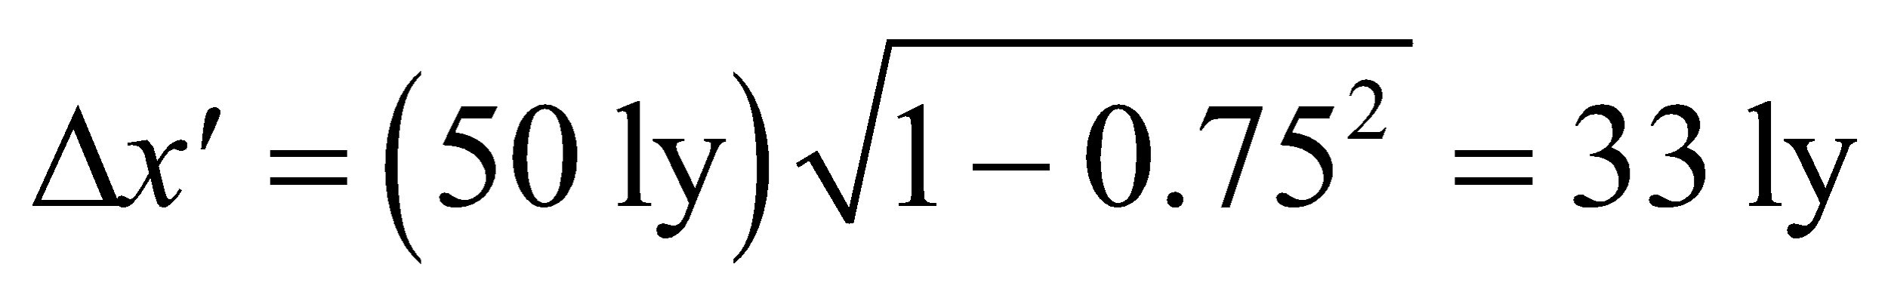

**Assess** The distance appears to be shortened or “contracted” as observed by the spaceship. Note that length contraction occurs only along the direction of motion.

**16. Interpret** We want to find how long a trip to Pluto takes according to a clock on Earth and on the spacecraft.

**Develop** For the distance, we'll assume that the Earth and Pluto are along the same radial line from the Sun, in which case:



where we've taken the orbital radii from Appendix E. But from the perspective of the spacecraft, the distance is contracted according to Equation 33.4: 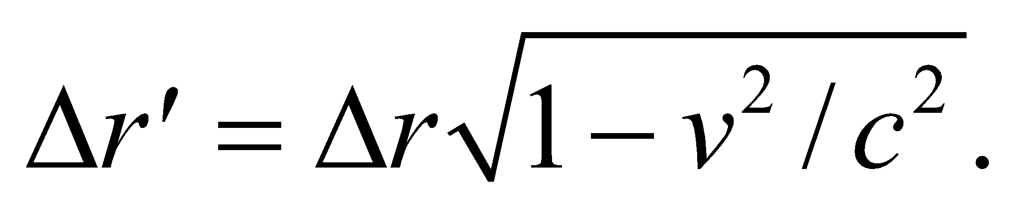 The time to reach Pluto in either case is the distance divided by the velocity, which is 0.65*c* for both cases.

**Evaluate**  **(a)** According to clocks on Earth, the trip takes

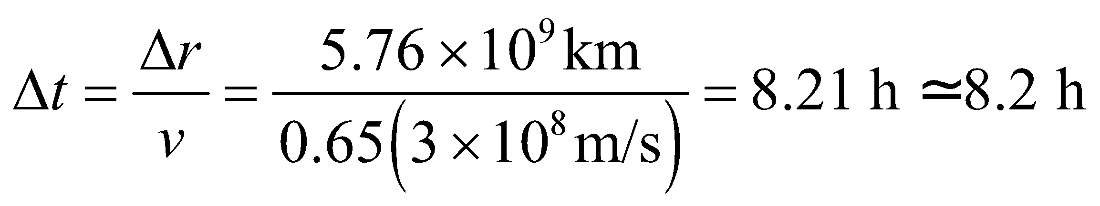

**(b)** According to clocks on the spacecraft, the trip takes

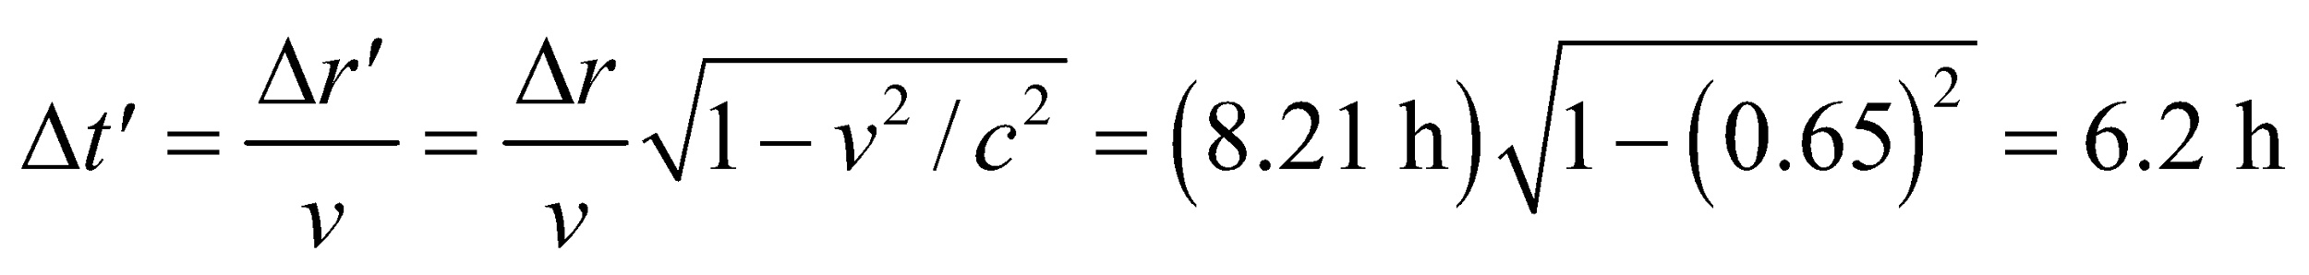

**Assess** The same answer can be reached by arguing that time dilation (Equation 33.3) makes the clock on the spacecraft appear to run slower than the clock on Earth.

**17. Interpret** This problem involves measuring the length of an object in its rest frame and in a frame of reference that is moving with respect to the object. The concept of length contraction will apply.

**Develop** We are given the length 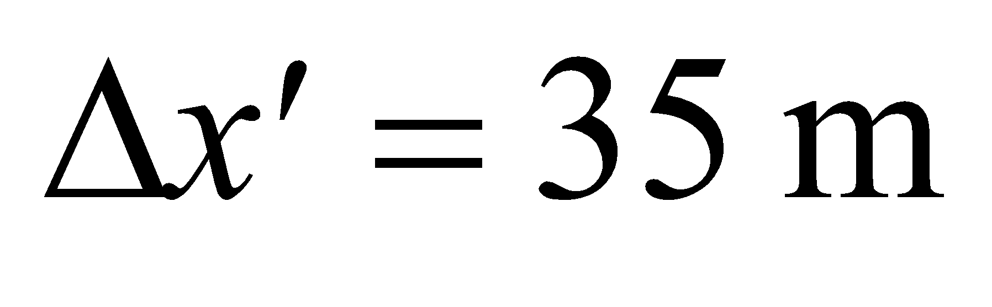, which is the length measured in a frame moving at *v* = 0.5*c*. Equation 33.4, , gives the length *Δx* measured in the rest system of the spaceship.

**Evaluate** Solving the equation for *Δx* gives

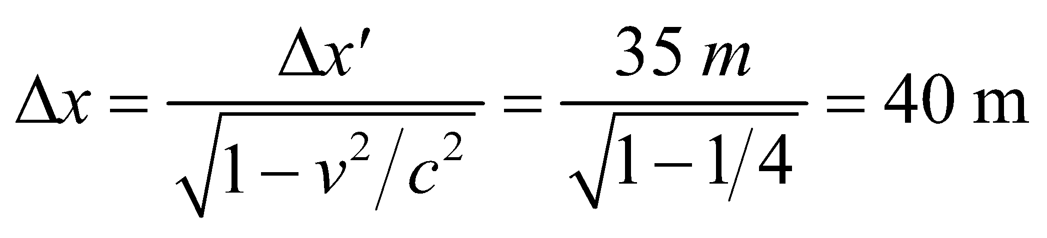

**Assess** The spaceship is longest in its own rest frame and is shorter to observers for whom it’s moving.

**18. Interpret** This problem involves measuring time in two different frames of reference. We are to find the time it takes a spacecraft to travel between two points according to an observer who is stationary with respect to these points and according to its internal clock. We shall use the principles of time dilation and proper time.

**Develop** According to an observer on Earth, the spacecraft moves a distance d = 8.3 light minutes at a speed *v* = 0.80*c*. From the definition of a light minute, we can obtain the time *Δt* the spacecraft takes according to the Earth observer. We then use the time dilation equation 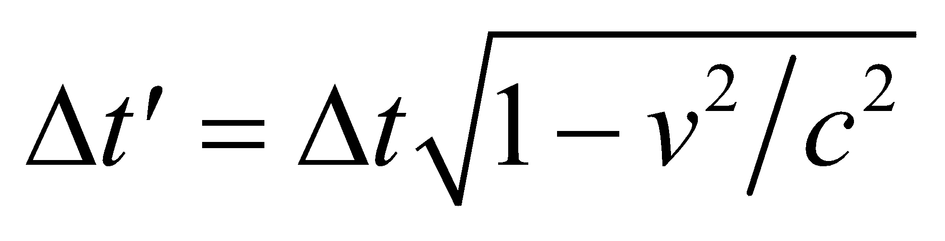 to find the time that a clock on the spacecraft measures.

**Evaluate** (**a**) Because the distance is measured in the Earth rest frame, the time is simply the distance divided by the speed of the spaceship:

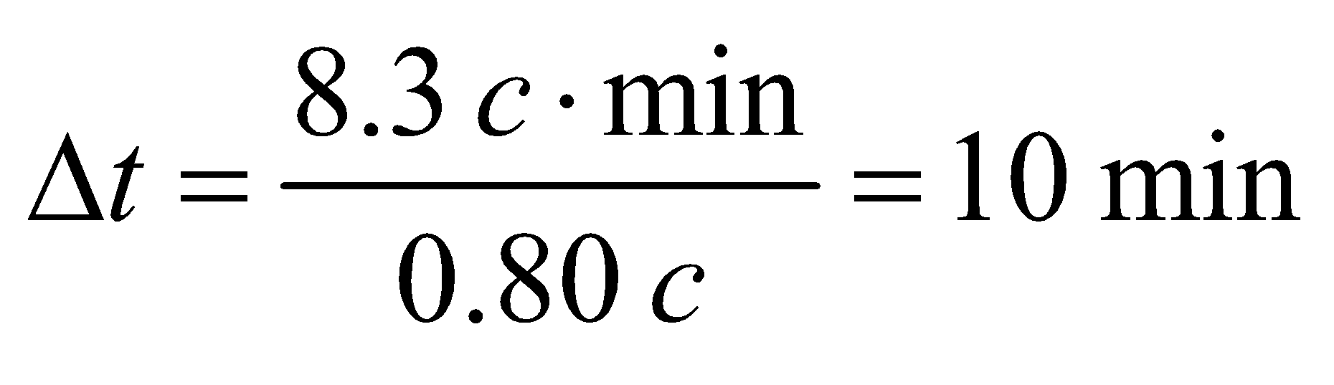

**(b)** An observer on the spaceship measures a time



**Assess** “Moving clocks run slow.” According to the clock in the spacecraft, it takes less time to cross the distance from the Earth to the Sun than it does according to the clock on the Earth.

**19. Interpret** This is a problem about length contraction. The meter stick is measured to be shorter when it appears to be moving relative to you.

**Develop** The distance you measure in a frame of reference  moving (in a direction parallel to the length of the meter stick) with speed *v* is 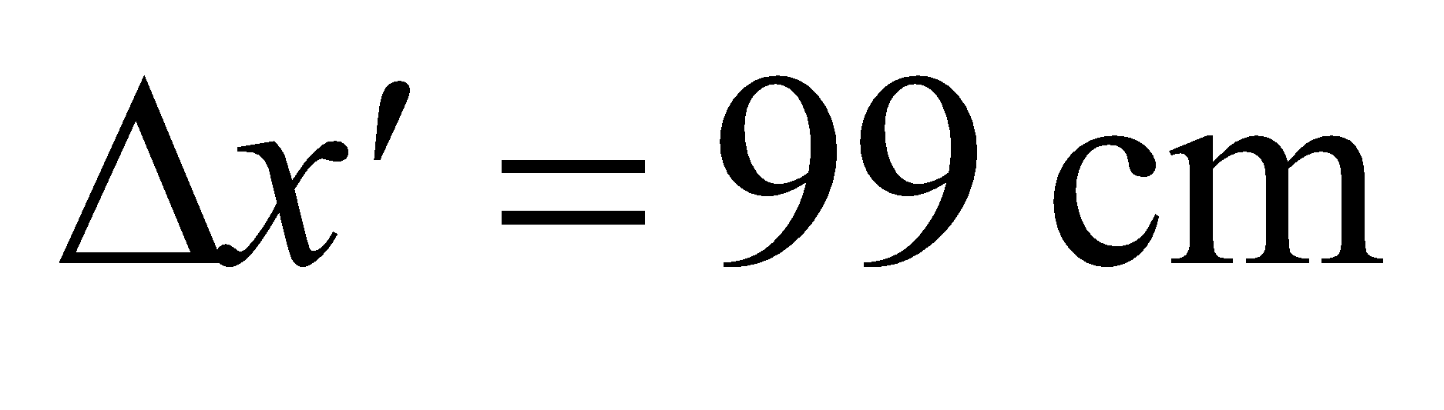, whereas the proper length of the meter stick is 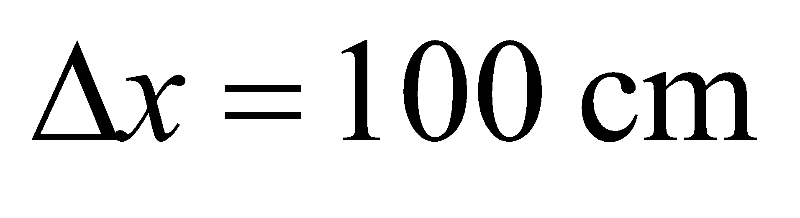 (in system *S*). These are related by Equation 33.4, , which gives 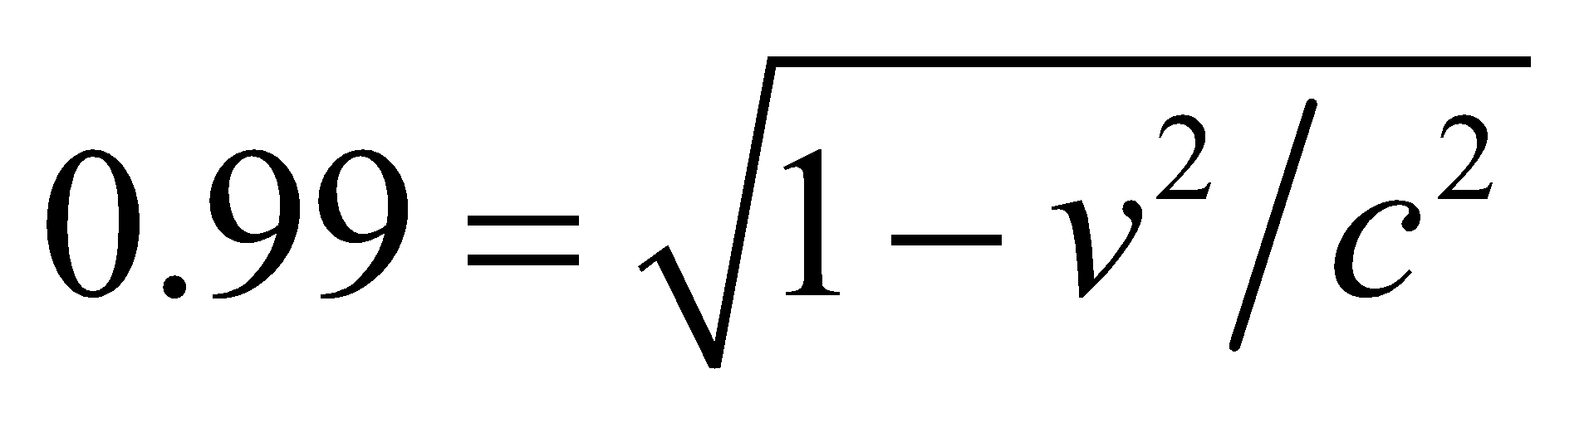.

**Evaluate** Solving for *v*, we get 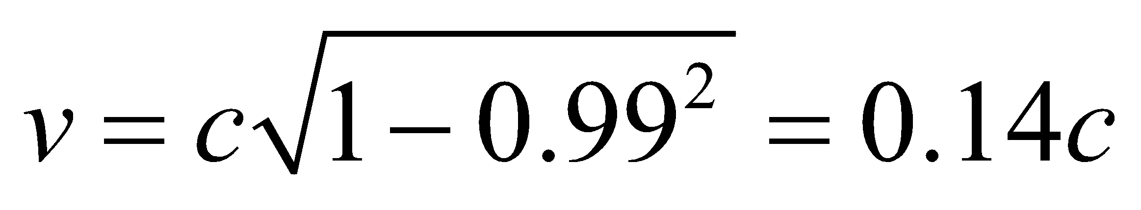.

**Assess** In order for the meter stick to measure 1% shorter, you would need to be moving at about 14% the speed of light with respect to the meter stick.

**20. Interpret** This problem deals with length contraction.

**Develop** In the electrons' reference frame, the accelerator is moving at a speed of 0.98*c*. Therefore, it's length will appear contracted according to Equation 33.4: 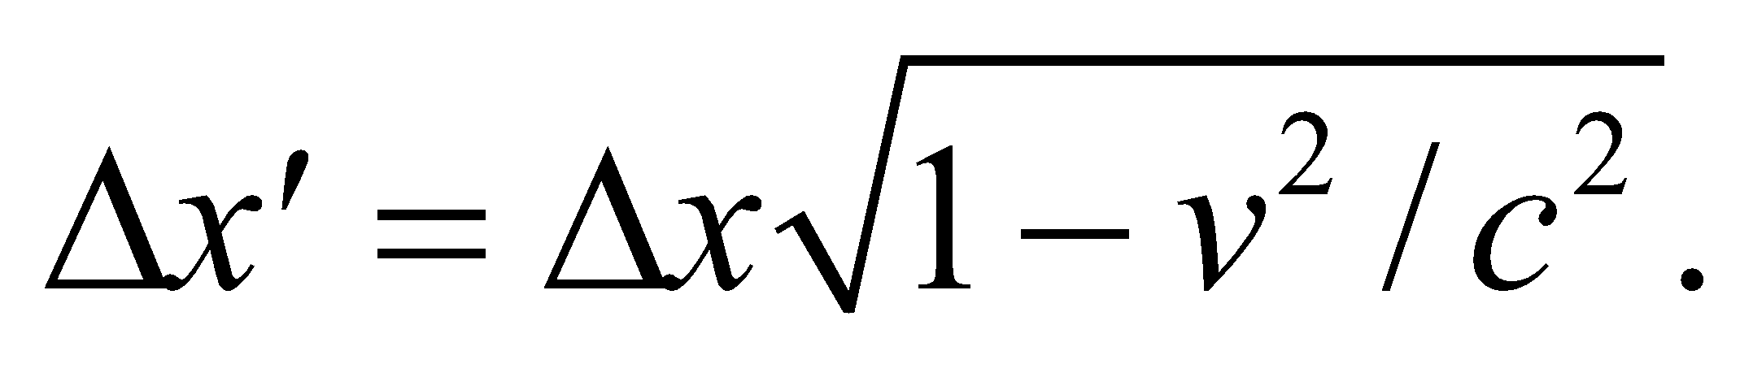

**Evaluate** The accelerator length in the electron frame is

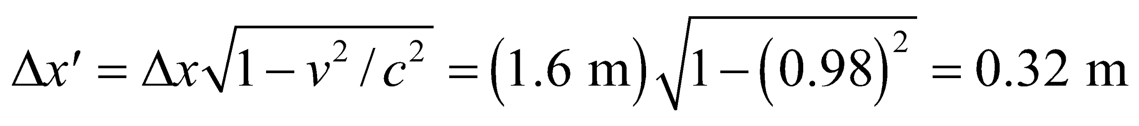

**Assess** This is a factor of 5 smaller than the length in the rest frame of the accelerator.

**Section 33.7 Energy and Momentum in Relativity**

**21. Interpret** We want to know the change in momentum when we double the speed, both in the nonrelativistic and relativistic limits.

**Develop** The measure of momentum valid at any speed is given by Equation 33.7:

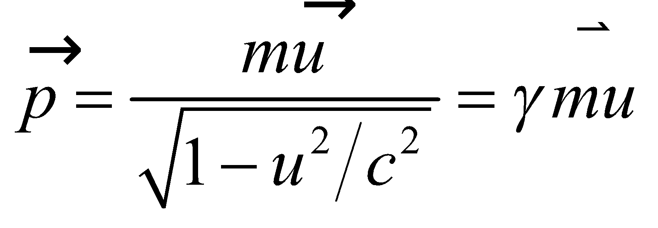

Thus, doubling the speed (*u* becomes 2*u*) increases the momentum by a factor

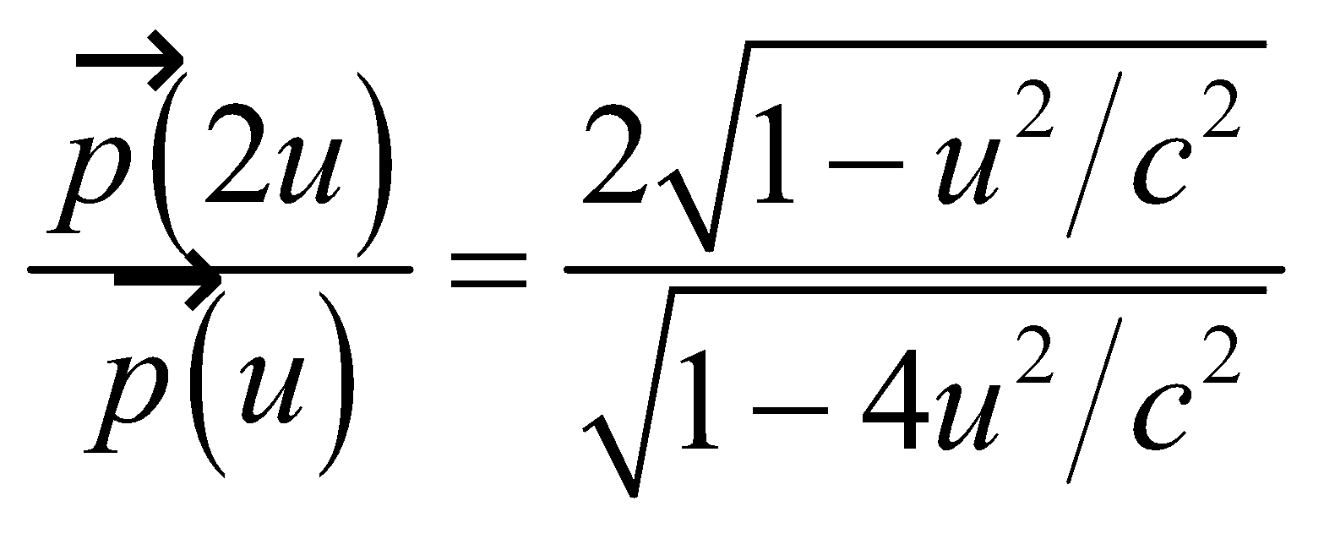

**Evaluate** **(a)** When *u* = 25 m/s, 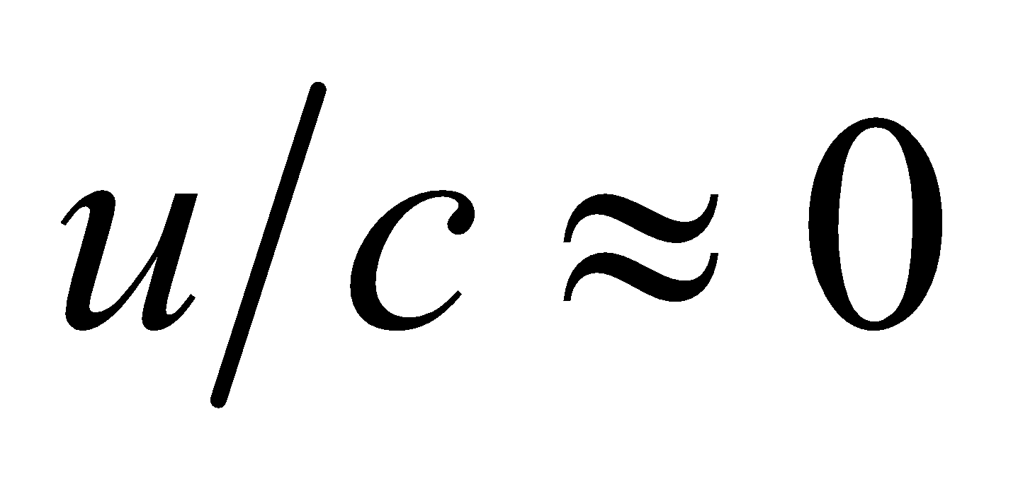, so the above factor is 2.0 (to two significant figures).

**(b)** If , the factor is

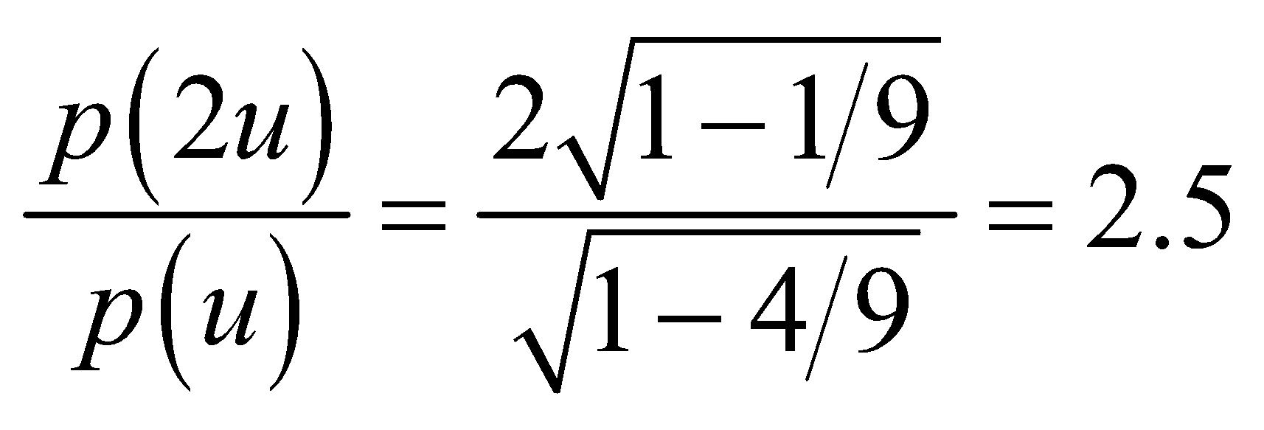

**Assess** In the nonrelativistic limit, momentum  is linear in  and 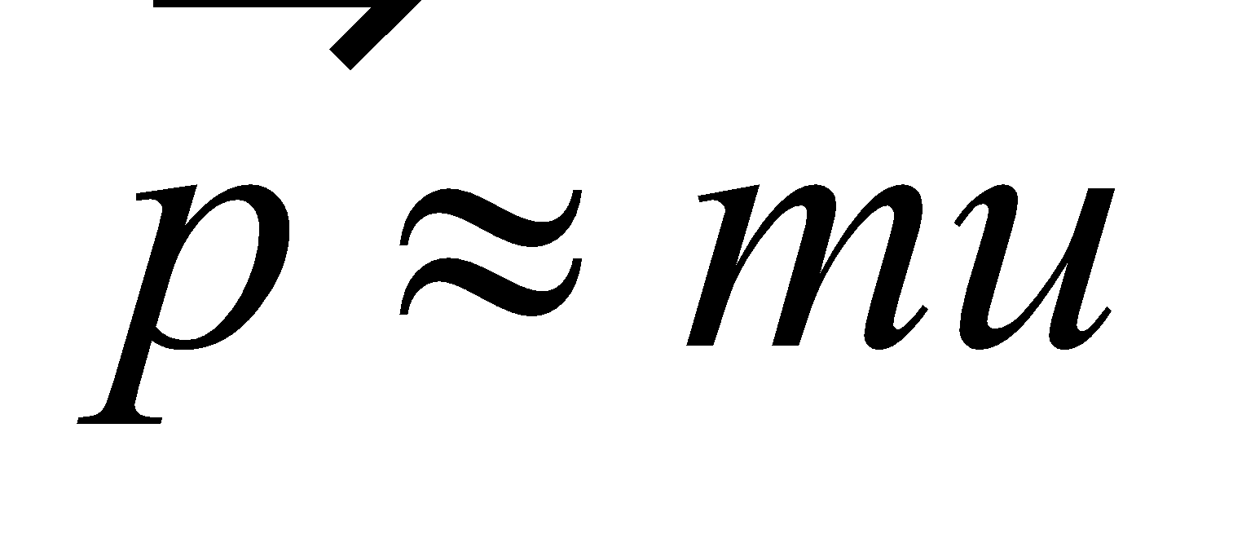, but this no longer holds in the relativistic limit.

**22.** **Interpret** This problem involves relativistic momentum. We are to find the speed at which an object with 1 unit of mass has the same momentum as that of a 4-unit-mass particle traveling at 0.5*c*.

**Develop** Using Equation 33.7, we see that the momenta of the proton and alpha particle are equal when

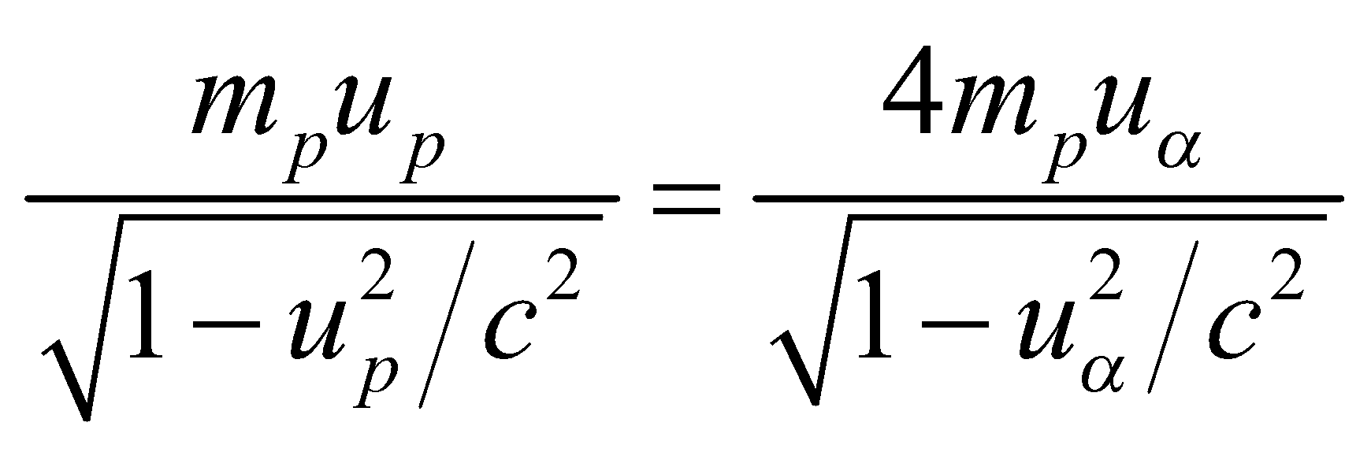

**Evaluate**  Square and solve for *up* to obtain

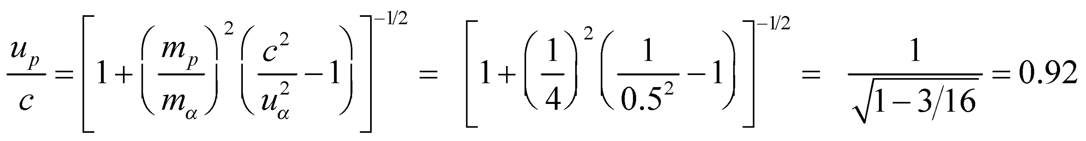

**Assess** The speed of the proton would need to be over 90% the speed of light.

**23. Interpret** The Newtonian expression 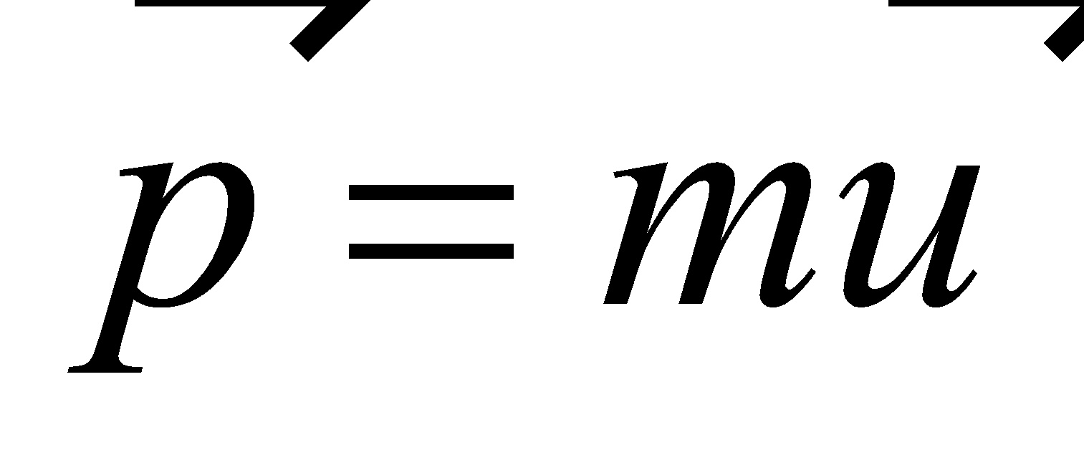 is valid only when 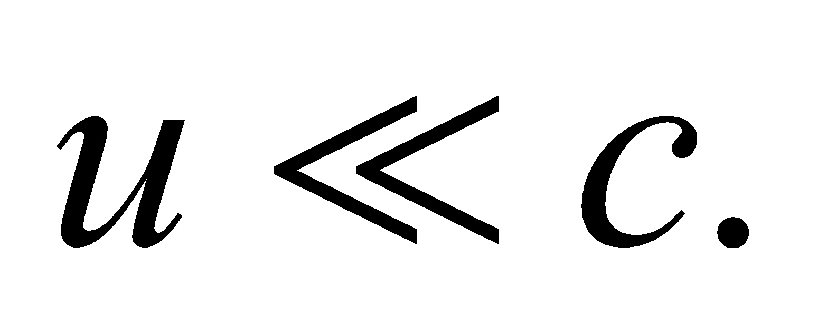 and for constant mass. We want to know the speed at which the difference between this and the relativistic expression is 1%.

**Develop** From Equation 33.7, we find that the error in the Newtonian expression of momentum is

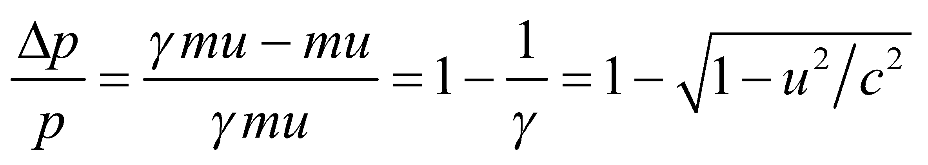

**Evaluate** When this factor is equal to 0.01, the speed is

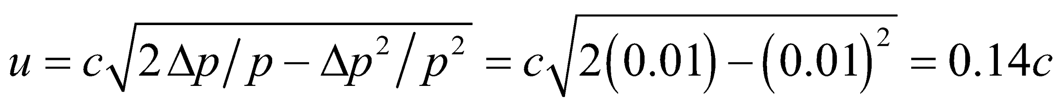

**Assess** Although  is valid at low velocity, in the relativistic limit where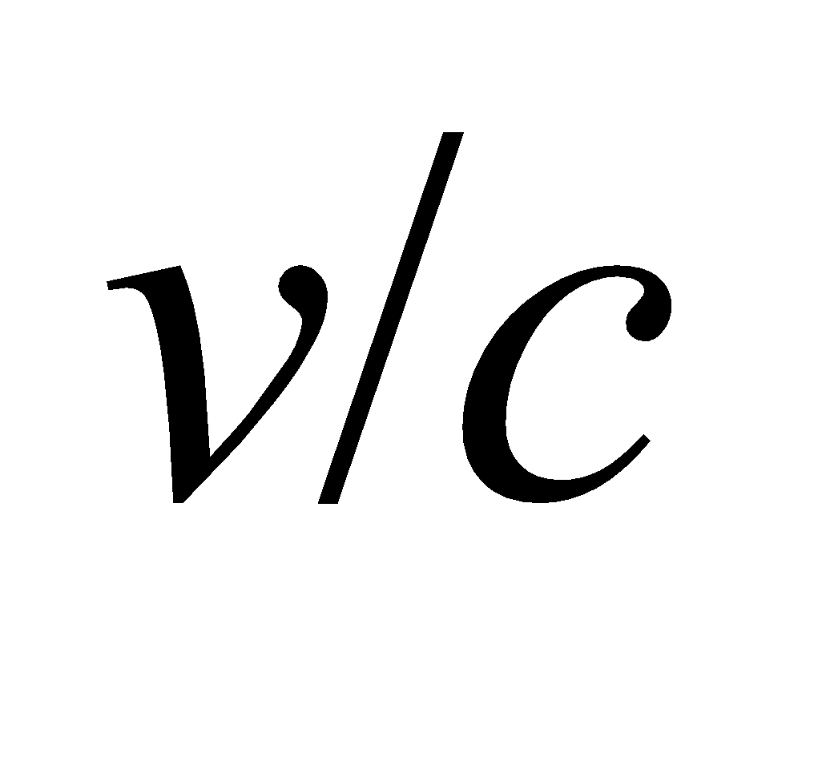is not negligible, Equation 33.7 should be used instead.

**24.** **Interpret** This problem concerns the relationship between relativistic momentum and velocity. We are to find by how much the momentum increases for a 10% increase in the given velocity.

**Develop** Apply Equation 33.7, 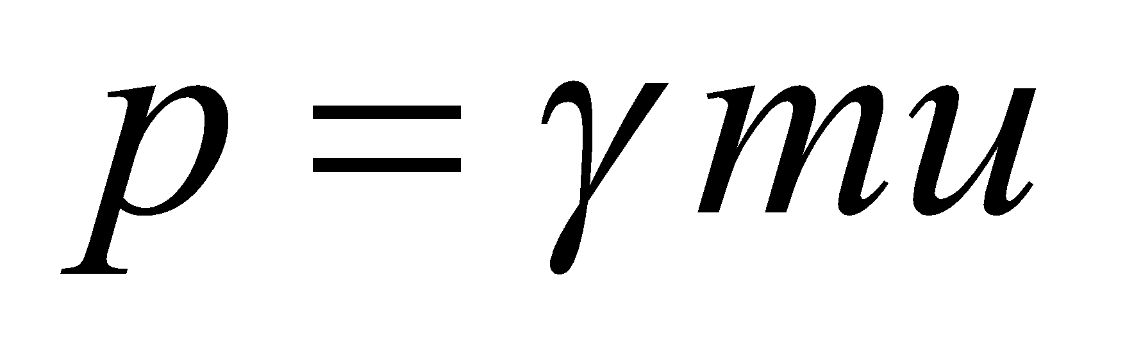. The initial momentum is

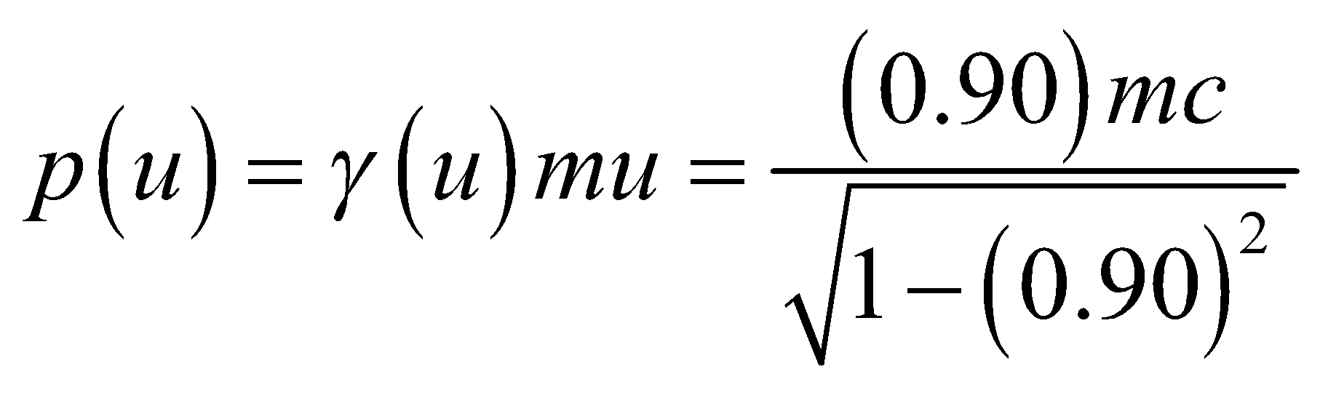

and the final momentum is

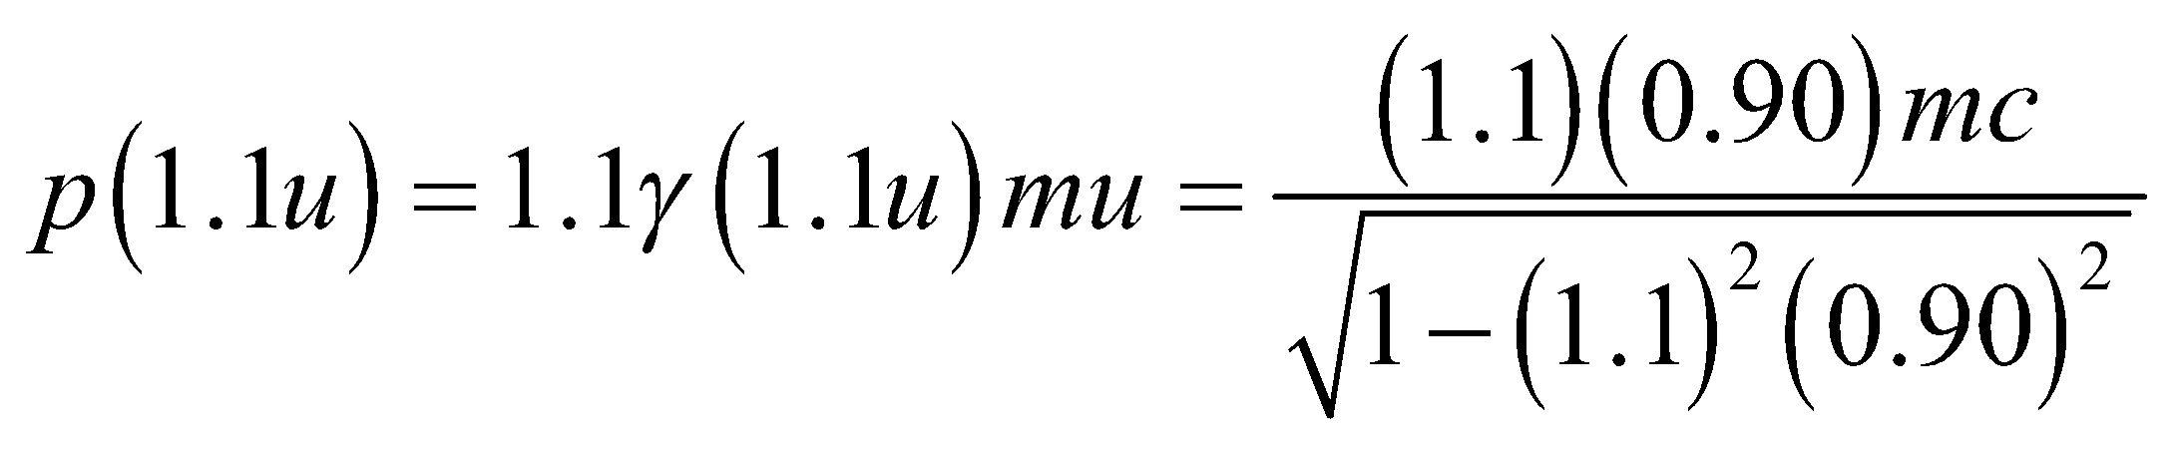

Take the ratio to find the increase in momentum.

**Evaluate** The increase in momentum is

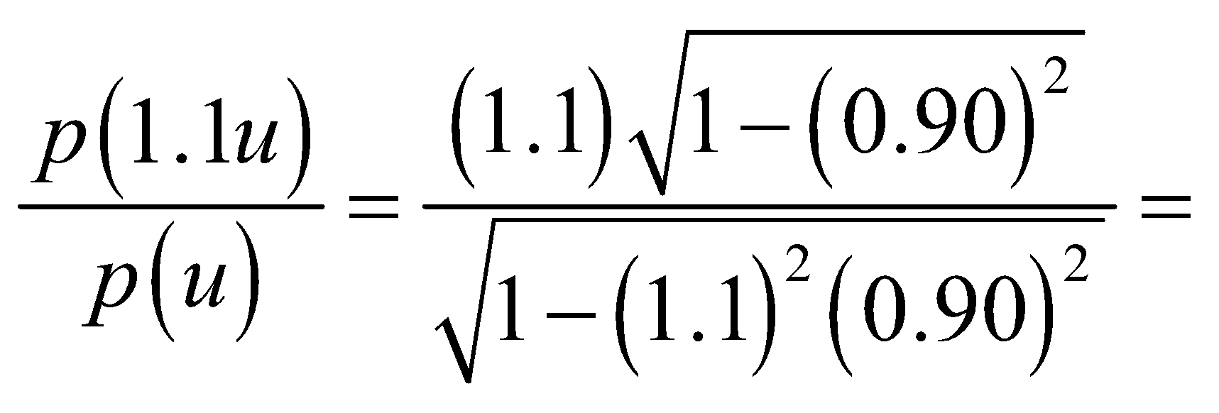3.4

**Assess** This results seems reasonable in light of Figure 33.17, which shows that the momentum increases superlinearly for .

**25. Interpret** The electron is moving at a relativistic speed, and we want to know its total energy and kinetic energy.

**Develop** The total energy of the electron is given by Equation 33.9:

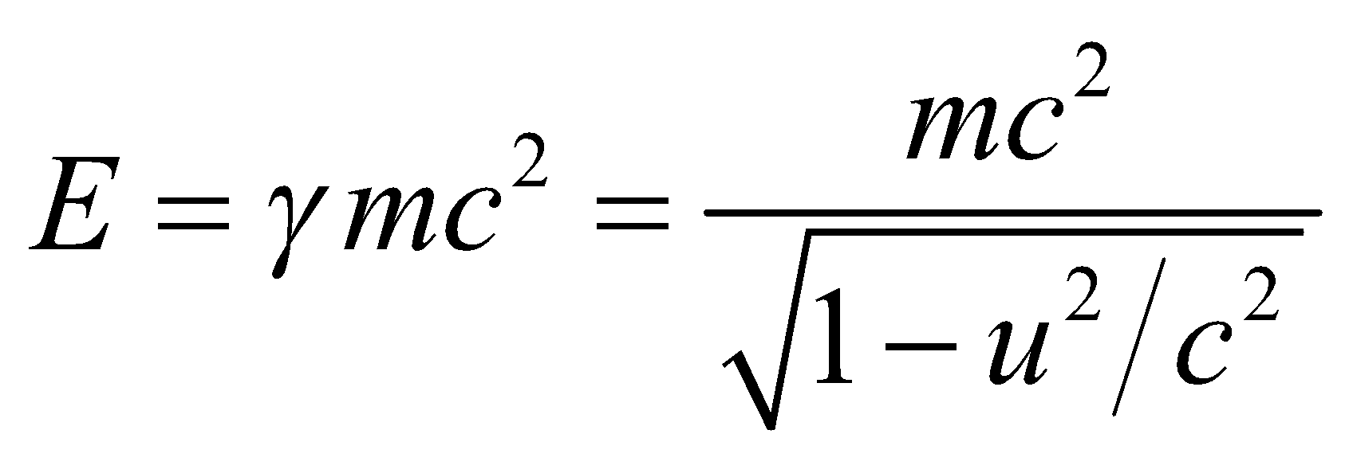

Its kinetic energy is given by Equation 33.8:

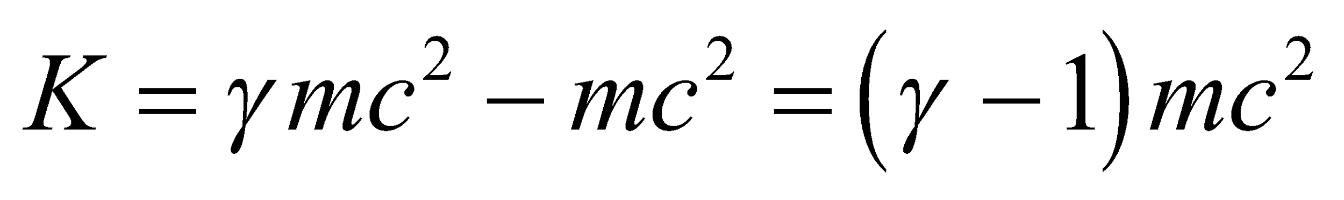

For this problem, the electron’s speed is *v* = 0.97*c*, so

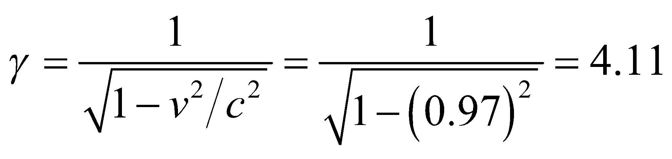

and 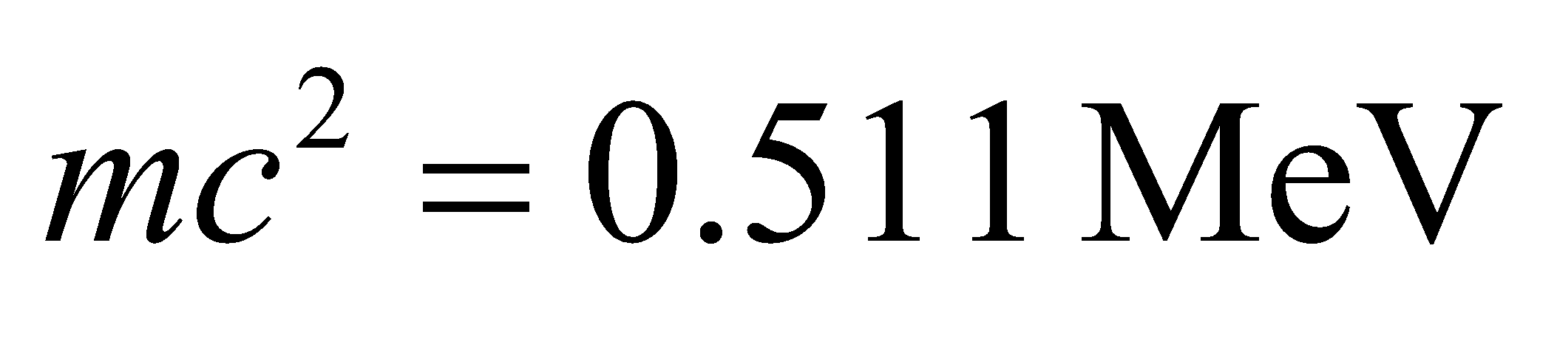.

**Evaluate** **(a)** From the information above, the total energy is

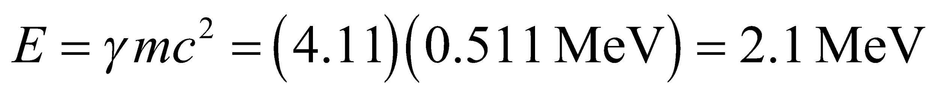

**(b)** The kinetic energy is



**Assess** The total energy and kinetic energy are related by 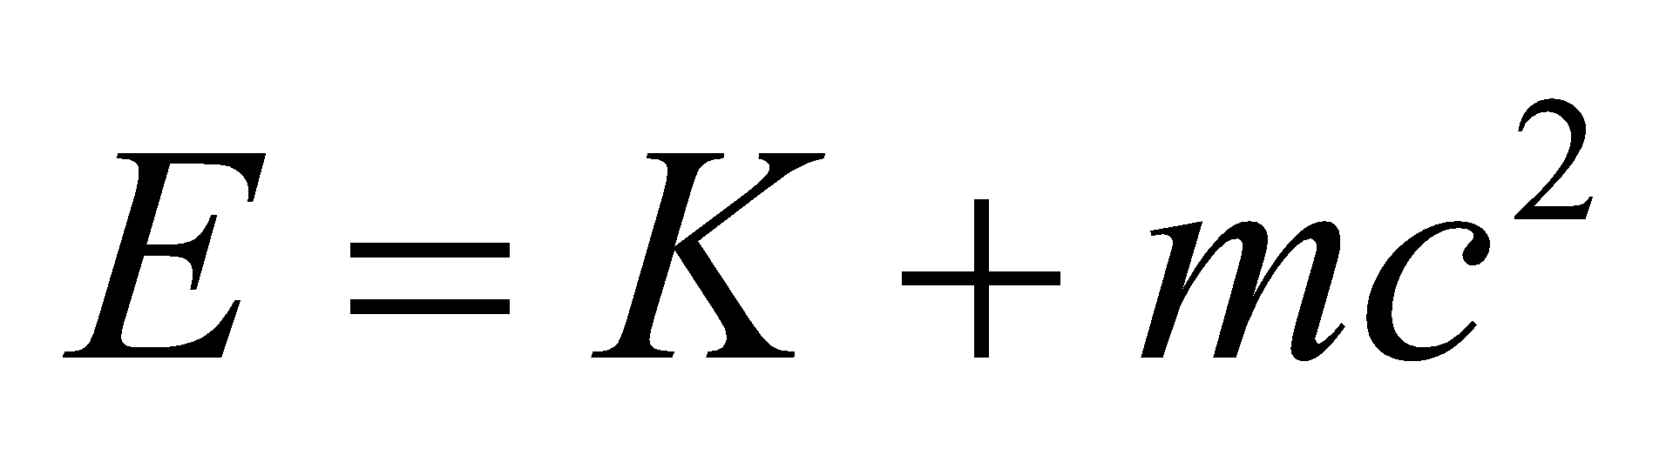, where 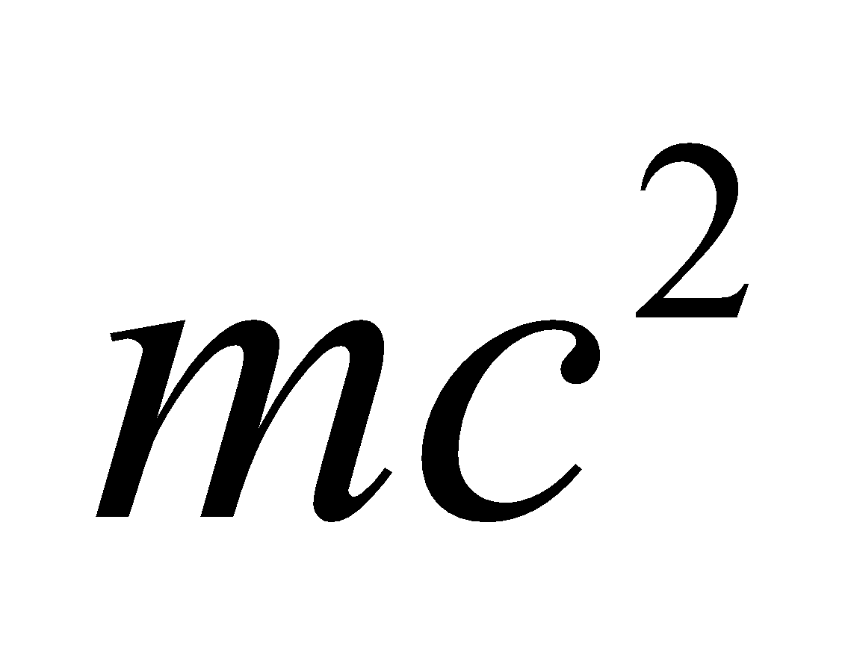 is the rest energy of the particle. The expression demonstrates the equivalence between mass and energy. The results are reported to two significant figures to reflect the precision of the input data.

**26.** **Interpret** This problem is similar to Problem 33.24, except that we are now to find the speed at which the relativistic and Newtonian kinetic energy differ by 10%.

**Develop** The Newtonian kinetic energy is 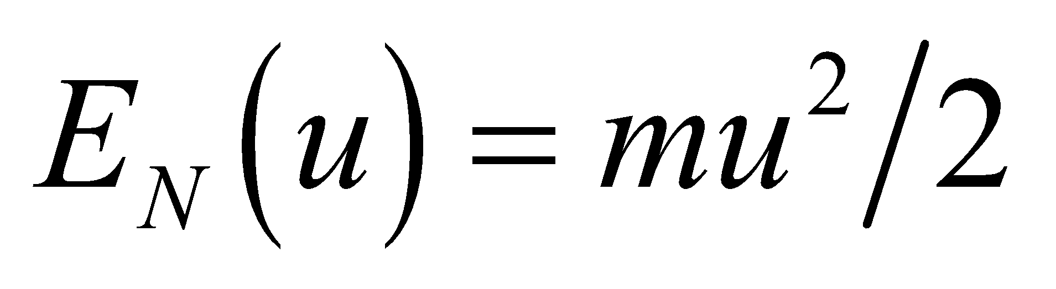 and the relativistic kinetic energy is (Equation 33.8) 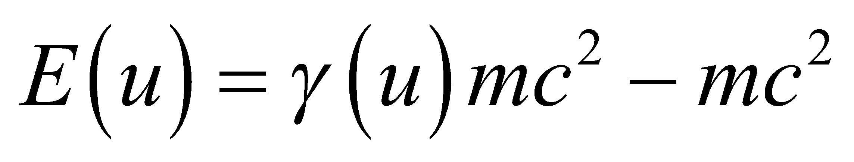. A difference of 10% translates to

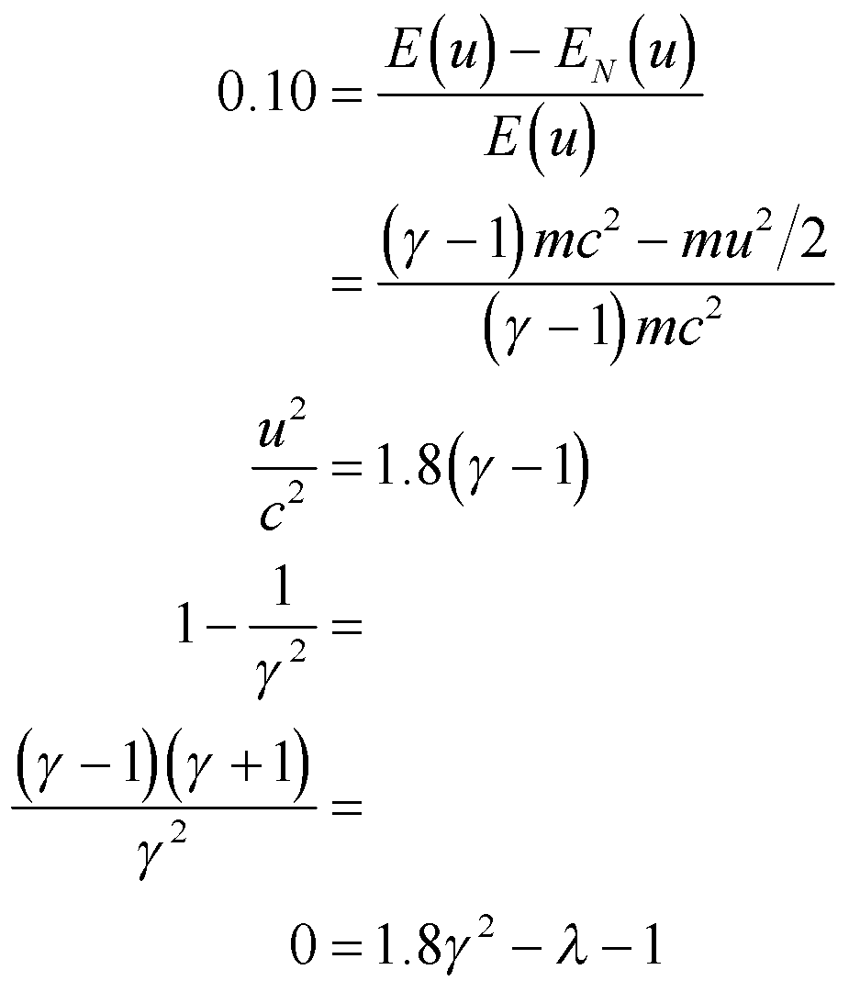

which we can solve for *γ* and thus find the speed *u*.

**Evaluate** The solution to the quadratic in *γ*  is

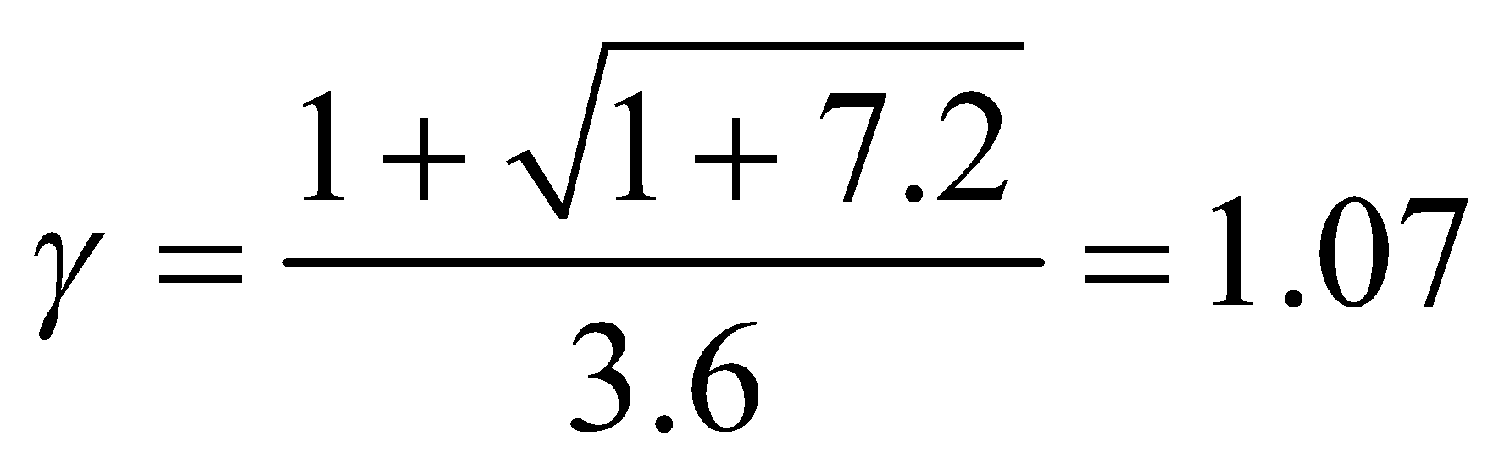

so the speed *u* is

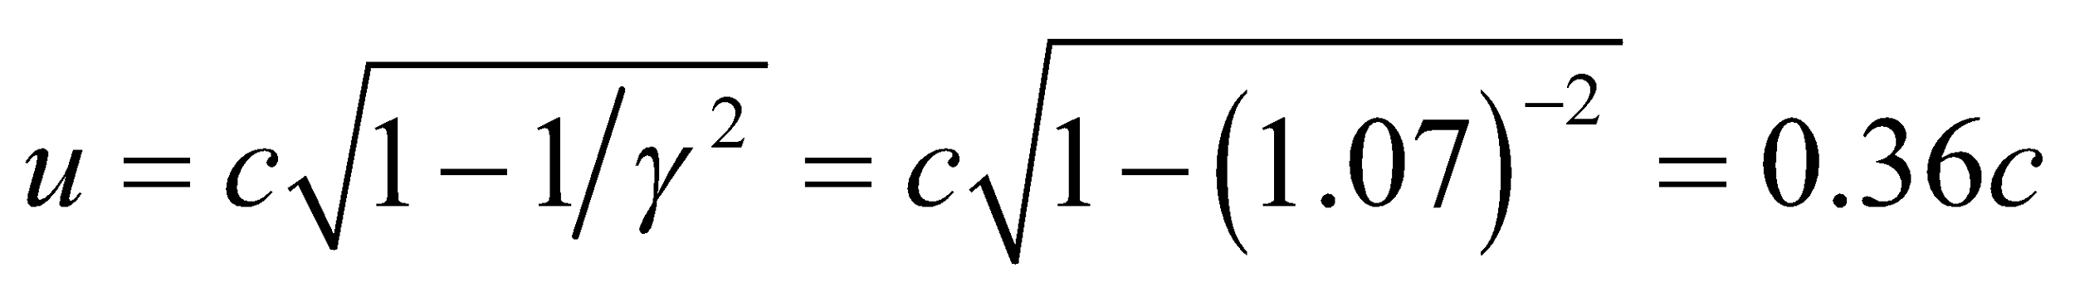

**Assess** The result is reported to two significant figures to reflect the precision of the data. From Figure 33.17, we see that a 10% error in kinetic energy occurs for speeds much lower than for momentum.

**Problems**

**27. Interpret** We are to compare the round-trip times in each branch of a Michelson–Morley interferometer. One branch is taken to be parallel to the hypothesized ether wind and the other branch is perpendicular to the ether wind. In particular, we are to show that *t*parallel > *t*perpendicular for 0 < *v* < *c*.

**Develop** The ratio of Equations 33.2 to 33.1 is

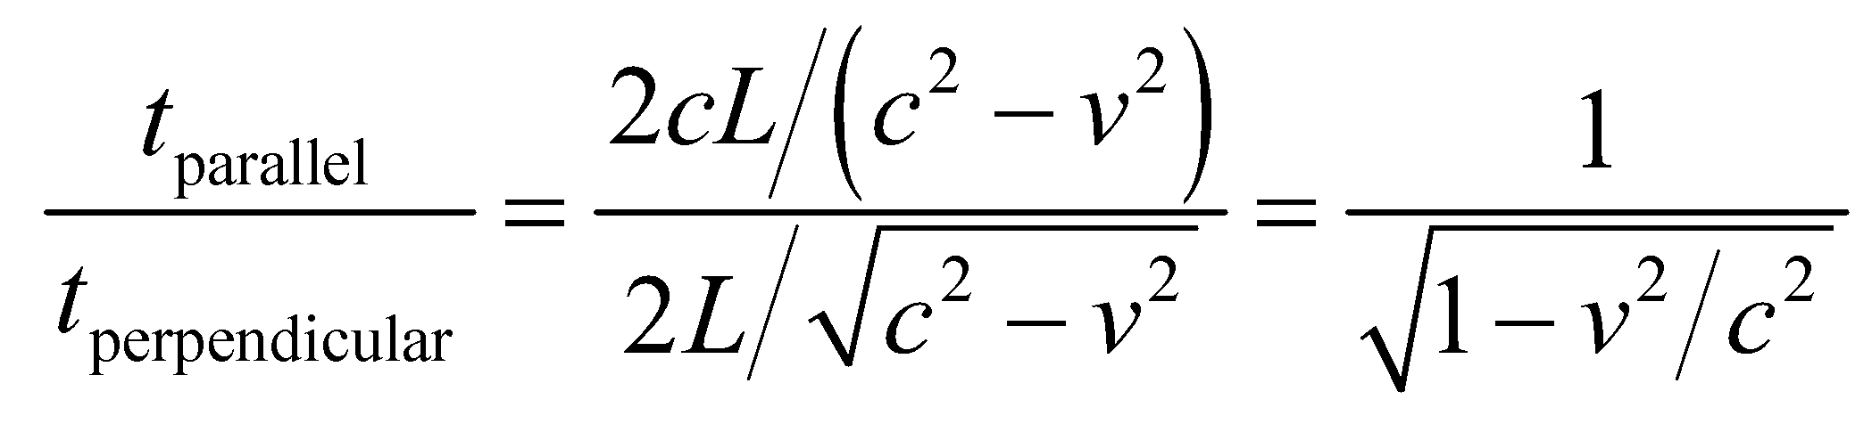

**Evaluate**  For 0 < *v* < *c*, the denominator of the ratio above ranges from unity to zero, so the ratio ranges from unity to infinity. Thus, we have

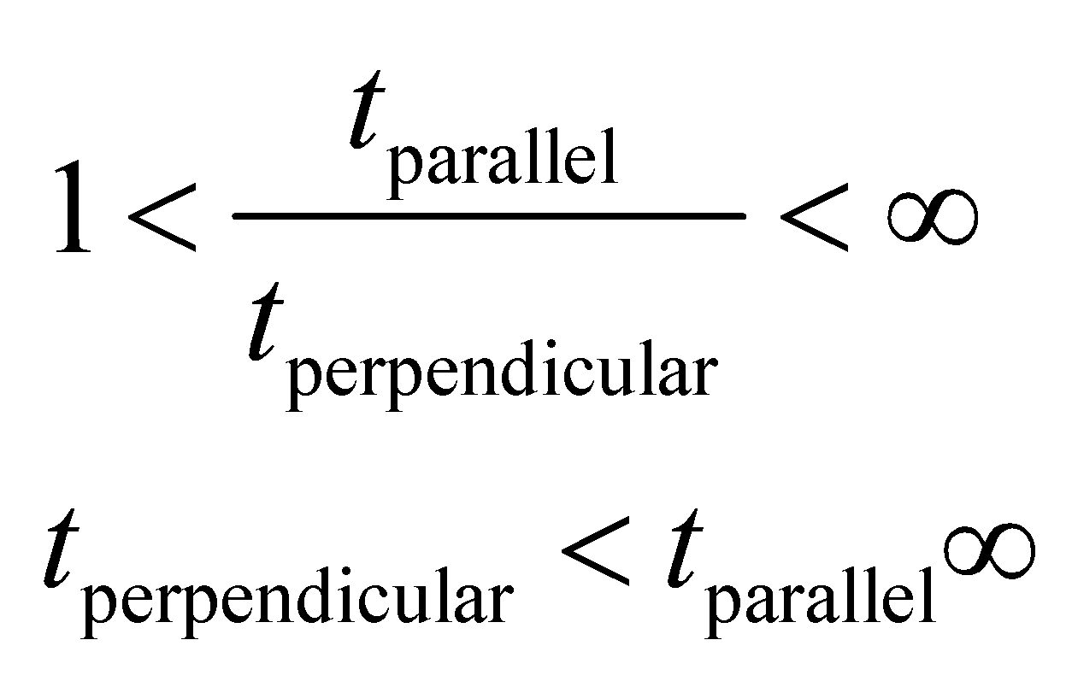

as claimed in the problem statement.

**Assess** Since , we conclude that the trip parallel to the ether wind always takes longer.

**28. Interpret** You want to design a Michelson interferometer that would be sensitive to speed of light variations as small as 100 m/s.

**Develop** Let's define 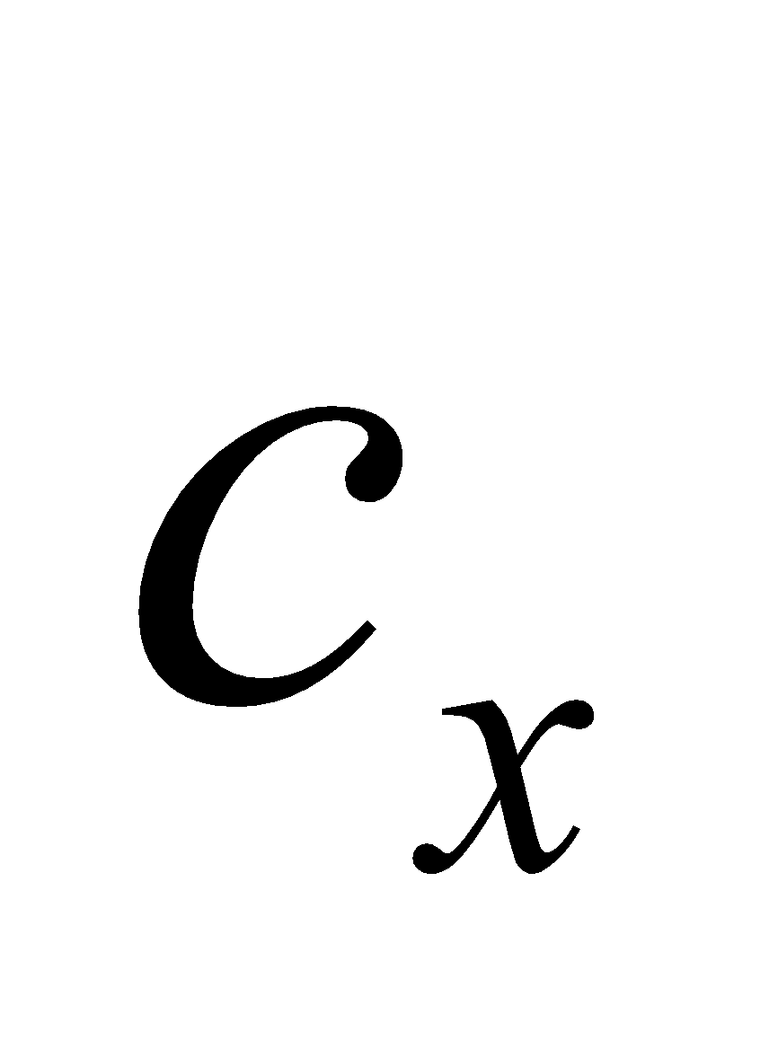 and 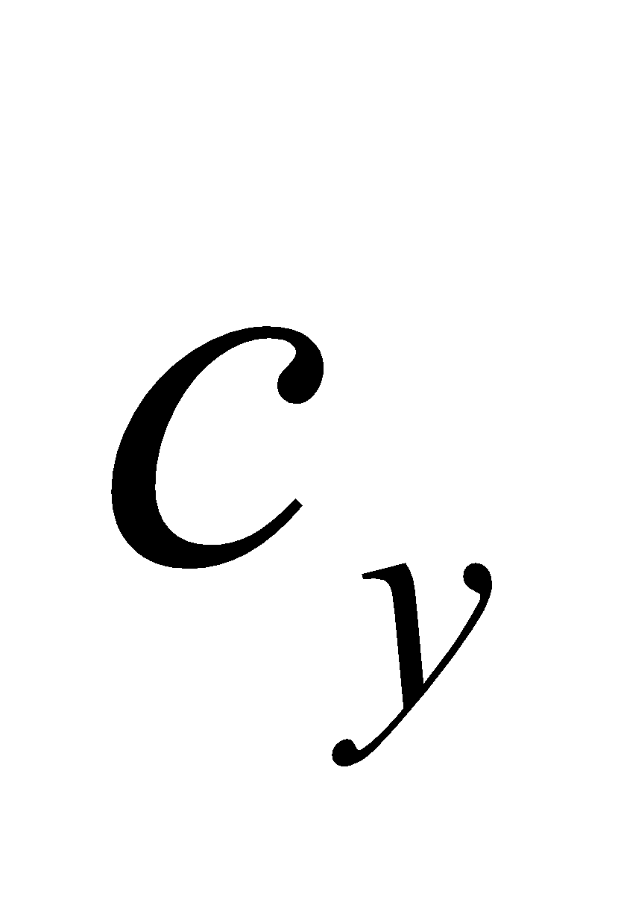 as the speed of light in the perpendicular *x* and *y* directions, respectively. You're told to assume that 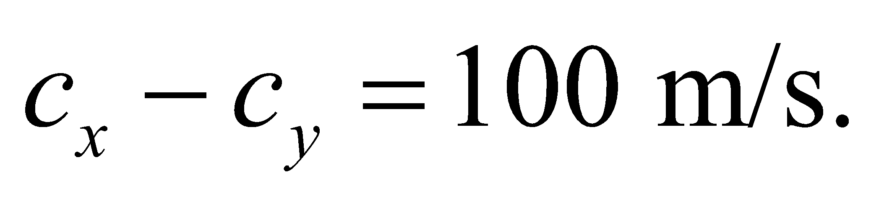 Therefore, it will take longer for light to make the round-trip in the interferometer arm aligned with the *y*-direction (see Figure 33.2):

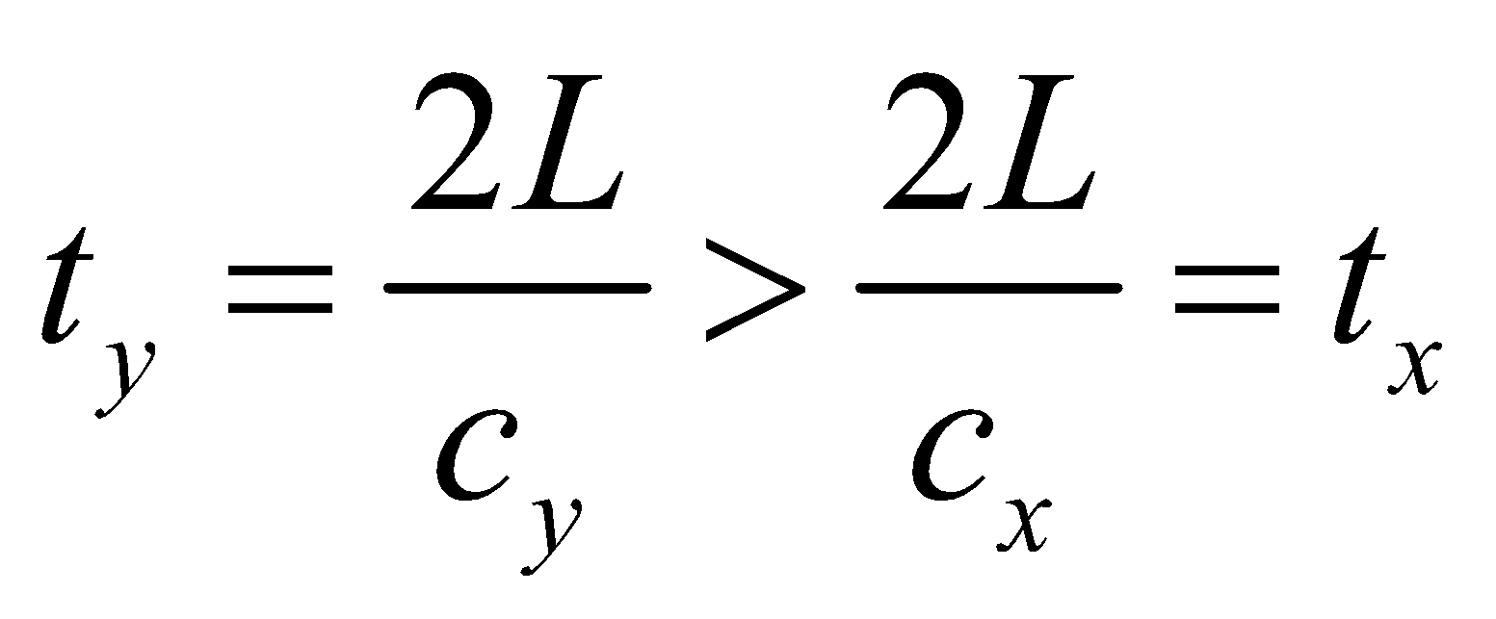

This time difference is supposed to cause a bright fringe in 550-nm light where the adjacent dark fringe would be in the absence of a speed difference. In other words, the speed difference should cause a 180° phase difference between the two paths:

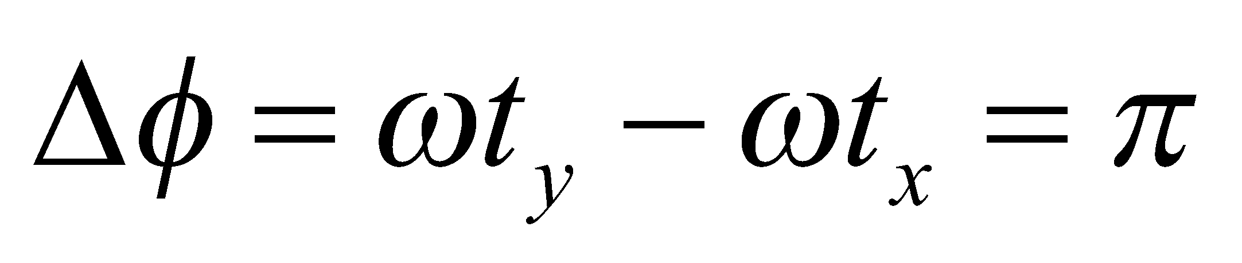

**Evaluate** Substituting the time values in the phase difference equation gives for the length of the interferometer:

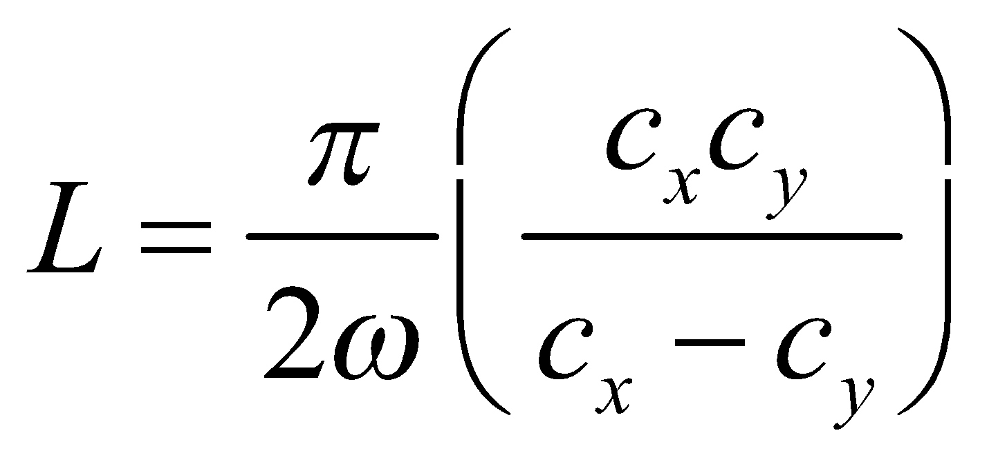

Since the speed difference is much smaller than the measured value of *c*, the numerator in the above fraction can be approximated as 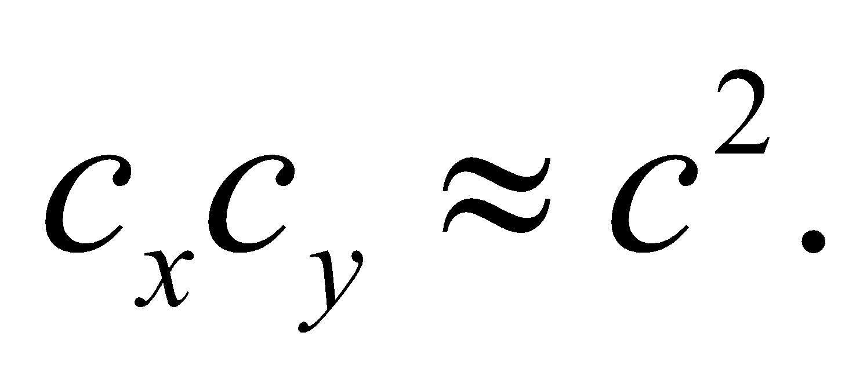Therefore, the length equation becomes

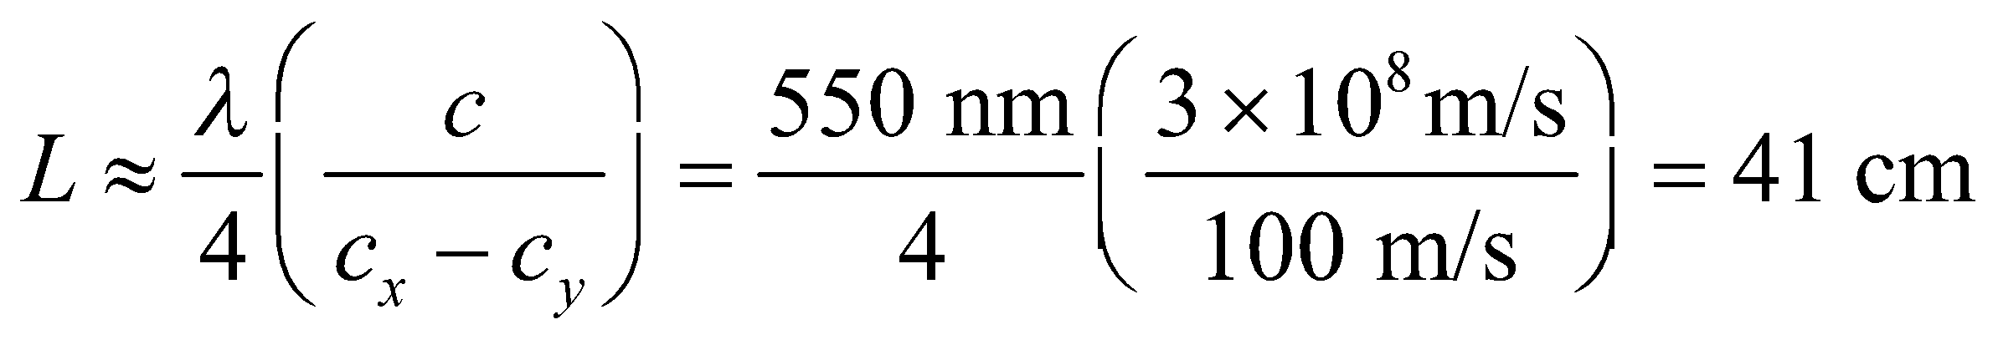

**Assess** The length is inversely proportional to the speed difference. This means that the interferometer would have to be 100 times longer in order to measure a speed difference of 1 m/s.

**29. Interpret** This is a problem about travel time measured in different reference frames; one reference frame is at rest with respect to the end points of the trip, whereas the other reference frame is not. Time dilation is involved.

**Develop** Note that the distance is given in the system *S*, where the Earth and the Sun are essentially at rest (the orbital speed of the Earth is very small compared to the speed of light or the speed of the spacecraft). However, the time interval is given in system , where the spacecraft is at rest. In other words, 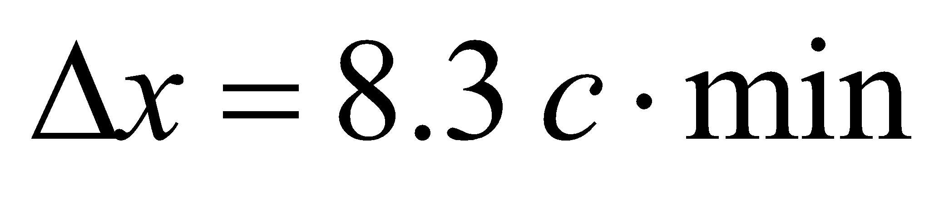and 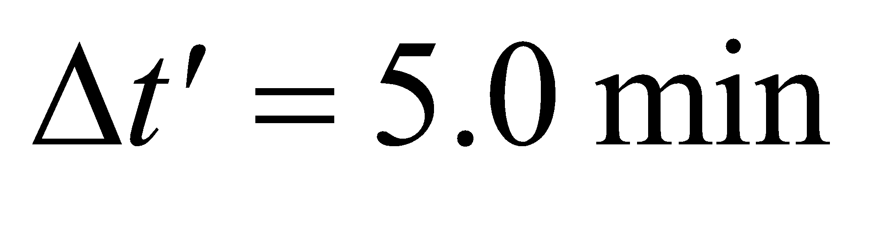. Equations 33.3 and 33.4

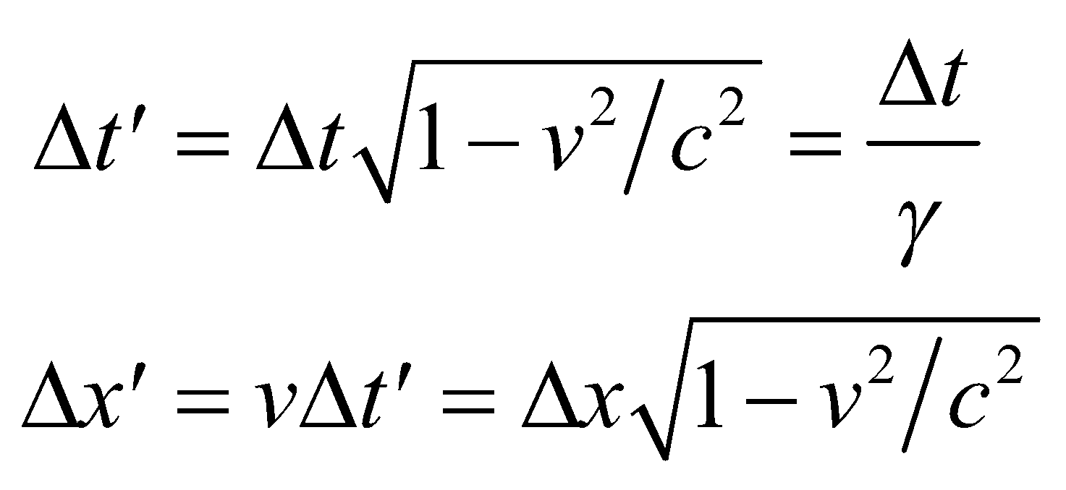

express time dilation and Lorentz contraction. The speed of the spacecraft can be found by using the second expression which gives

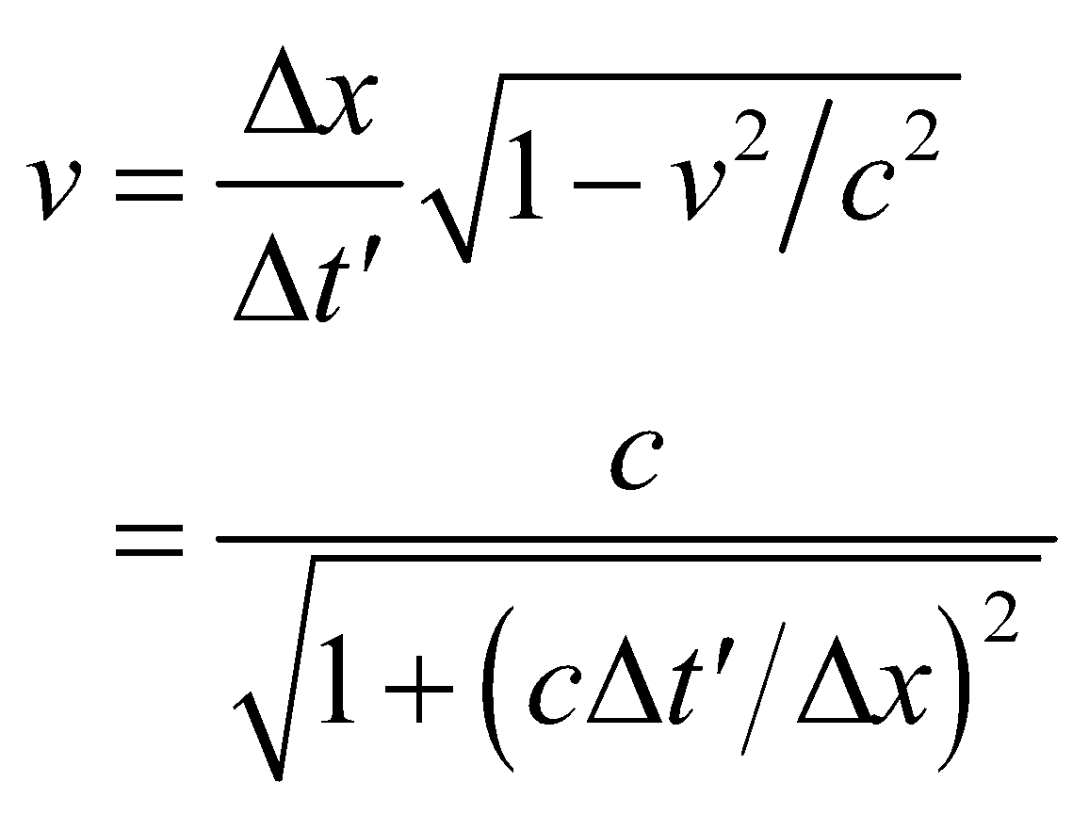

Once we know *v*, we can evaluate 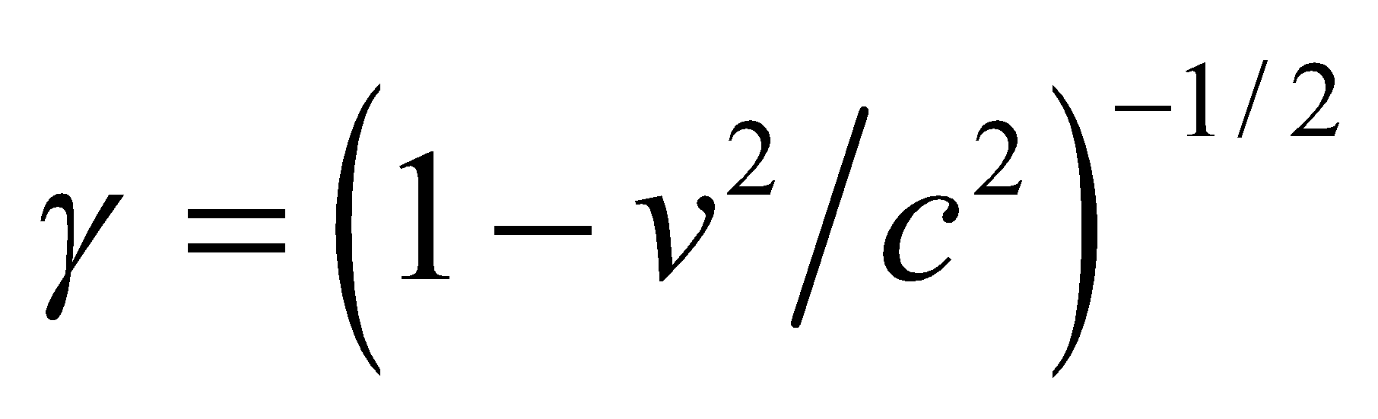 and find the time in the rest frame using the expression above for time dilation, which gives 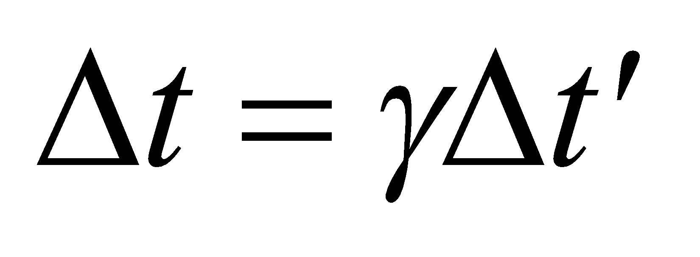.

**Evaluate** **(a)** Inserting the given values into the expression for velocity gives

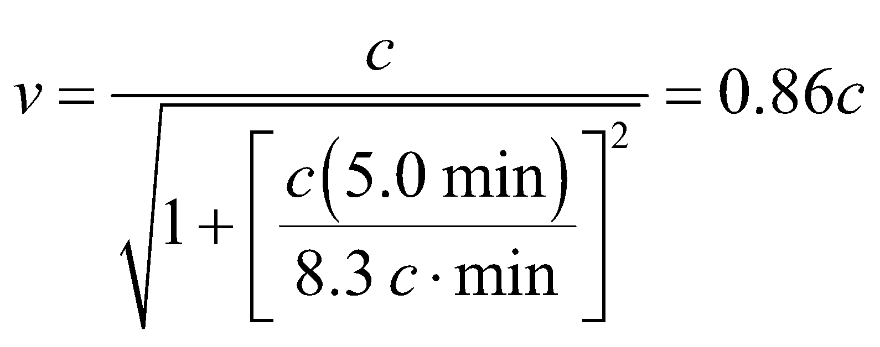

**(b)** The time in the rest frame is

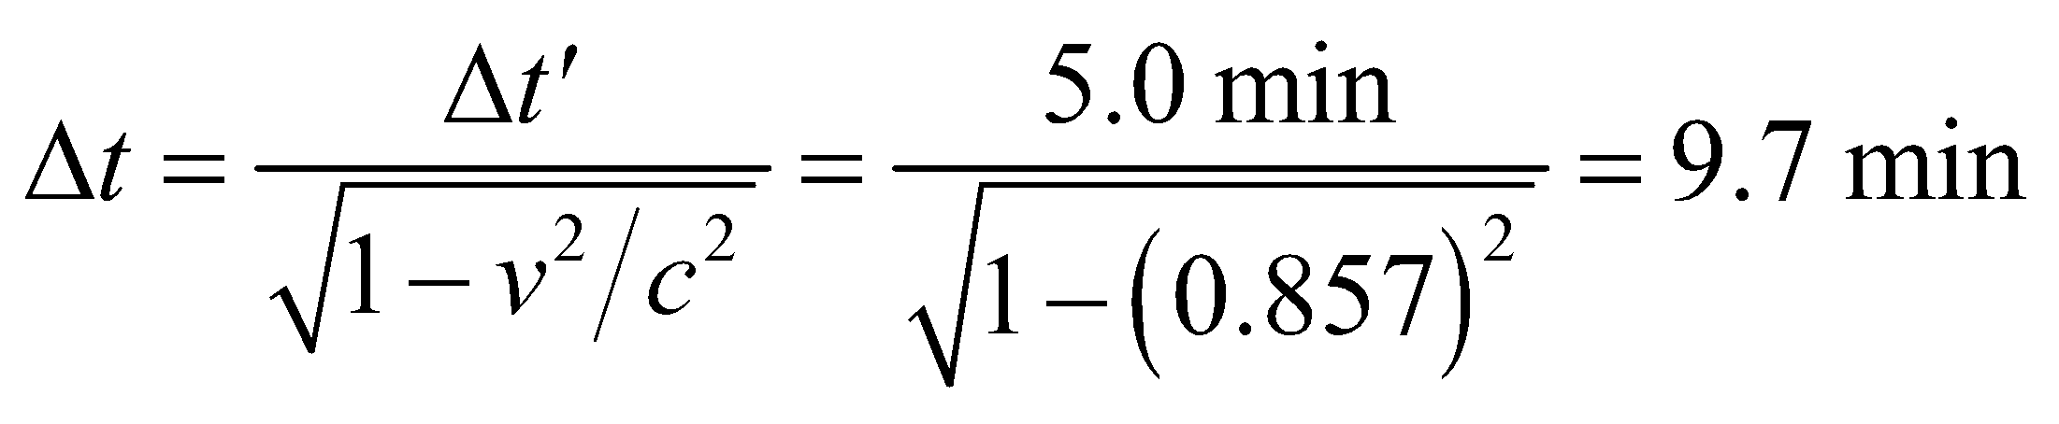

**Assess** The result demonstrates that clocks (inside the spacecraft) moving relative to the Earth-Sun frame appear to run more slowly (5.0 min) compared to the clocks at rest (9.7 min).

**30. Interpret** You need to determine the time it will take to for an intergalactic message to be received.

**Develop** The captain assumes that clocks on Earth are running at the same rate as clocks on the spacecraft. But this is not true. To complete the 2-million-light-year trip in 50 years means the spacecraft is traveling very close to the speed of light, so you have to consider time dilation between the clocks on Earth and the spacecraft.

**Evaluate** Since the ship is moving very close to the speed of light, it will take a little over 2 million years in the Earth's reference frame for the ship to complete its journey to the Andromeda Galaxy. Likewise, it will take 2 million years for the message to travel back to Earth. Thus, the message will arrive about 4 million years after the ship left Earth.

**Assess** Although it's not necessary, you can calculate your ship's velocity from the time 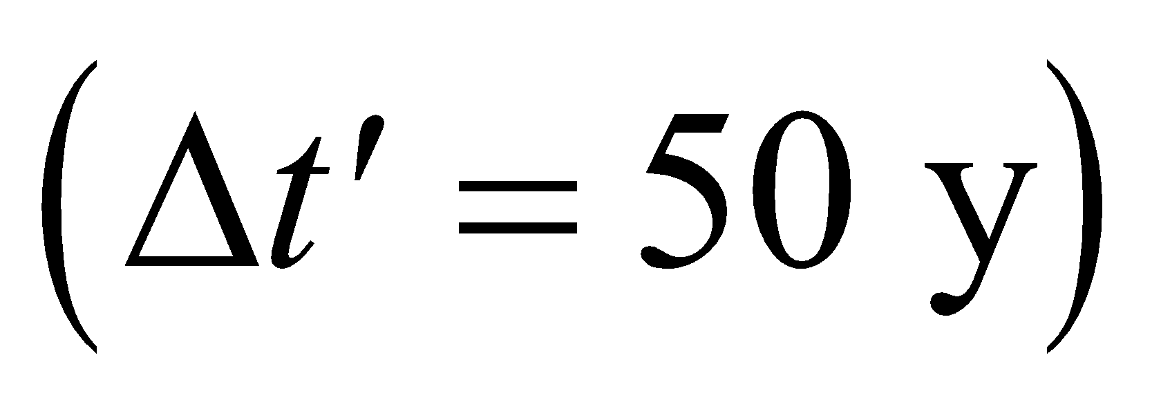 that it takes you to reach Andromeda. You assume there has been time dilation according to Equation 33.3: 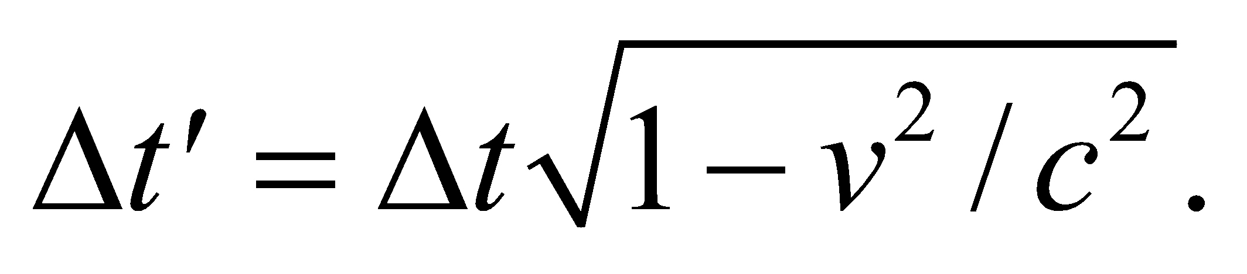 You can express the time measured on Earth as 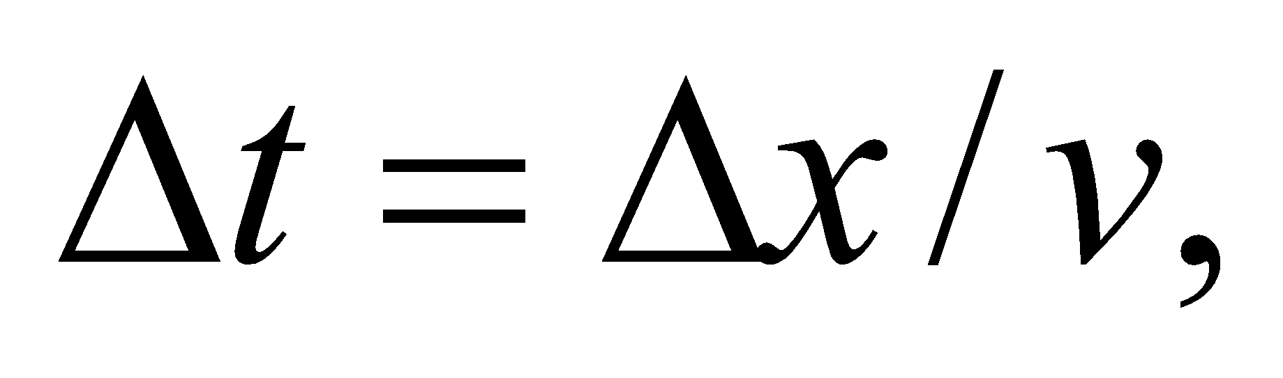where 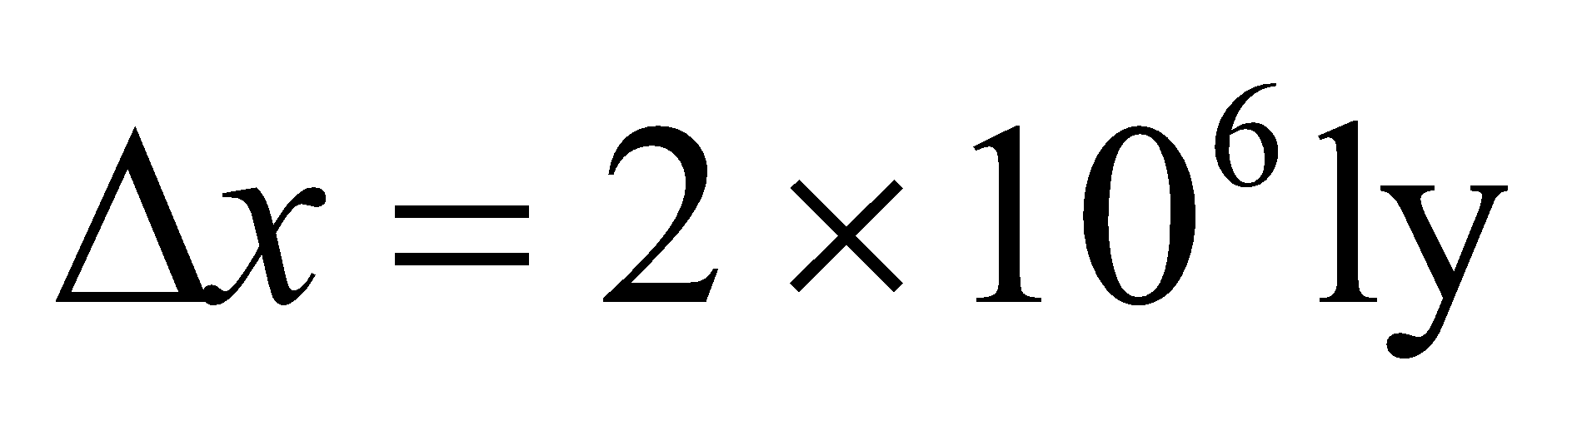is the distance to Andromeda measured in the Earth's reference frame. With a little algebra, you can show that the ship's velocity is

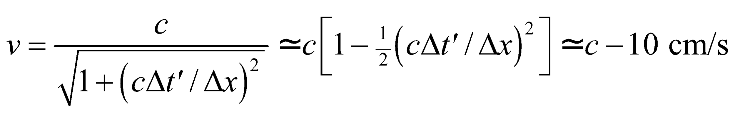

This is close enough to the speed of light that in the Earth's reference frame the ship arrives at Andromeda 2 million years after it left.

**31. Interpret** This is a problem about time measured in different reference frames. The first frame is the rest frame of the end points of the journey (separated by *N* light years), and the second frame is the moving frame of the spaceship (in which the time spent traveling is to be *N* years). Time dilation is involved.

**Develop** The distance is given in the system *S*, where the Earth and the distant star are essentially at rest, but the time interval is given in the moving system , where the spacecraft is at rest. Thus, 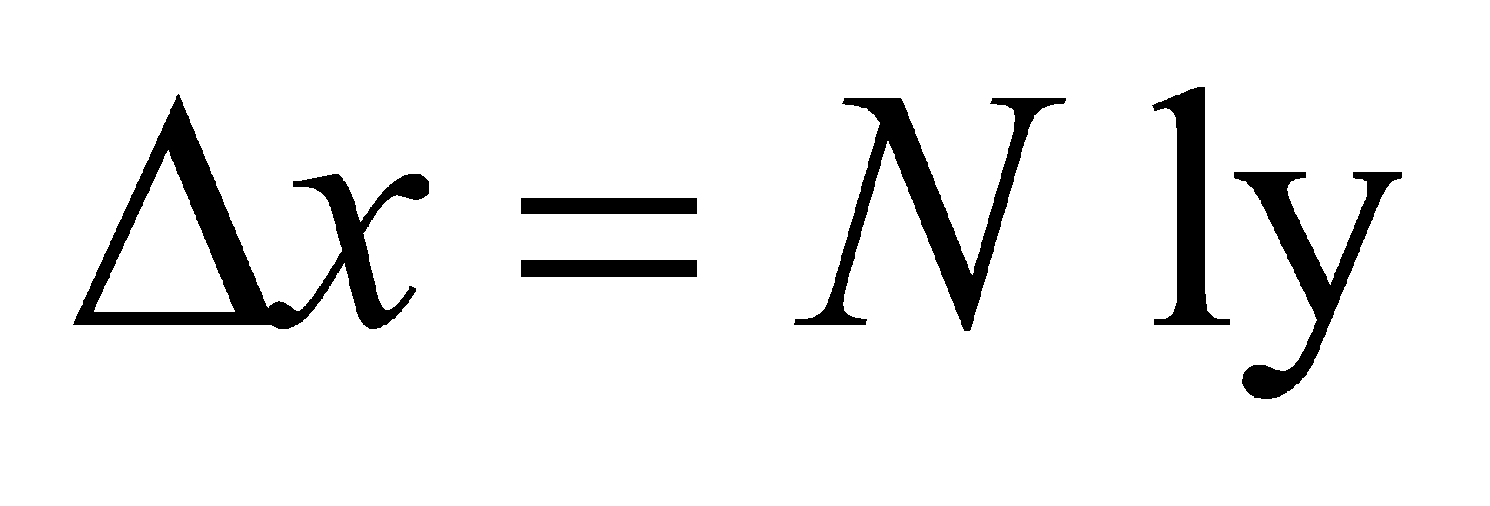 and 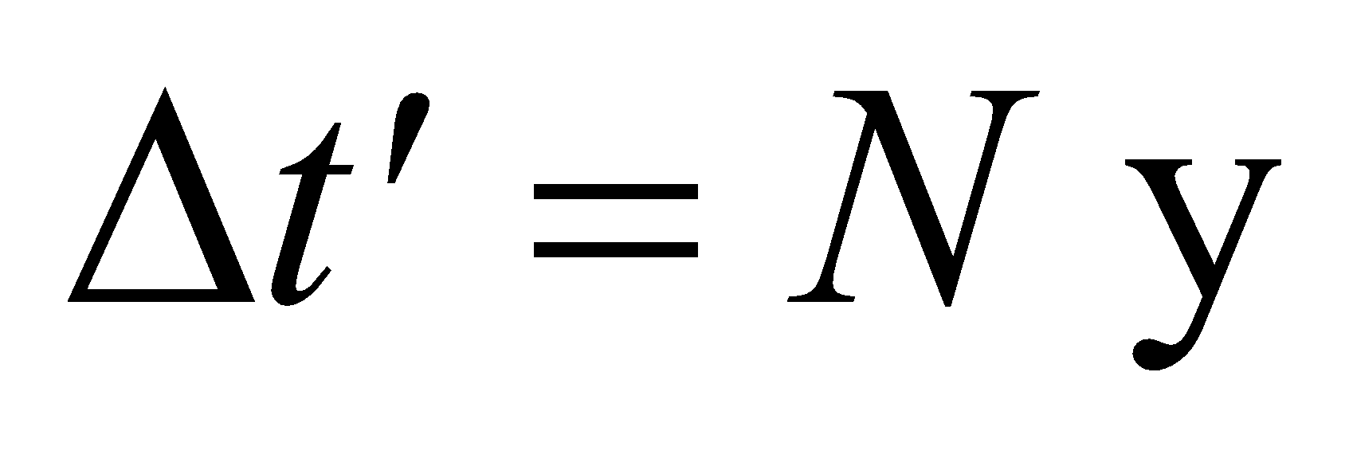. One ly, or light-year, is the distance light travels in one year, and equals *c* multiplied by one year. Equations 33.3 and 33.4,



for time dilation and Lorentz contraction, relate the given quantities to 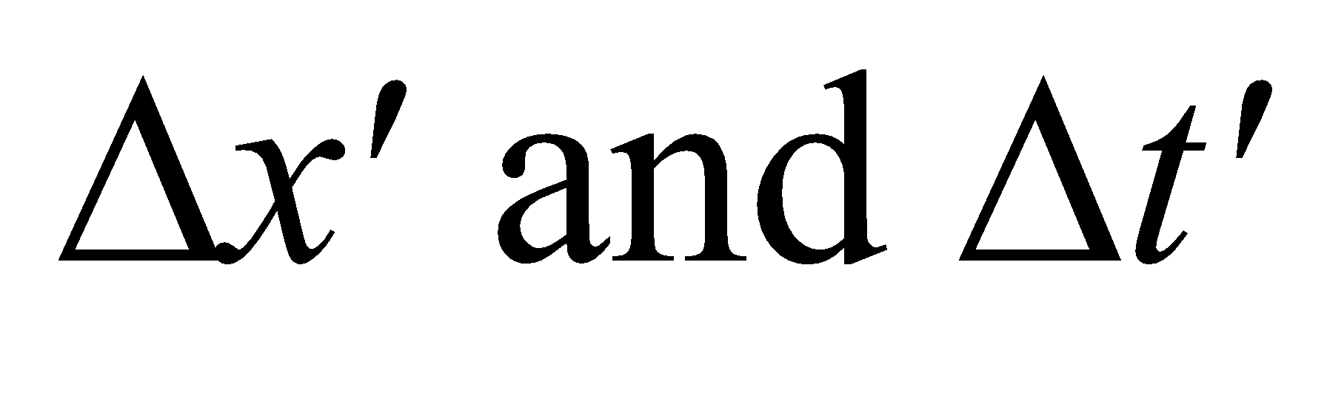. We use the second expression (i.e., the expression for length contraction) to find



**Evaluate** Inserting the given quantities gives

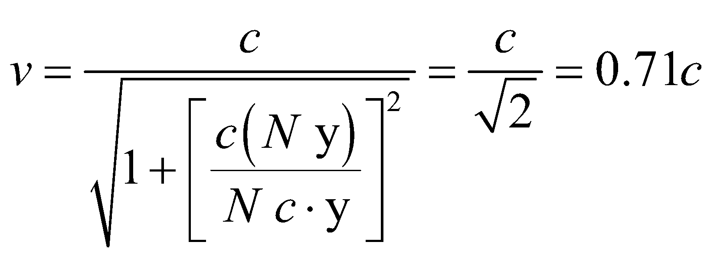

**Assess** To show that the result is consistent, we note that in the reference frame of the spacecraft the distance 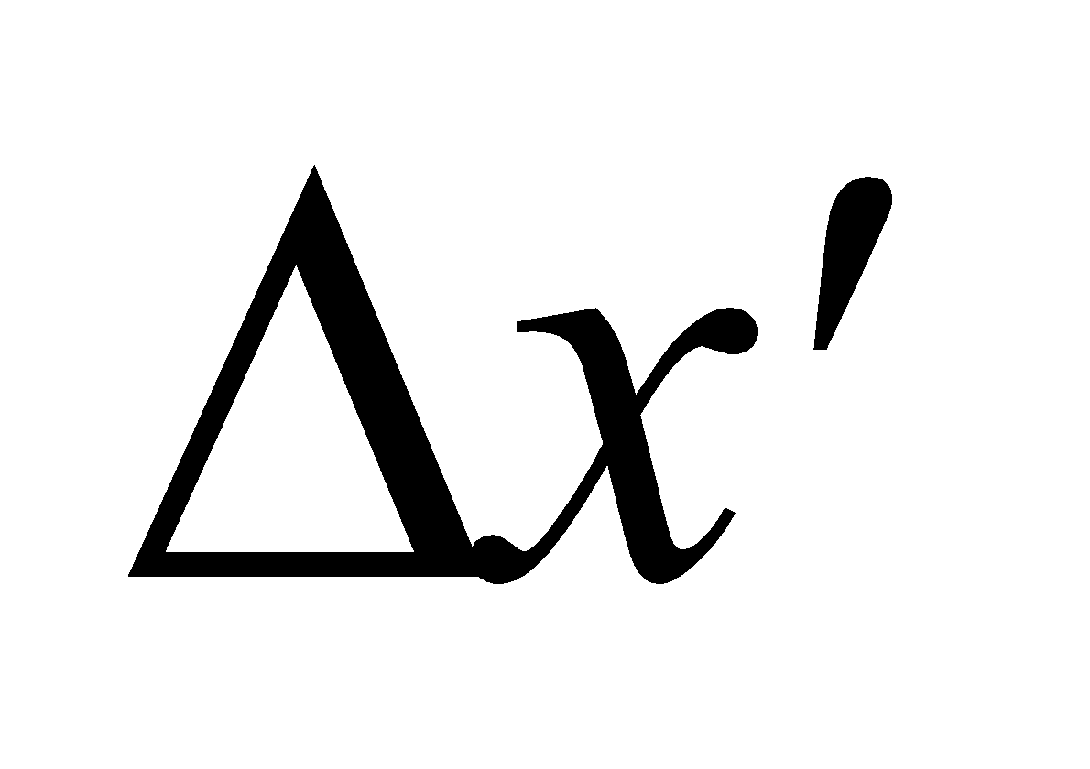 is contracted:

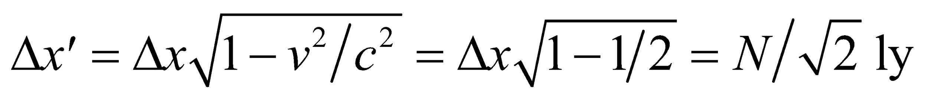

So it will take

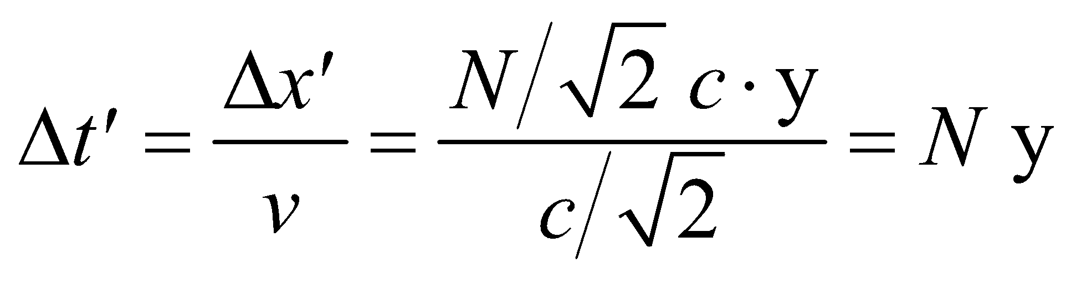

of the traveler’s life to get there.

**32.** **Interpret** This problem involves measurements of time and space in different inertial reference frames. The first frame is at rest with respect to the end points of the journey, and the second frame is the moving frame in which the spaceship is at rest. We are given the distance and the time as measured in the first frame and are asked to find the distance and time in the second frame.

**Develop** The stationary frame S is that in which the Earth and the star are essentially at rest, and the distance and time for the journey in this frame are *Δx* = 4 ly and *Δt* = 5 y. Thus, the speed of the spaceship is 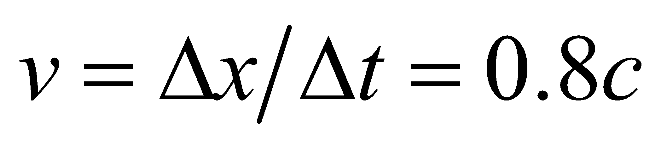. From this, we can evaluate the factor *γ* :

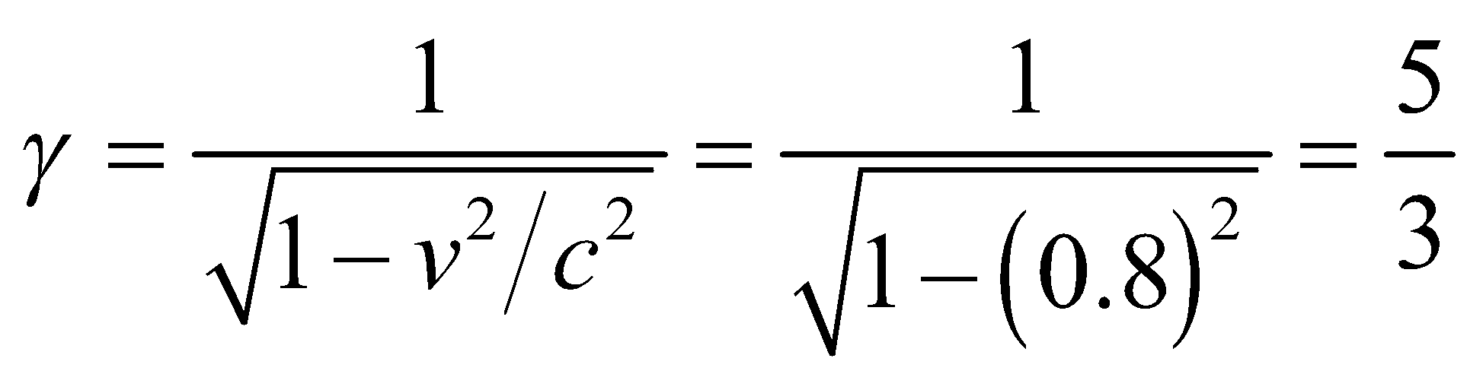

and find  using Equations 33.4 and 33.3, which give

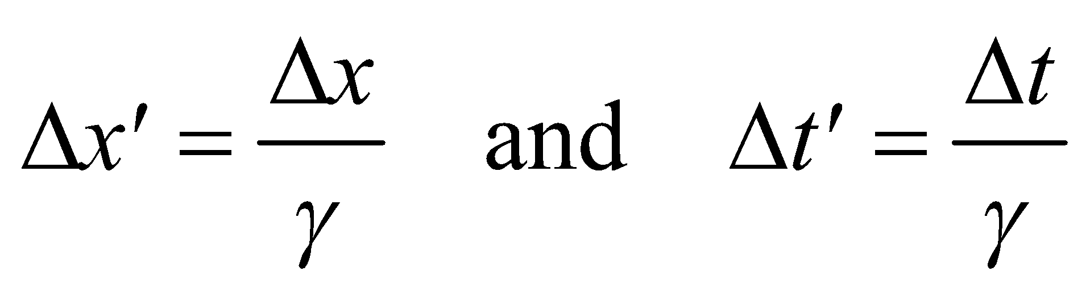

which are the distance and time for the trip as measured aboard the spaceship.

**Evaluate** **(a)** Equation 33.3 for time dilation gives

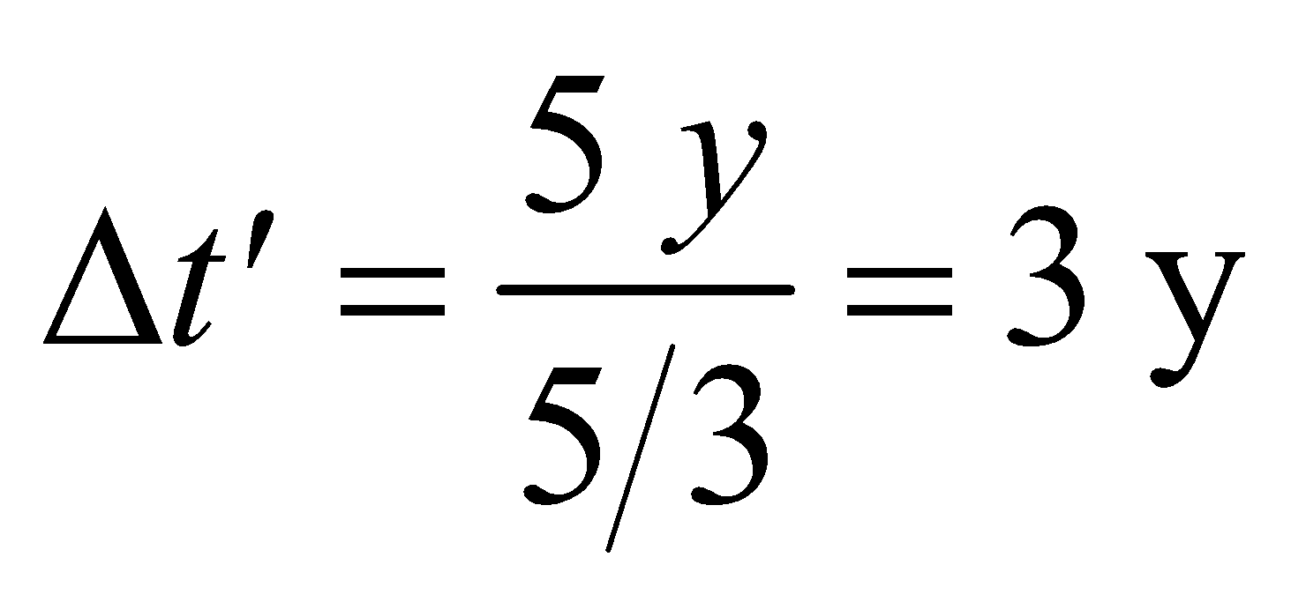

**(b)** Equation 33.4 for length contraction gives

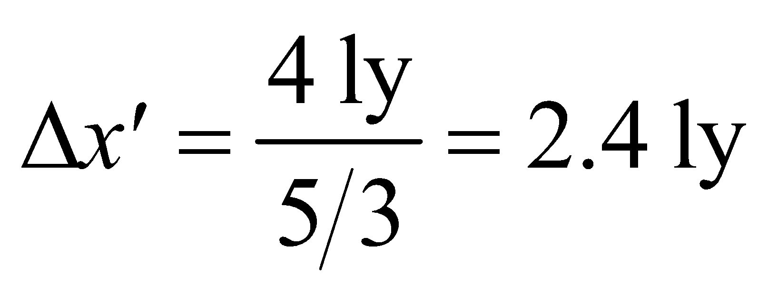

**Assess** To check that our answer is consistent, we can check that the speed of the spaceship is the same as measured by both observers (i.e., an observer in the frame *S* and one in the frame :

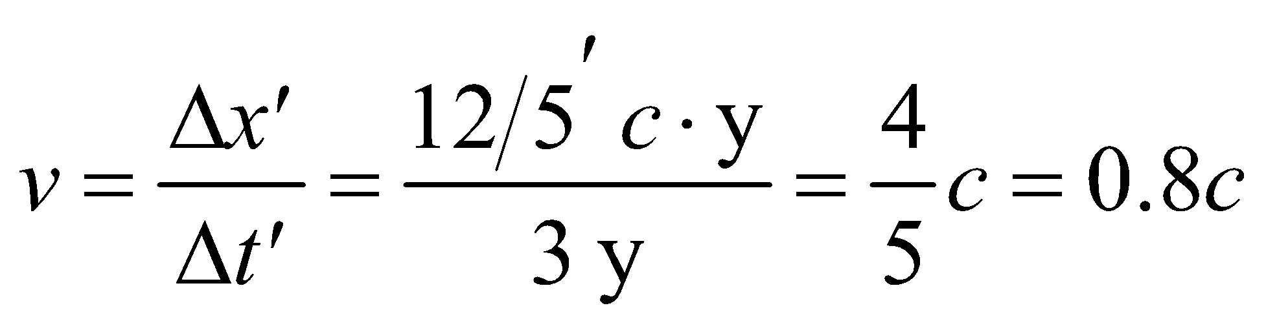

which is the same as found above using distance and time from the rest frame *S*.

**33. Interpret** This is the well-known “twin paradox” problem involving time dilation. We want to know the ages of the twins after one undergoes space travel and returns. The two reference frames are that of the Earth and the distant star, which is the rest frame, and that of the spaceship, which is the moving frame.

**Develop** In the rest frame *S*, twin A must wait 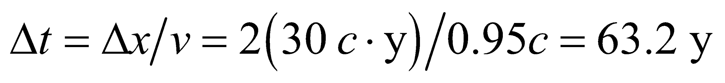 for twin B to return. Using Equation 33.3 for time dilation, twin B (who is in the frame ) ages for

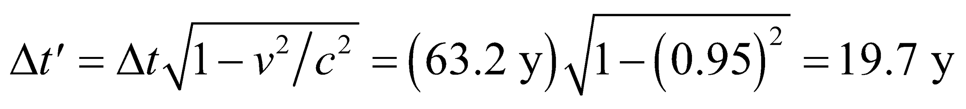

during the trip.

**Evaluate** Therefore, twin A is 83.2 y old (63.2 + 20), while twin B returns at age 39.7 y (19.7 + 20).

**Assess** This is an intriguing consequence of time dilation. Note that only twin A’s reference frame is inertial.

**34.** **Interpret** This problem involves a measurement of time in two reference frames: the stationary frame of the Earth and the moving frame of the spaceship. We are given the time in the stationary frame and are asked, in essence, to find the time in the moving frame.

**Develop** For a spaceship traveling at *v* = 0.80*c*, the factor *γ* relating the two frames of reference is

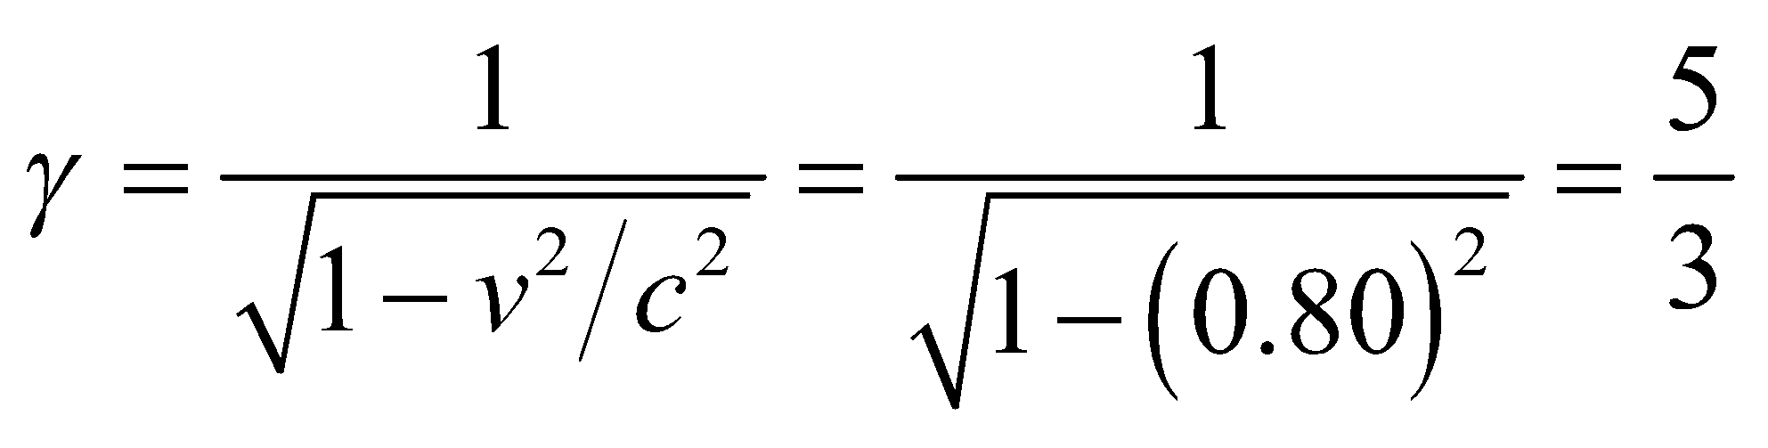

This allows us to convert Earth time *Δt* (i.e., frame *S*) to spaceship time 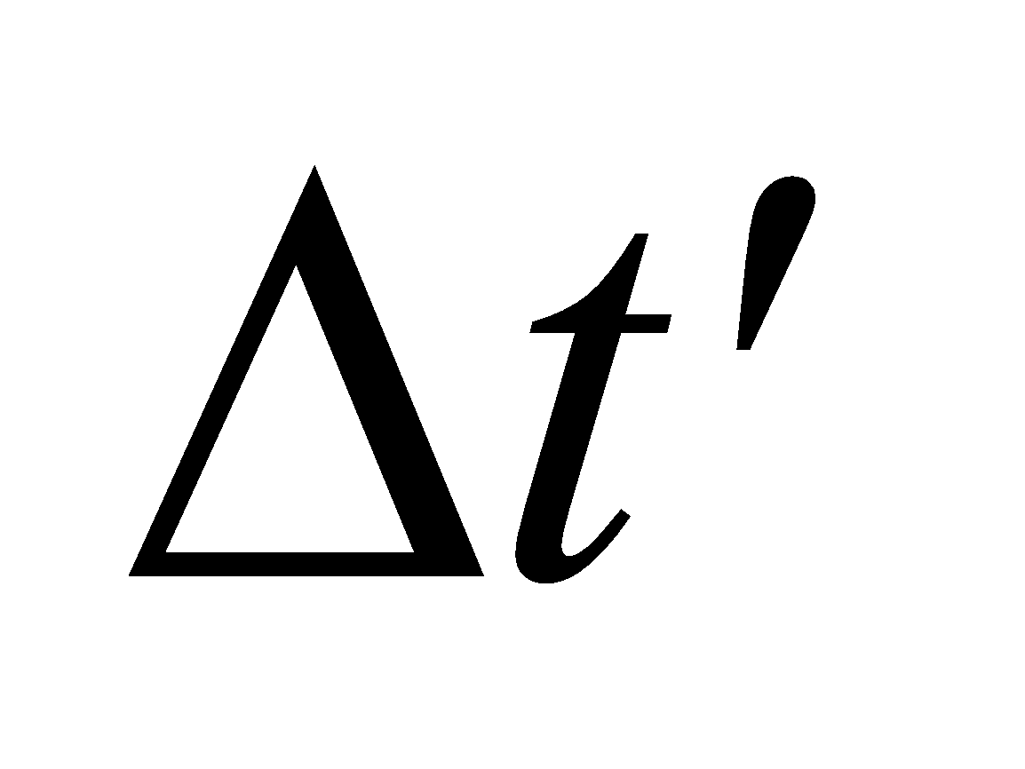 (i.e., frame ) using Equation 33.3 for time dilation:

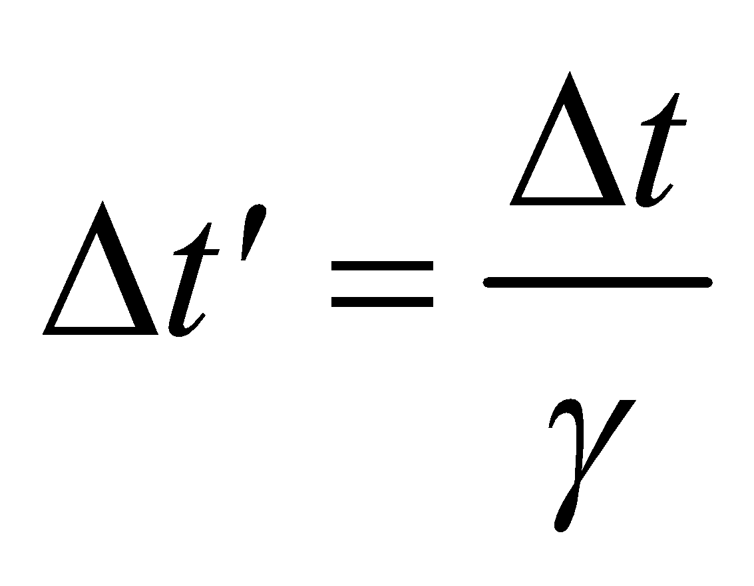

**Evaluate** For 6.67 minutes of Earth time, the time elapsed on the spaceship is

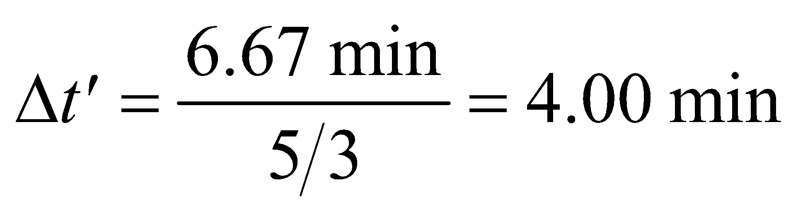

Four minutes is two half lives, so one quarter of the atoms remain after this time (i.e., 250 atoms).

**Assess** The same initial number of atoms on Earth would have decayed to

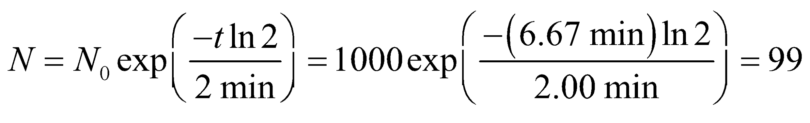

Such an experiment demonstrates that time dilation is not an apparent effect, but a real physical phenomenon. Time is not absolute, but depends on the frame of reference in which it is measured.

**35. Interpret** This is a problem involving relativistic velocity addition.

**Develop** Our galaxy  is moving with speed *v* = 0.75*c* relative to one of the galaxies *S* mentioned in the question, and the other galaxy is moving with speed 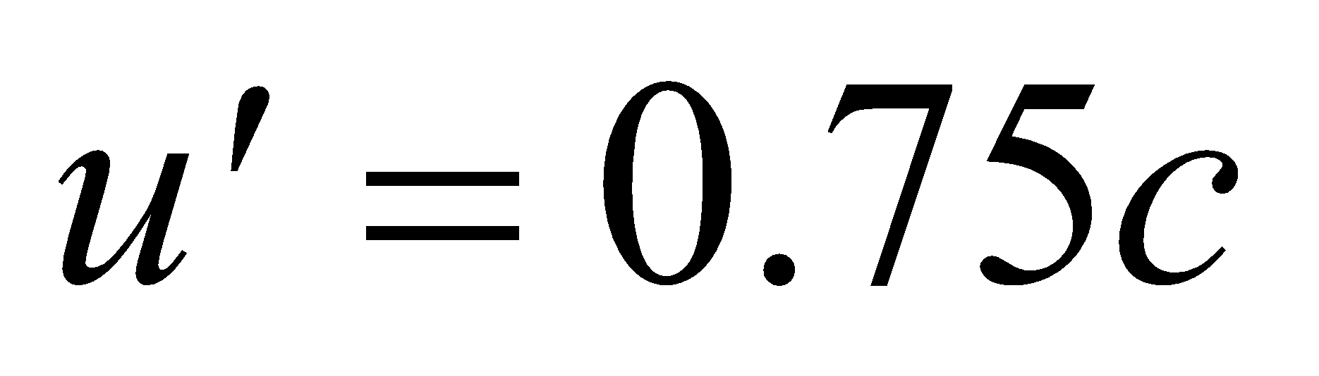 relative to us. All velocities are assumed to be along a common 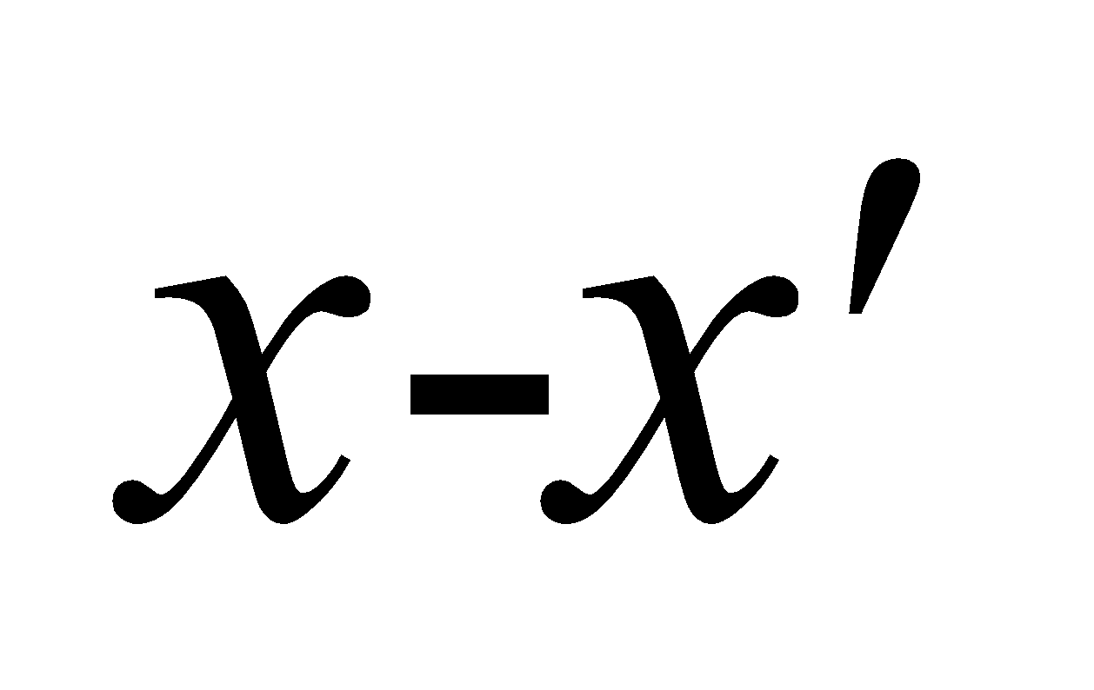 axis. The speed of one galaxy as measured by an observer in the other galaxy can be obtained by using the relativistic velocity addition formula (Equation 33.5a):

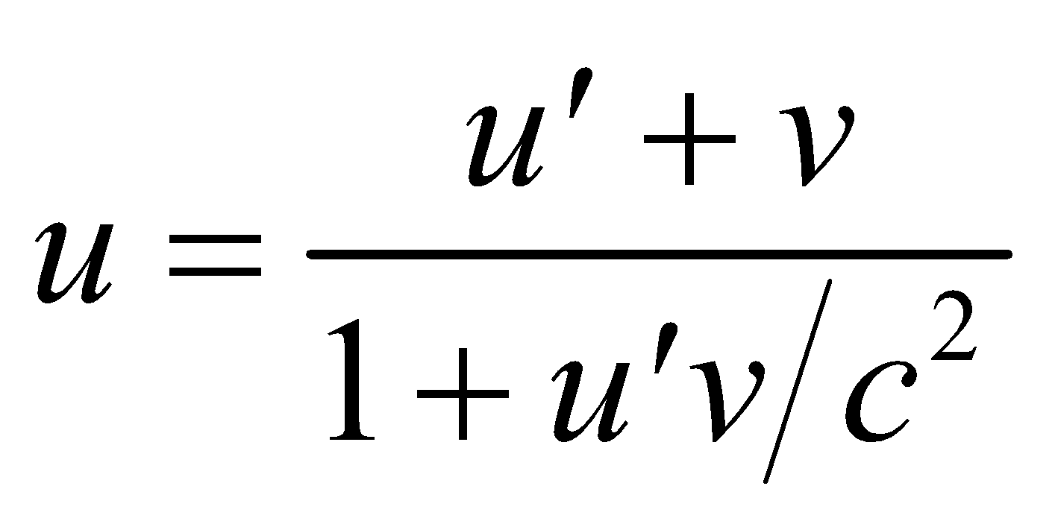

**Evaluate** Substituting the values given, we get

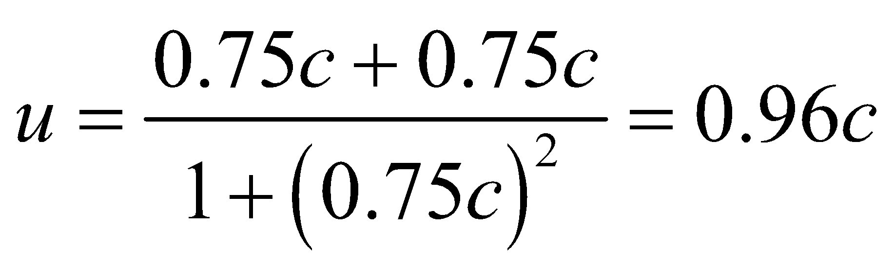

**Assess** The naïve answer, 0.75c + 0.75c = 1.5c, is inconsistent with relativity.

**36.** **Interpret** This problem involves adding relativistic velocities. We want to find the fast ship’s speed relative to the Earth, so the Earth is frame S. The slower ship is in frame  and tells us the velocity 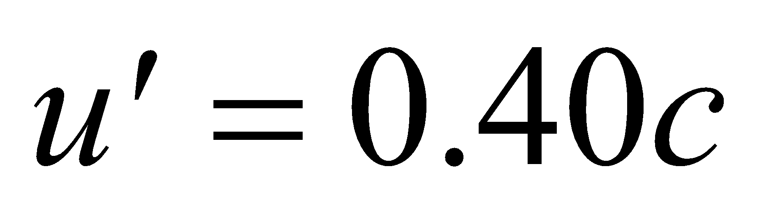 of the fast ship relative to the itself. The frame  is moving at speed *v* = 0.70*c* with respect to frame *S*.

**Develop** Apply Equation 33.5a to find the speed *u* of the fast ship in the Earth reference frame (i.e., frame *S*).

**Evaluate** Inserting the quantities into Equation 33.5a gives

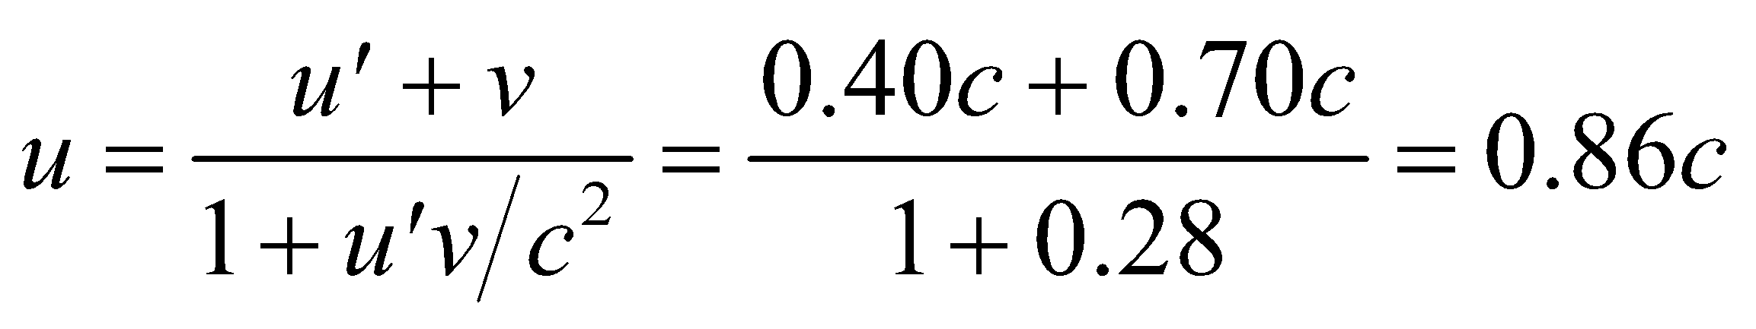

**Assess** This velocity is less than the speed of light, as expected.

**37. Interpret** In this problem we are to show that if the speed of an object is less than *c* in one inertial reference frame, then the same conclusion holds in any other inertial frame.

**Develop** The problem is equivalent to showing that, if 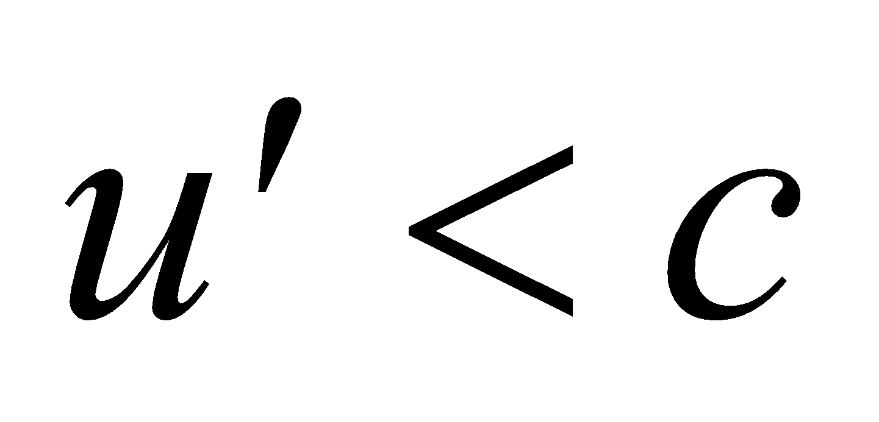 and *v* < *c* in the relativistic velocity addition formula (Equation 33.5a)



then *u* < *c*. Note that the two initial conditions above may be written as

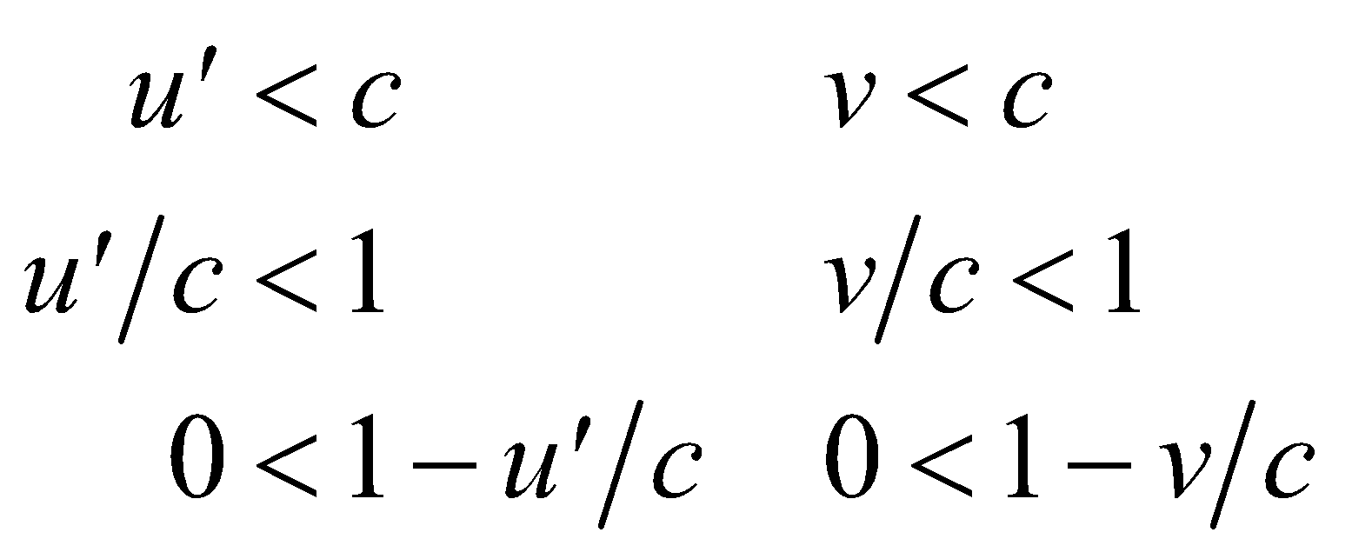

**Evaluate** The conclusion follows almost immediately, because if 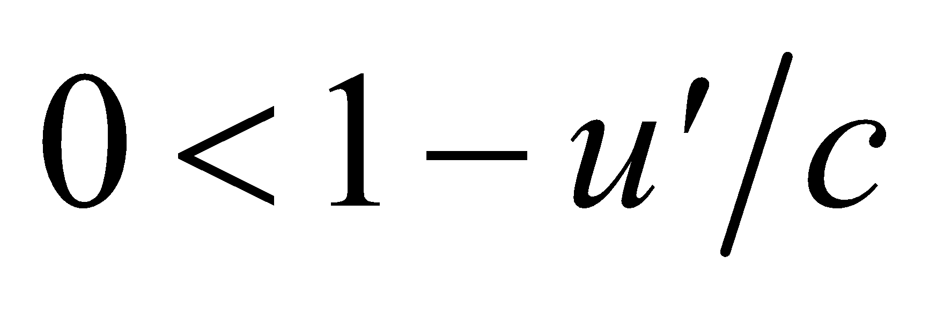 and 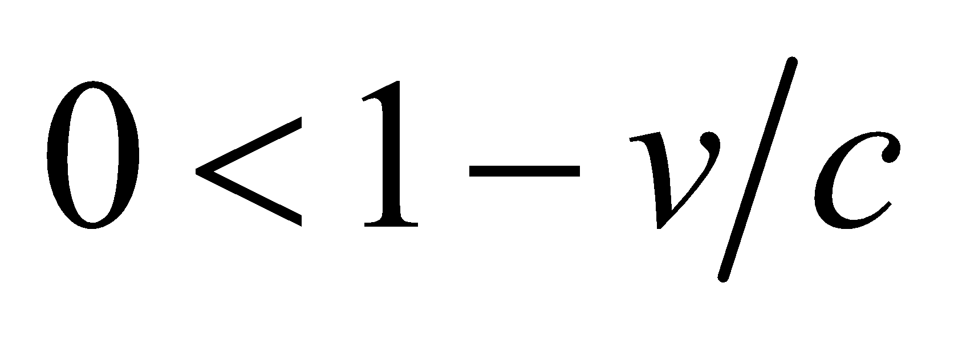, then

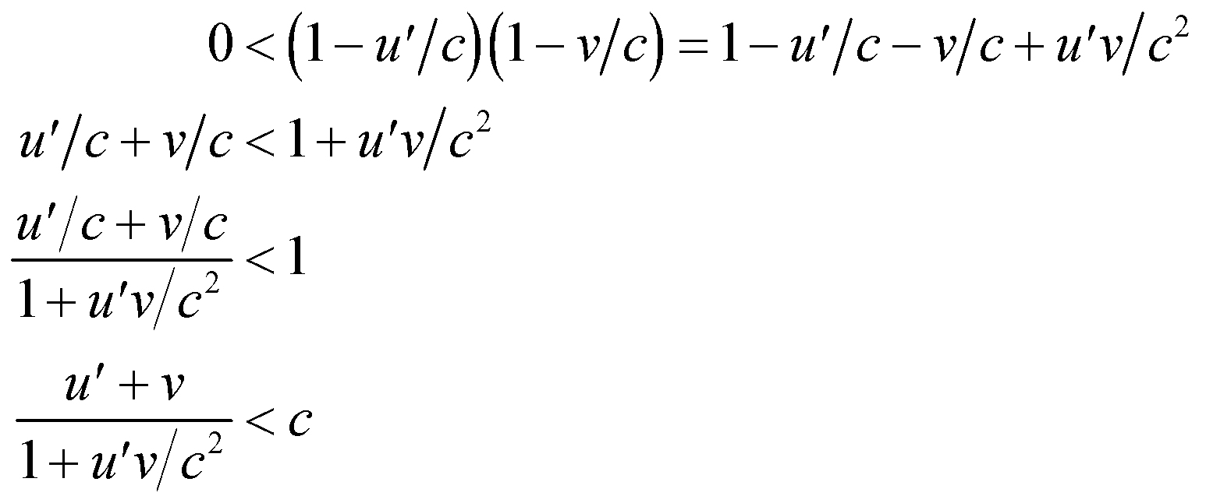

but the left-hand side is just *u* (compare with Equation 33.5a), so we have shown that *u* < *c*.

**Assess** Equation 33.5a applies to the special case where all the velocities are collinear, but the conclusion is true   
in general.

**38.** **Interpret** This problem involves the concept of simultaneity in different reference frames. The relative speed of the Earth and the Sun is small compared to *c* (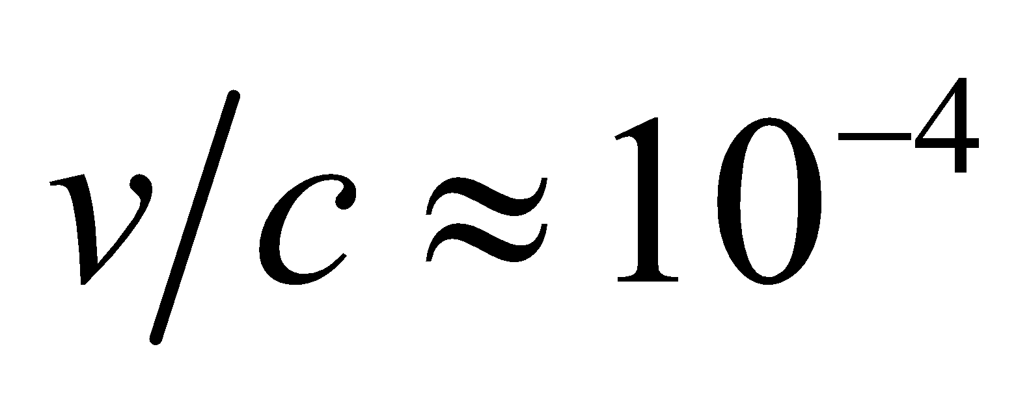), so we may consider the Sun to be approximately at rest at a distance 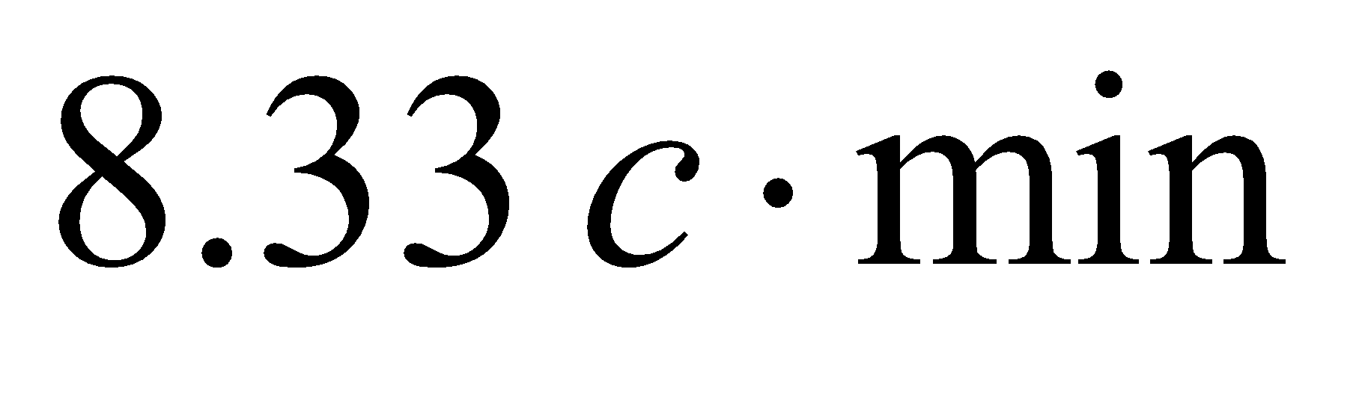 from Earth (system *S*).

**Develop** We chose the Earth as the origin and the *x* axis in the direction of the Sun. In frame *S*, events A and B have coordinates 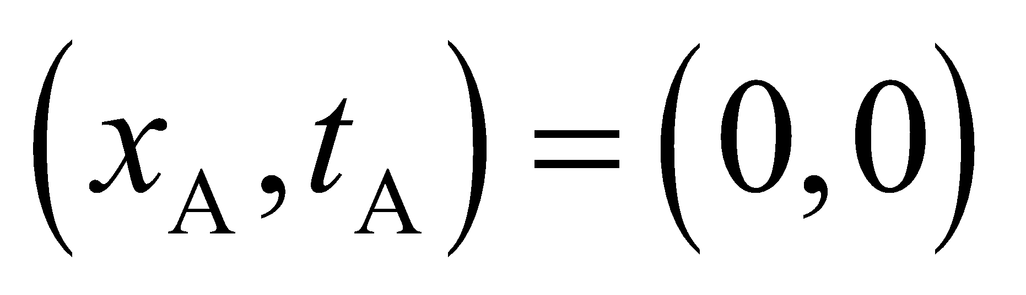 and 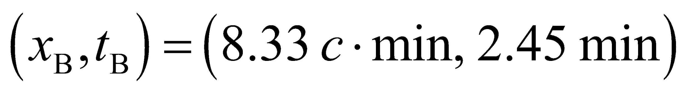. An observer in systemmoving along the *x* axis with speed *v* sees these events separated by a time interval



Using the Lorentz transformations from Table 33.1, we can convert these times in  to times in S:

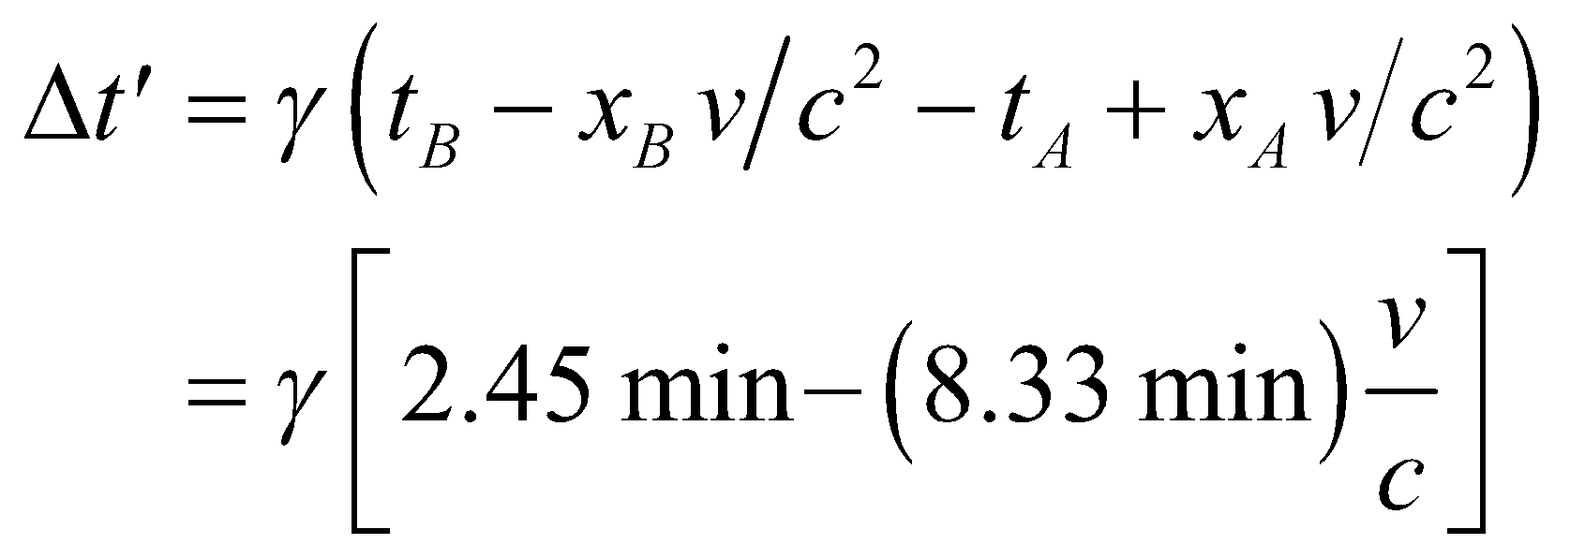

**Evaluate (a)** For *v* = 0.75c, *γ* = 1.51, so the time difference in frame  is



so event B occurs before event A.

**(b)** For 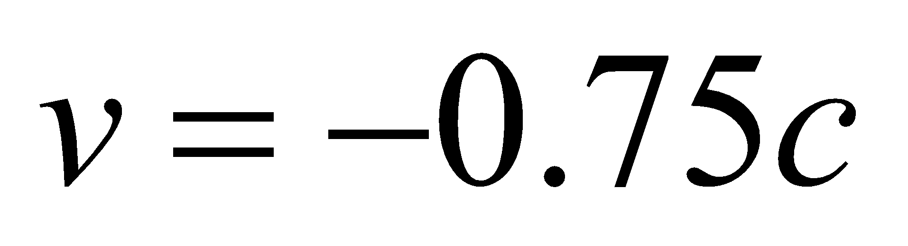, *γ* = 1.51, and the time difference in frame  is



so event A occurs before event B.

**(c)** For *v* = 0.294c, *γ* = 1.046, and the time difference in frame  is



so the events are essentially simultaneous in this frame.

**Assess** The order of events reverses in frames that are moving in opposite directions with respect to the order in frames moving in the same direction.

**39. Interpret** We are given two events (interstellar spacecraft launching) that take place at different instants as observed in the rest frame of the common galaxy. We want to know the order of occurrence as observed in the frame of reference of a spaceship moving at 0.99*c* with respect to the galaxy.

**Develop** Denote the frame of the galaxy by *S*. The spacecraft are launched at 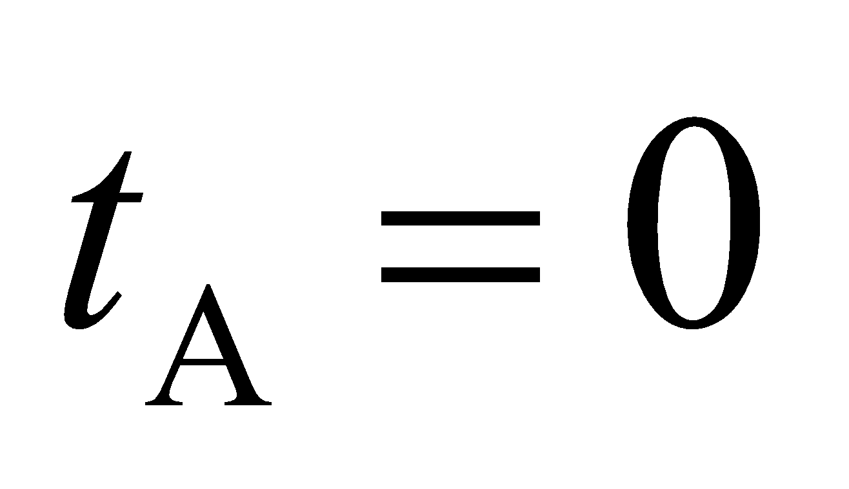 and 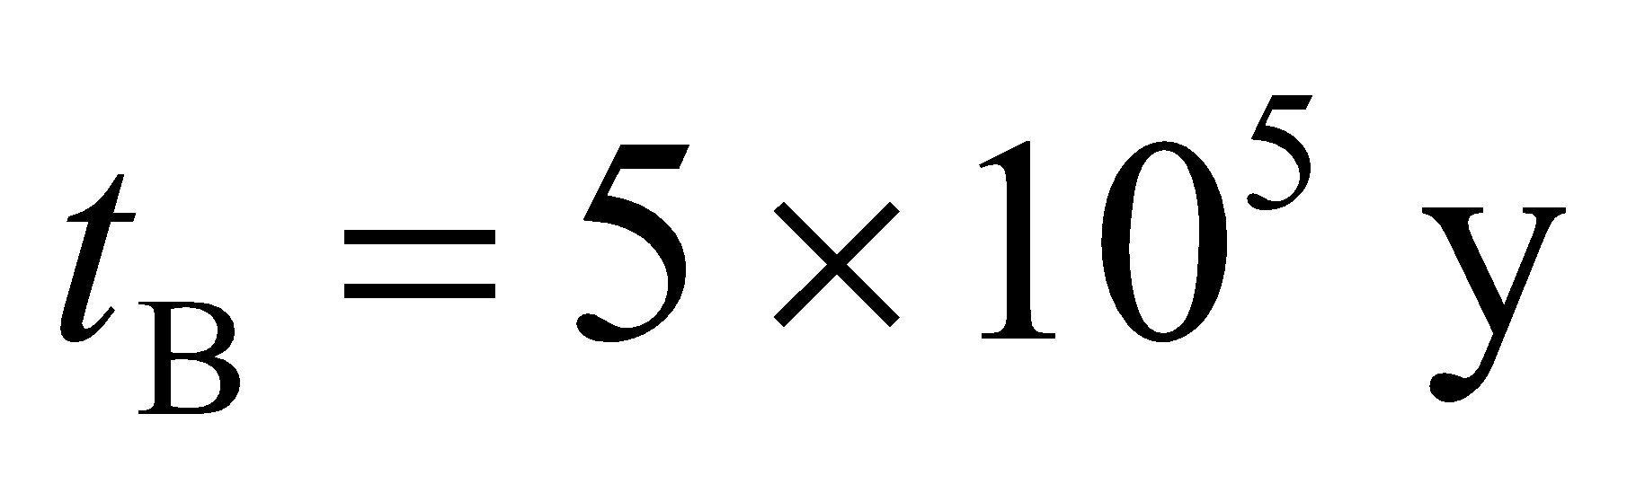 from

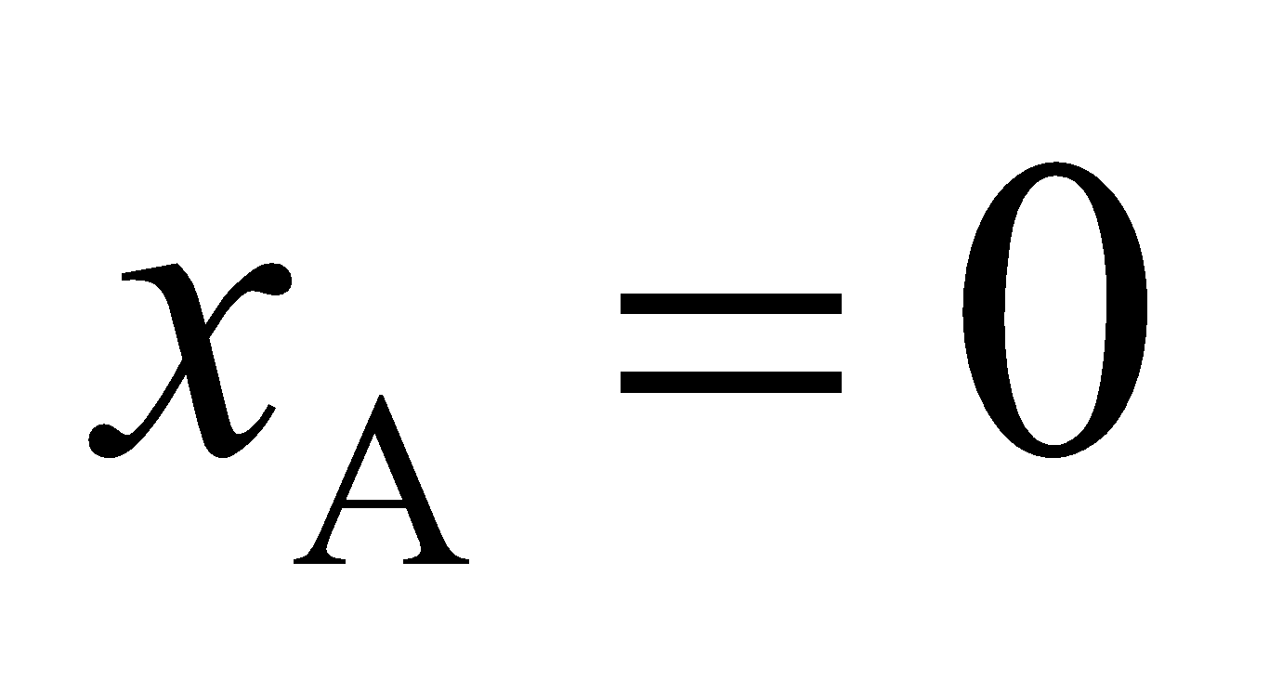 and 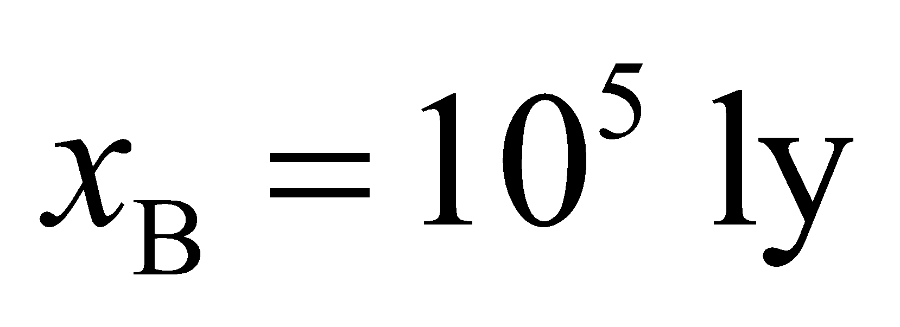 (we choose the origin of *S* at civilization A for simplicity). Let  be the frame of the

traveler from C. The Lorentz transformation between *S* and  is summarized in Table 33.1, where *v* = 0.99*c* (positive x and 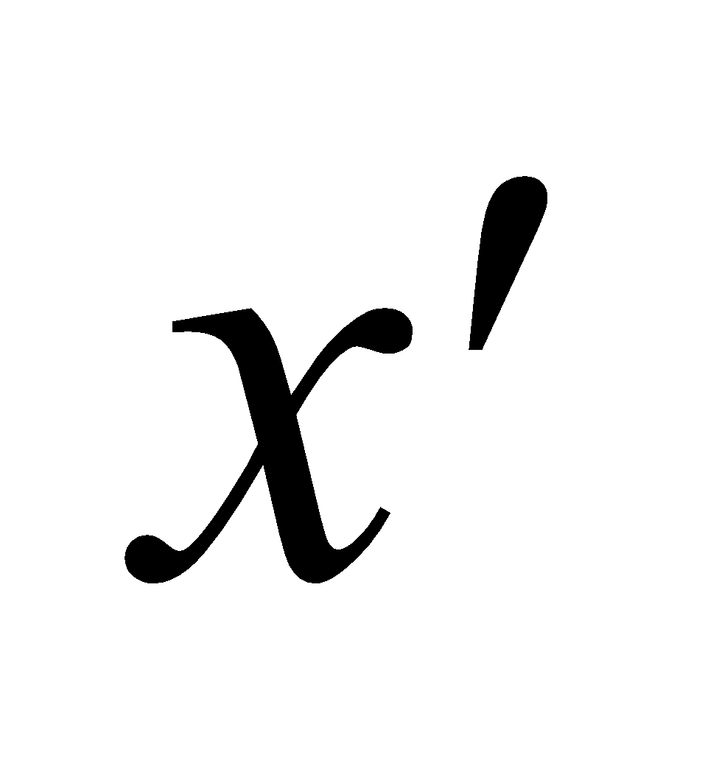 axes from A to B), and

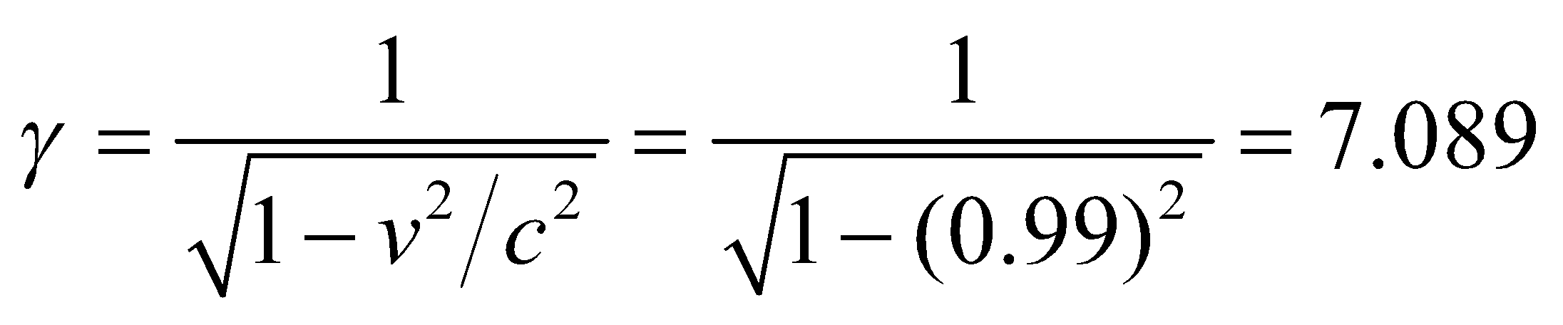

To see which event happened first in , use the Lorentz transformation to transform *t*A and *t*B into  In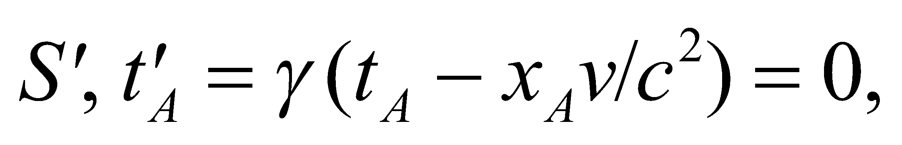and



which is earlier than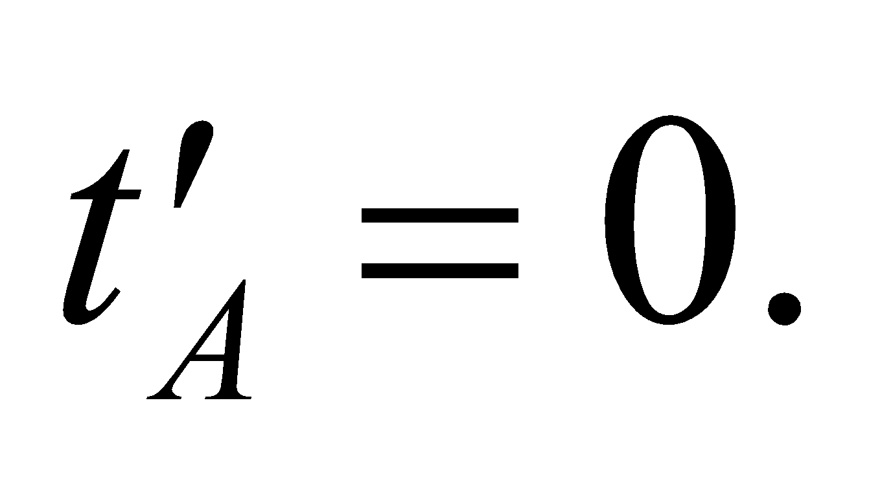

**Evaluate** In ,

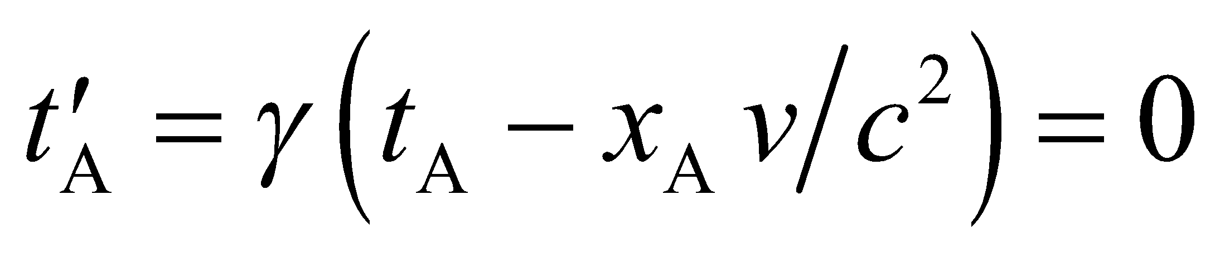

and



so the observer from C assigns priority to civilization B by 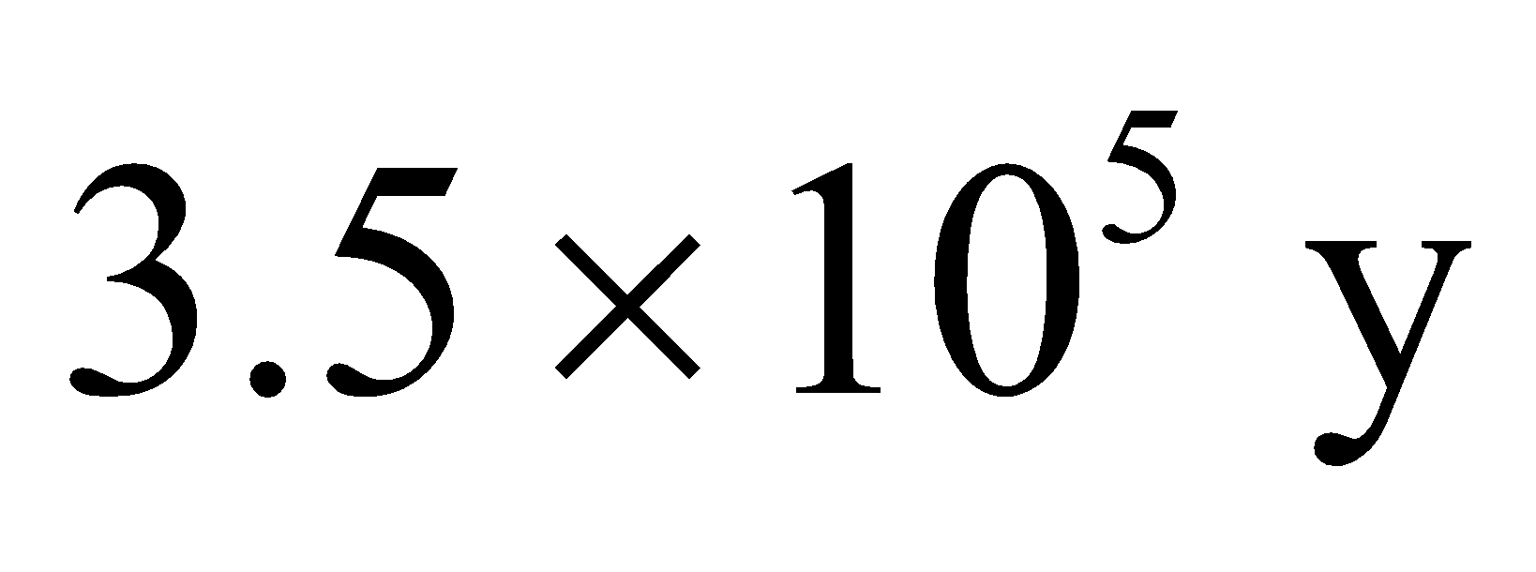.

**Assess** This problem demonstrates that two observers may see the occurrence of two events differently, depending on their frame of reference.

**40.** **Interpret** We are to repeat the previous problem, with the only change being that 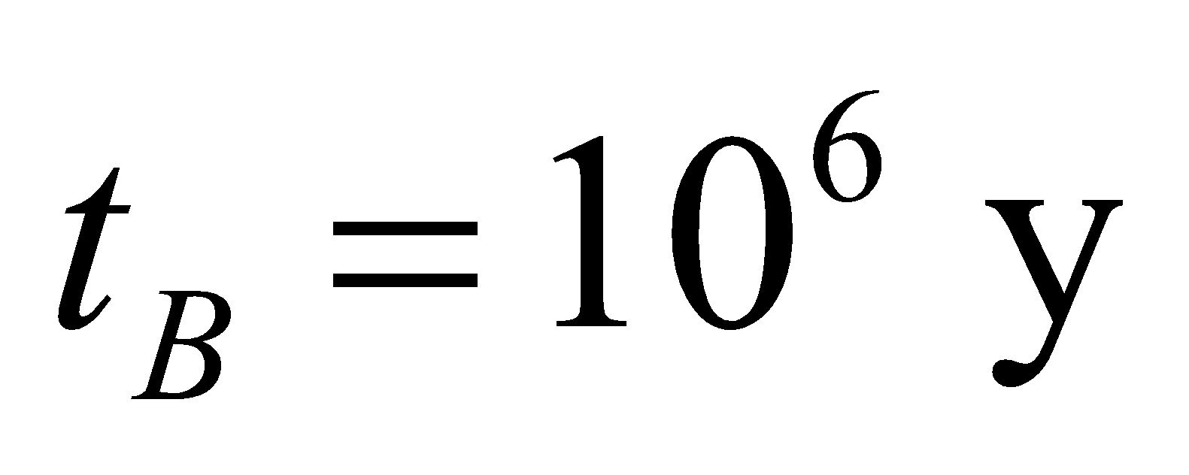.

**Develop** Use  in the Lorentz transformation from the preceding problem to find the new 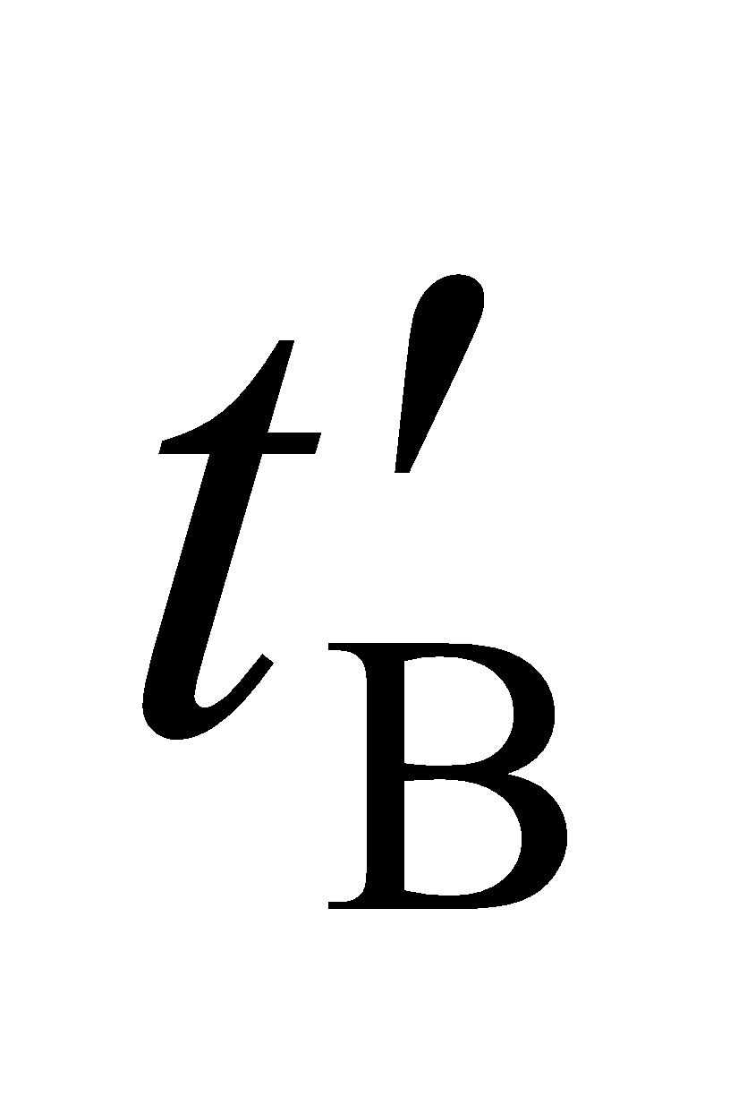.

**Evaluate** The observer in the spaceship observes the launch of the B spacecraft at



so the observer assigns priority to civilization A because 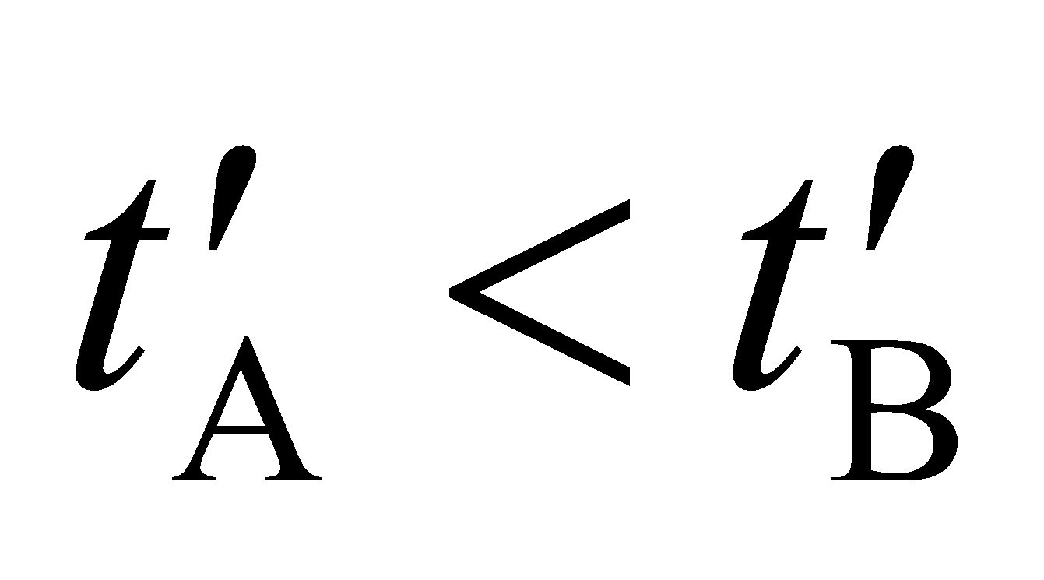.

**Assess** The priority is reversed as compared to the previous problem.

**41. Interpret** In special relativity the concept of simultaneity is not absolute but relative; it depends on the reference frame of the observer. We want to know whether or not there exists a reference frame in which the two events described in Problem 33.39 are seen to take place simultaneously.

**Develop** Refer to Problem 33.39 for a description of the frames of reference. In frame *S*, the light travel time between A and B is 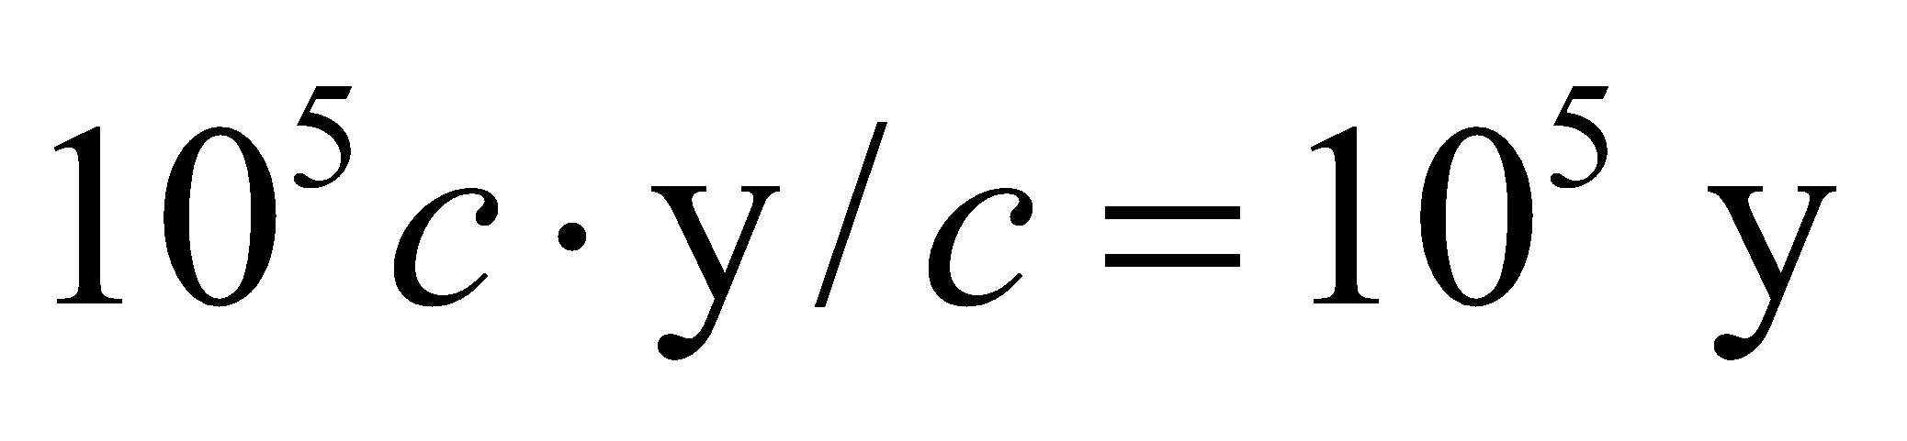. In Problem 33.39, *t*B is less than this, so the two launchings cannot be causally related. Therefore, there is a frame  moving from A to B with speed *v* relative to *S* in which the events are simultaneous.

**Evaluate** Simultaneity requires that (see Table 33.1) 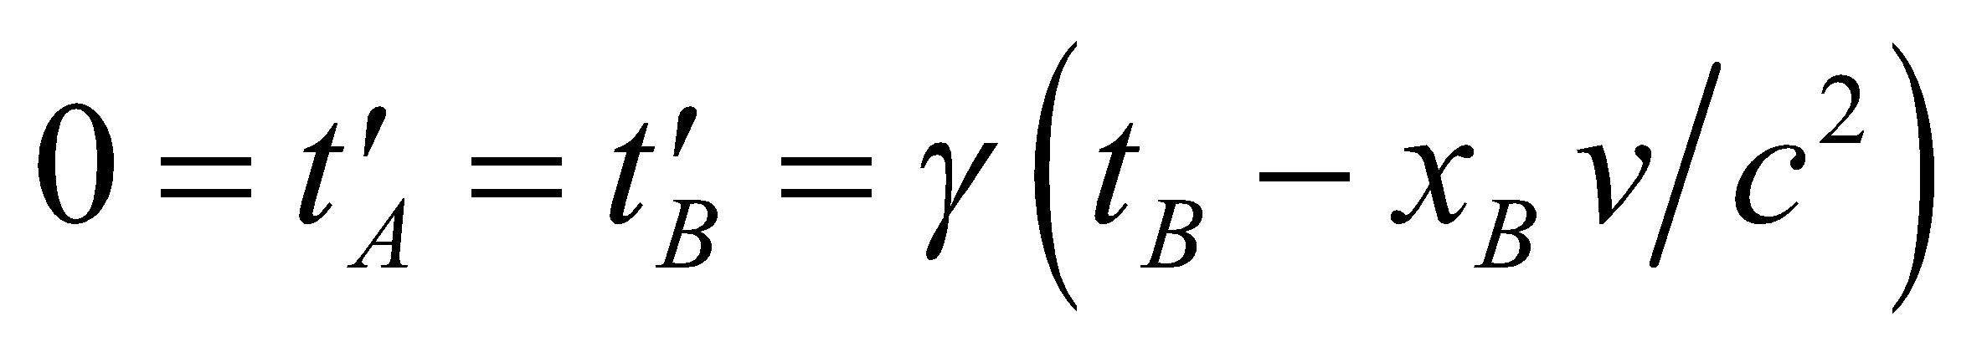or

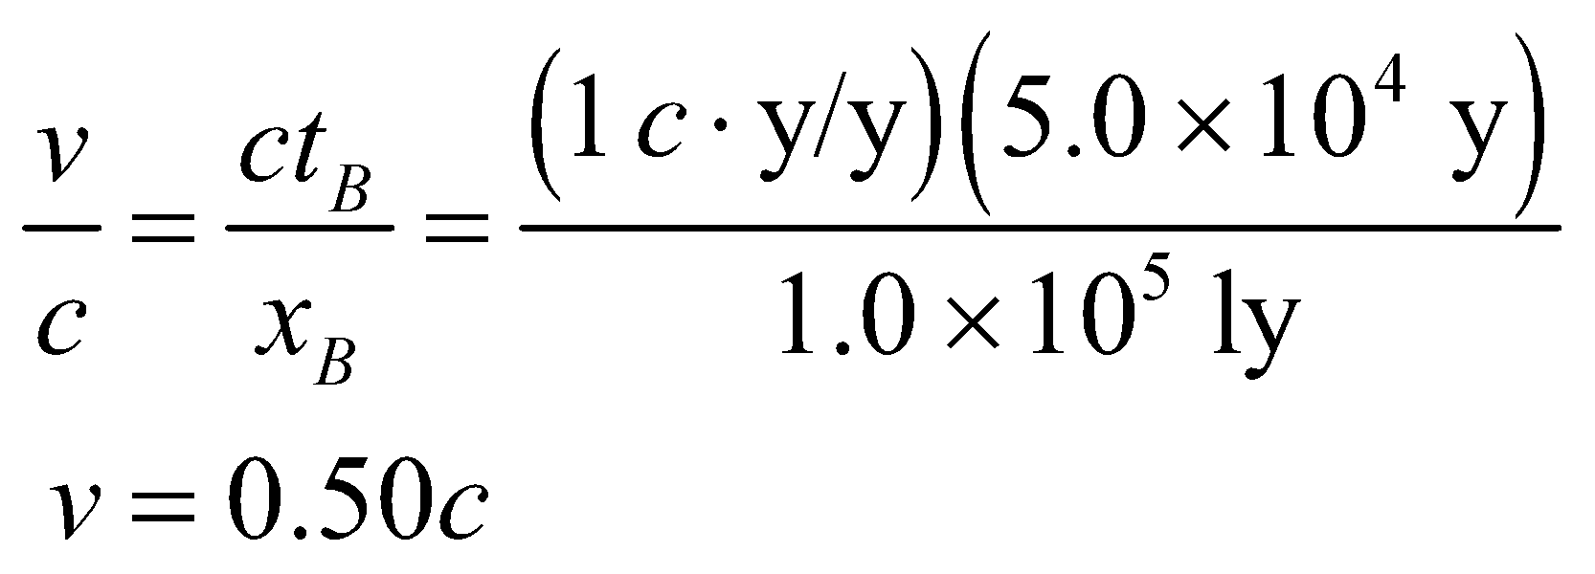

**Assess** If the launchings are causally related, then they cannot be simultaneous in any frame ( always).

**42.** **Interpret** Given the Lorentz transformations for space (see Table 33.1), we are to derive those for time.

**Develop** The Lorentz transformation from *S* to  for space is

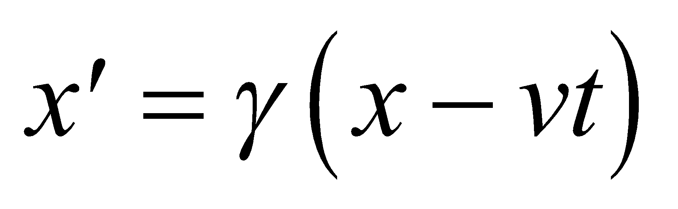

Solving this for *t* gives

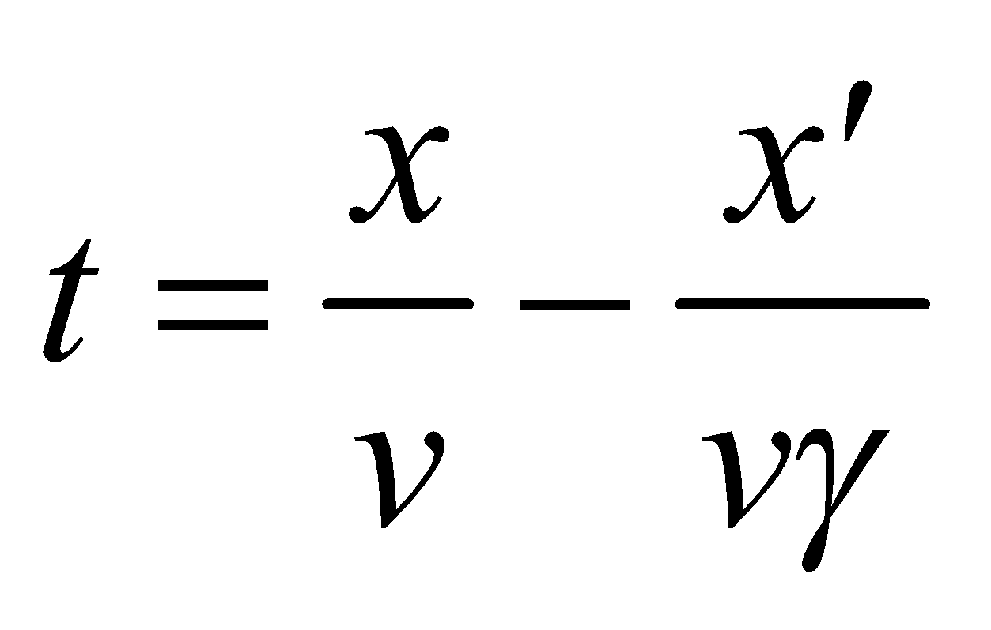

Use the Lorentz transformation from  to *S* [i.e., 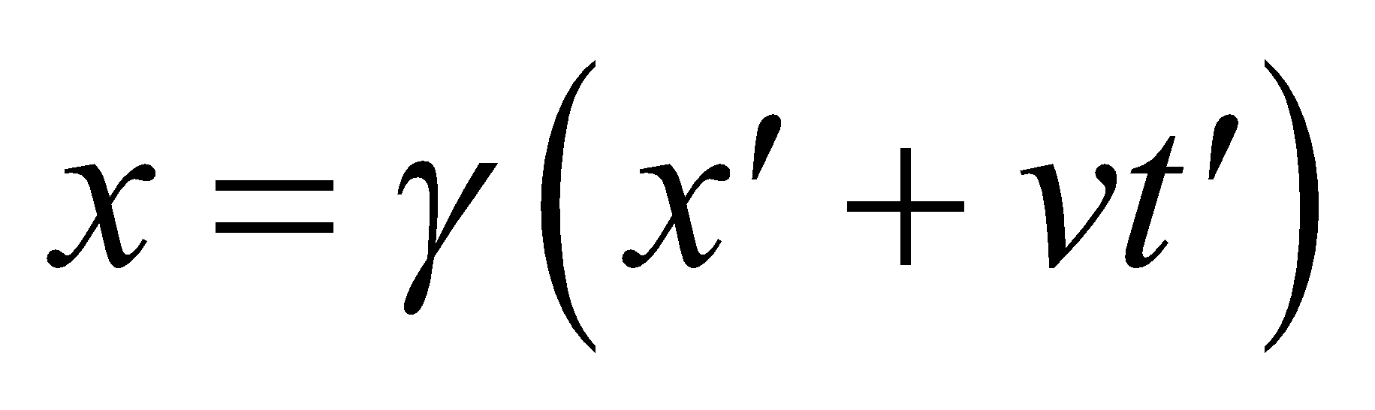] to eliminate *x* in the expression above and get an expression for t as a function of  and .

**Evaluate** Performing the indicated substitution gives

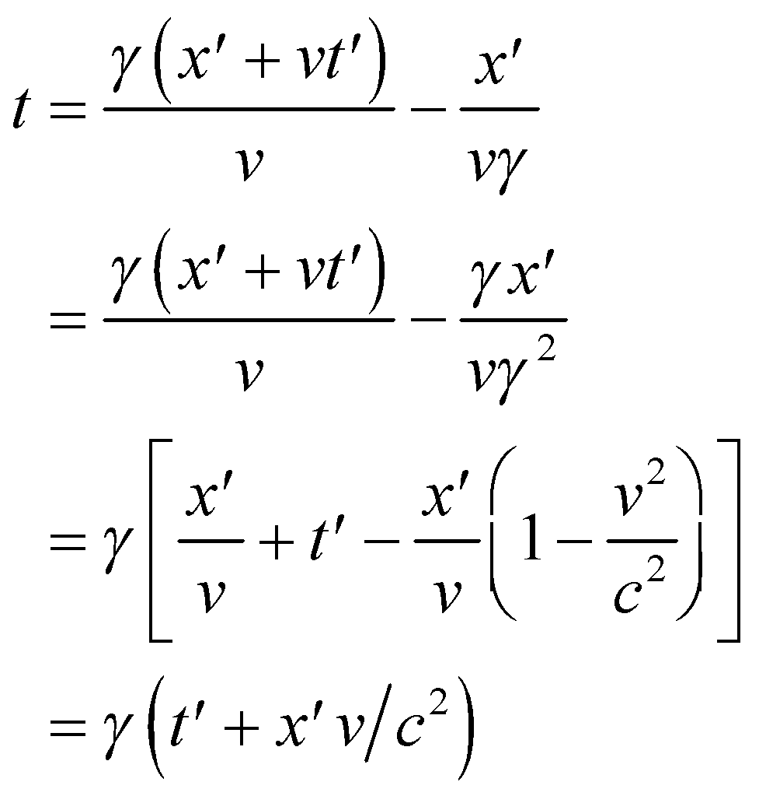

Reversing the process gives the Lorentz transformation from *S* to .

**Assess** We have verified the work of Lorentz and Fitzgerald.

**43. Interpret** In this problem we want to use the “light box” to derive the time dilation formula given in Equation 33.3.

**Develop** The reference frame of the box  is moving with speed *v* in the *x* direction relative to the frame *S*, which is at rest in Figure 33.6b. Let the *S* coordinates of event A be *tA* and *xA*, and those of event B be *tB* and 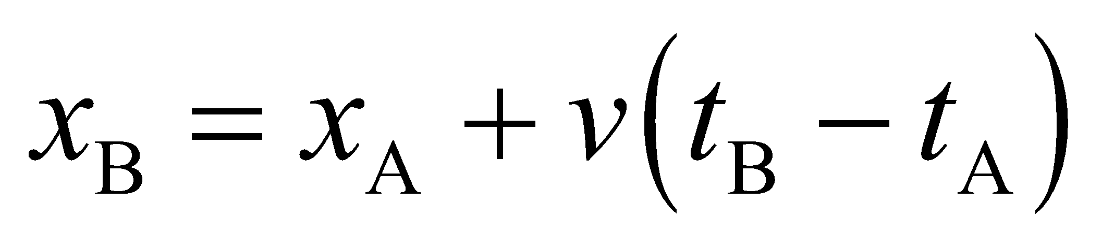. To find , we apply the Lorentz transformation from S to  (see Table 33.1).

**Evaluate** With , we get



which is Equation 33.3.

**Assess**The equation shows that 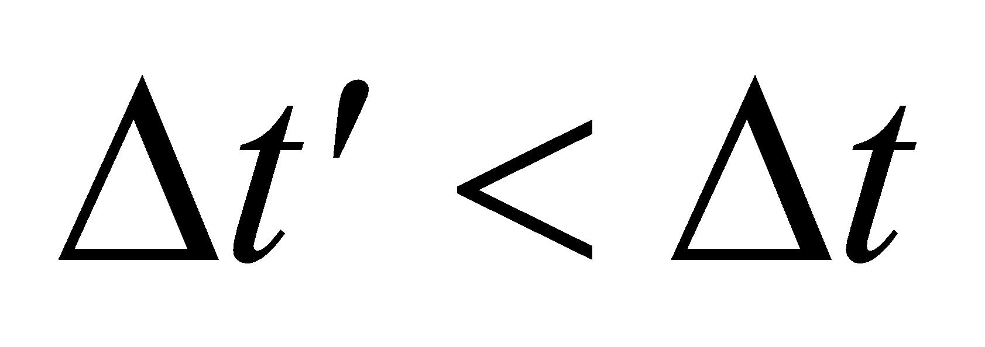. That is, the time interval measured in the spaceship frame  is shorter than that measured in *S*.

**44.** **Interpret** This problem involves length contraction and relativistic velocity addition. Our two frames of reference are (1) that of the Earth and (2) that of ship A (see figure below). We are to find the length of ship B in both reference frames.

**Develop** In the Earth’s reference frame *S*, the velocity of ship B is *v*B = 0.50*c*, so we can use this in Equation 33.4, which gives the length contraction of an object due to its velocity. In this case, the distance 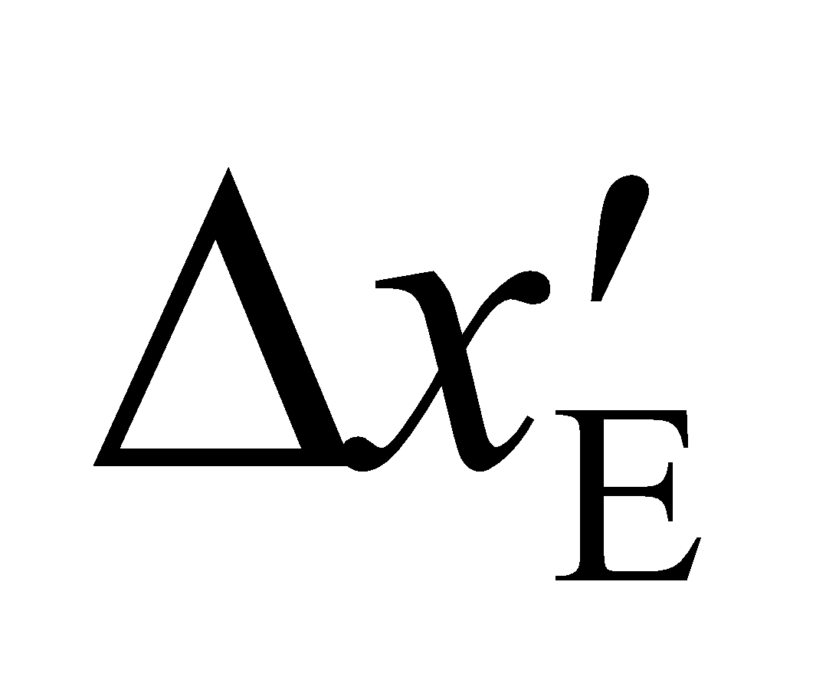 will be the distance measured in the Earth’s frame, and the distance *Δx*B = 25 m is the distance measured in the rest frame of ship B. The velocity of ship A (system ) relative to Earth is  (since ship A is approaching along the *x* axis from the opposite direction compared to ship B), so the velocity of ship B relative to ship A can be found from Equation 33.5b, which gives



This is the speed we shall use in Equation 33.4 to find the length of ship B in the frame of reference of ship A.



**Evaluate (a)** Inserting the given quantities into Equation 33.4 gives the length of ship B in the frame of reference of the Earth. The result is



**(b)** Substituting  for *v* in Equation 33.4 gives the length of ship B in the frame of reference of ship A. The result is



**Assess** The length of the ship is more contracted in the reference frame of ship A than in the reference frame of the Earth because ship A is moving faster with respect to ship B than is the Earth.

**45. Interpret** This problem involves time dilation. We are given the time limit of 75 years in the reference frame of the human who is traveling, and asked how fast she should go to reach a star 200 ly away as measured in the reference frame of the Earth.

**Develop** The distance is given in the system *S*, where the Earth and the star are essentially at rest, but the time interval is given in the system  where the spacecraft is at rest. Thus, *Δx* = 200 ly and . Equations 33.3   
and 33.4,



for time dilation and Lorentz contraction, relate the given quantities to . We use the second expression (i.e., the expression for length contraction) to find



**Evaluate** Inserting the given values into the expression above for velocity gives

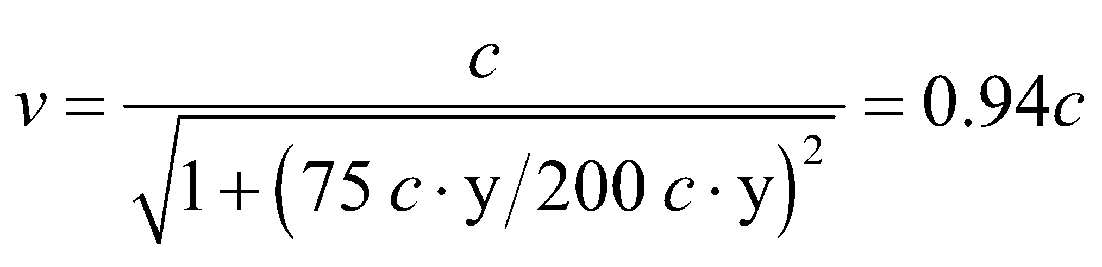

**Assess**The time elapsed on the Earth may be found from Equation 33.3 for time dilation. The result is



Thus, none of her colleagues would be alive when she arrives at the star (not to mention that it would take another 200 years for her to signal her arrival to those on Earth!).

**46.** **Interpret** This problem involves time dilation and length contraction. We are given the speed of the spaceship with respect to the galaxy’s frame S and the distance in this frame, and are asked to find the time it takes to cross the galaxy in the ship’s reference frame  and the size of the galaxy in the ships reference frame.

**Develop** In frame *S*, the time it takes to cross the galaxy is



where *Δ* = 50 km/s and 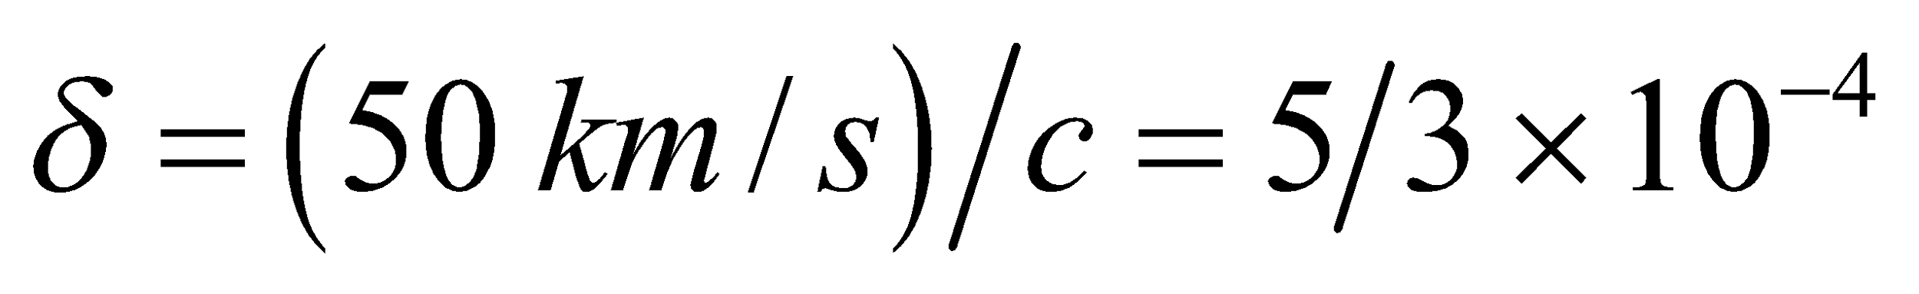. The factor *γ* may also be approximated to lowest order in *δ* as follows (see binomial approximation in Appendix A):



Use Equation 33.3 and 33.4 to find the trip time and the galaxy size in the spaceship’s reference frame .

**Evaluate (a)** To first order in *δ*, the time it takes to cross the galaxy in the ship’s reference frame is



**(b)** To first order in *δ*, the galaxy’s diameter as measured in the ship’s reference frame is



**Assess** In the ship’s reference frame, the clock runs slow and the length is contracted, as expected. Any correction to these results would be second order in *δ* and thus below the precision of the data.

**47. Interpret** This is a problem about calculating the distance and time between two events, as measured in different reference frames. The first reference frame *S* is essentially stationary with respect to the Earth and the star, whereas the second reference frame  is that of the spaceship moving at velocity *v* with respect to *S*.

**Develop** We shall follow the Problem-Solving Strategy 33.1 for Lorentz transformation. In the Earth-star frame (system *S*), we choose *x*A = 0 and *t*A = 0. In system , events A and B both occur at the spaceship, for which we can choose  and .

**Evaluate** **(a)** In system *S*,we are given , so



**(b)** In system , we have . However,  from time dilation   
(Equation 33.3), so .

**(c)** For the space-time interval, one has



as required by invariance.

**Assess**Our result shows that . In other words, the time interval measured in the spaceship frame  is shorter than that measured in *S*. The space-time interval, however, remains the same in both reference frames; .

**48.** **Interpret** This problem involves finding the spacetime intervals between the two events that are the subject of Problems 33.39 and 33.40.

**Develop** The square of the spacetime interval between the first launchings by civilizations A and B in Problem 33.39 is most easily calculated in the frame *S* of the galaxy. In this case,  and 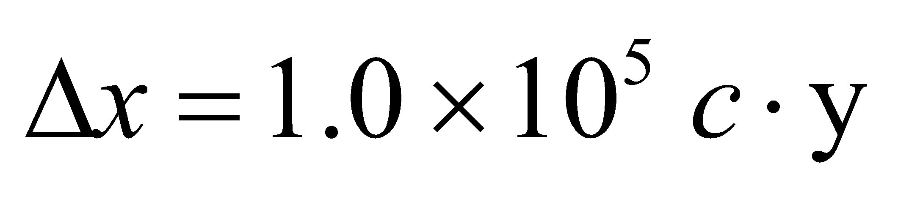. Since the spacetime interval is Lorentz-invariant, the same result would be found in any frame moving with constant velocity relative to *S*. For events A and B in Problem 33.40,  and 

**Evaluate (a)** The spacetime interval for the events in Problem 33.39 is



**(b)** The spacetime interval for the events in Problem 33.40 is



**Assess** If the square of the spacetime interval between two events is positive (called a timelike separation), then the events can be causally connected. If  is negative (a spacelike separation), the events cannot be causally connected, and a Lorentz frame exists in which they occur simultaneously.

**49. Interpret** This is a problem about the spacetime interval between two events. The events are connected by a light signal.

**Develop** Choose the *x* axis along the line separating the positions of the events. Since A and B are connected by the passage of a light beam,



**Evaluate** From Equation 33.6, one sees that the spacetime interval between them is zero:

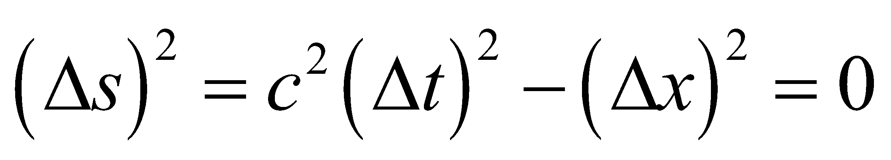

**Assess** An event with zero spacetime interval relative to A is said to lie on the light cone of A.

**50.** **Interpret** We are to find the momentum changes that correspond to the given changes in speed.

**Develop** Relativistic momentum is given by Equation 33.7:



We shall calculate the momentum for each speed and take the difference to find the momentum change needed.

**Evaluate** For  and , the change in momentum is



For  and , the change in momentum is



Thus, the .

**Assess** This result reflects the fact that ever-increasing energy is required to accelerate as the speed approaches *c*. For objects with nonzero rest mass, an infinite amount of energy is required to achieve the speed of light.

**51. Interpret** We’re given the time and distance between two distant events observed in a particular reference frame *S*, and are to find the time and distance in another reference frame  that is moving at the given speed with respect to *S*.

**Develop** The coordinates of the events in *S* and  are related by the Lorentz transformation in Table 33.1, with

*v*/*c* = 0.8 and .

**Evaluate** **(a)** The distance between A and B measured by an observer in  is

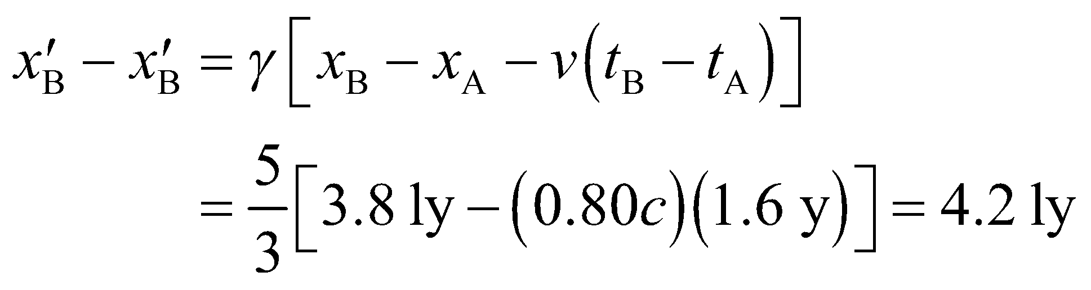

**(b)** Similarly, the time between A and B measured by an observer in  is

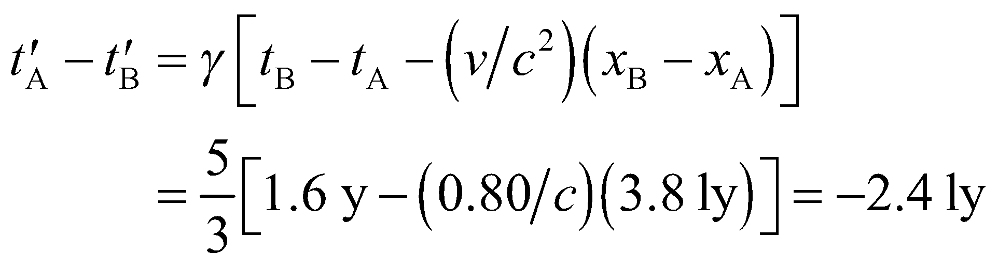

Thus, B occurs before A in .

**Assess** Since the light travel time from the position of A to that of B is greater than the magnitude of the time difference (3.8 y versus 1.6 y in *S*, or 4.2 y versus 2.4 y in ), the events are not causally connected.

**52.** **Interpret** We are given two speed and momentum ratios of a particle and are asked to find its original speed.

**Develop** We are given  and . Divide these equations and use Equation 33.7 to obtain:



Square this and use the first condition again to solve for the original speed.

**Evaluate** The original speed is



**Assess** The original speed is about 40% the speed of light.

**53. Interpret** We’re given the kinetic energy of a proton and asked to find its speed and momentum.

**Develop** For the proton, 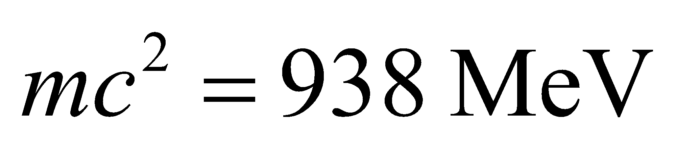, so  implies



**Evaluate** **(a)** Since , the speed of the proton is



**(b)** Using Equation 33.7, we find the momentum to be



**Assess** Since the kinetic energy is not negligible compared to the rest energy, the Newtonian expression of momentum (*p* = *mv*) is not applicable.

**54.** **Interpret** We are given a proton’s rest energy and are asked to find its momentum and to compare that momentum to that of a crawling insect.

**Develop**  Apply Equation 33.10



to find the momentum of the proton. The momentum of the insect may be found using Newtonian mechanics.

**Evaluate** The proton’s energy is so much greater than its rest energy (*mc*2 = 938 MeV) that



The momentum of the insect is



which is the same as that of the proton.

**Assess** This is quite amazing considering that a the insect contains the equivalent of about



protons.

**55. Interpret** This is a problem about mass-energy conversion using *E* = *mc*2.

**Develop** The energy-equivalent of 1 g is



**Evaluate** This amount of energy could supply a large city, with a power consumption of 109 W, for a period   
of time



**Assess** This is an enormous amount of energy harnessed from just 1 g of raisin (or of any other matter).

**56.** **Interpret** This problem involves converting energy into mass.

**Develop** If *K* = 0 then *γ* = 1 and Equation 33.9 reduces to *E* = *mc*2. Thus, the mass equivalent of the released energy is . Using the conversion factors from Appendix C, we can find the equivalent mass in kg.

**Evaluate** In conventional SI units,



**Assess** The fraction *f* of mass converted to energy is approximately



**57. Interpret** We are asked about the kinetic energy of an electron, with its speed given. The relativistic formula is needed when *v*/*c* is not negligible.

**Develop** The kinetic energy of the electron is given by Equation 33.8:



where  is the rest energy for an electron.

**Evaluate** **(a)** Since , we expand the square root and obtain



**(b)** When *v*/*c* = 0.60, we use the exact expression above for kinetic energy. The result is



**(c)** Similarly, when *v*/*c* = 0.99,



**Assess** The Newtonian result () is valid only when 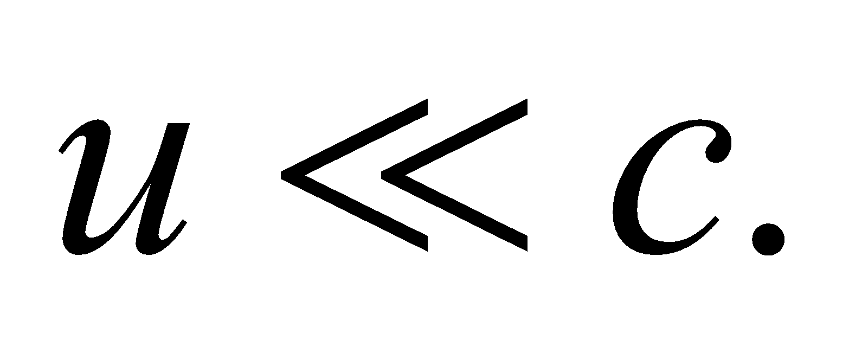

**58.** **Interpret** Given various kinetic energies for an electron, we are to find its speed. Because some energies put are in the relativistic domain and some are not, we shall make appropriate approximations where needed.

**Develop** The rest energy of the electron is , so *γ* corresponding to kinetic energy



is



from which

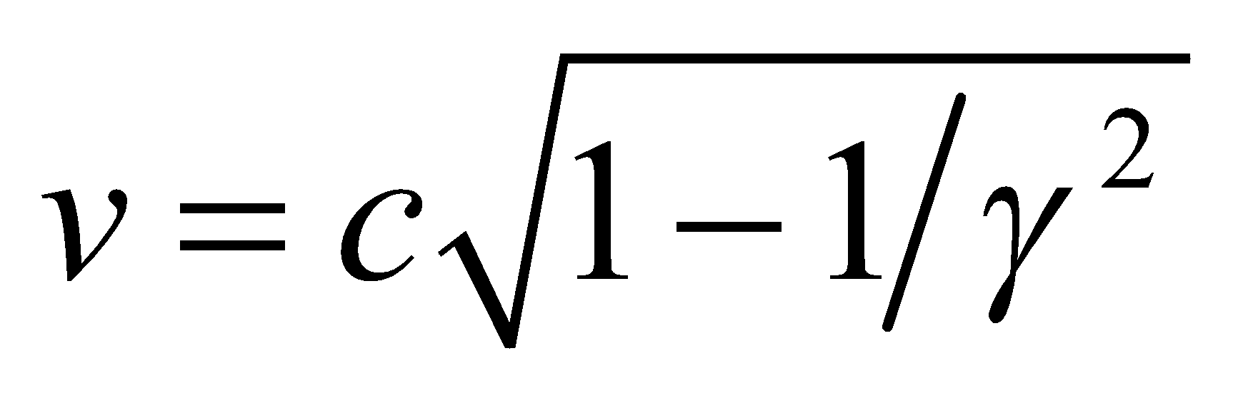

can be found (see Equation 33.8 and Table 33.1).

**Evaluate** **(a)** If 



so  and the nonrelativistic expression  can be used (see the solution to the next problem). Thus, the velocity is

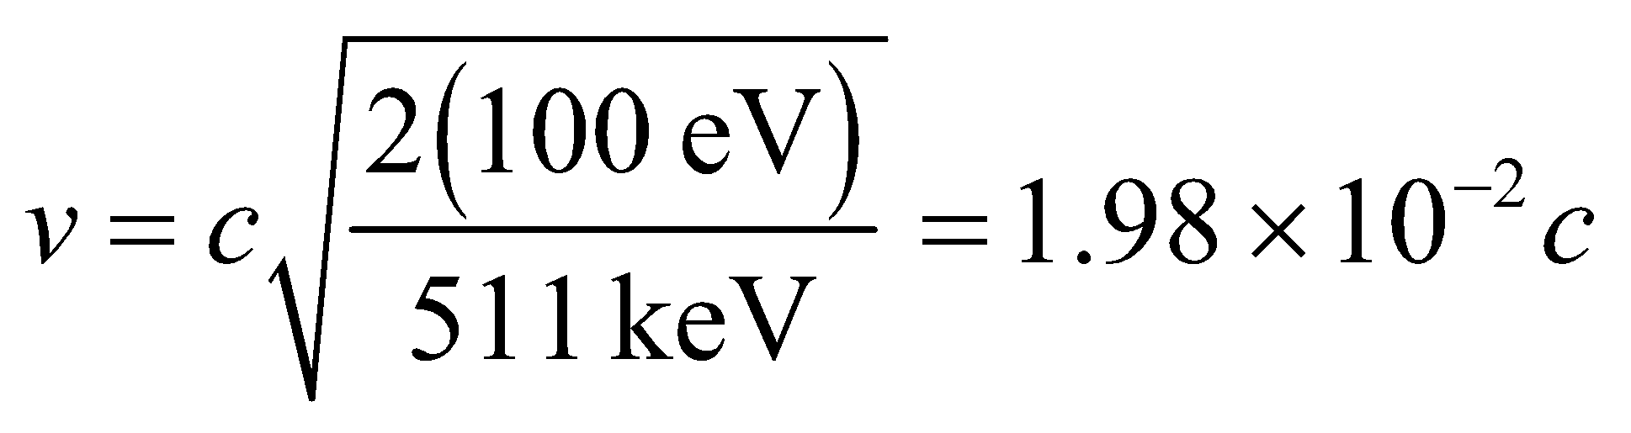

**(b)** If100 keV, then *γ* = 1.20 and *v*/*c* = 0.548 so we must use the full relativistic expression. This gives

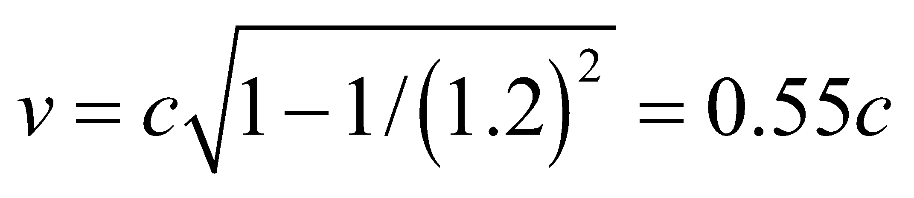

**(c)** If , *γ* = 2.96 and *v*/*c* = 0.941 so we must use the full relativistic expression. The result is



**(d)** For K = 1 GeV,  is large and . If we expand the square root in



in powers of  we find



**Assess** Both in the low- and high-energy limit, approximations are appropriate.

**59. Interpret** In this problem we are to show that the kinetic energy in Equation 33.8 reduces to the Newtonian result  when 

**Develop** The binomial expansion valid for  is



**Evaluate** For  Equation 33.8 can be expanded to yield



**Assess** We indeed recover the Newtonian expression for kinetic energy when 

**60.** **Interpret** We are to derive the relativistic energy-momentum expression (Equation 33.10) from the expressions for kinetic energy and total energy (Equations 33.8 and 33.9).

**Develop** Equations 33.7 and 33.9 are *p* = *γmu* and *E* = *γmc*2. Dividing the former by the latter gives



From Equation 33.9, we find



from which we can show the desired expression.

**Evaluate** Inserting  into the expression above and using the result *u*/*c* = *pc*/*E*, we find



**Assess** We have derived the relativistic energy-momentum relationship.

**61. Interpret** In this problem, we want to prove that the spacetime interval is relativistically invariant.

**Develop** Consider two frames *S* and  that are related by the Lorentz transformations of Table 33.1. (Since the equations are linear, they also apply to differences between coordinates.) Forming the spacetime interval in  and transforming it using the Lorentz transformations gives



**Evaluate** Therefore, , and the spacetime interval is invariant.

**Assess** The spacetime interval  describes the relationship between two events in a manner that is independent of the chosen reference frame.

**62.** **Interpret** This problem involves time dilation. We have two reference frames: that of the Earth (S) and that of the traveler (). The distance is given in S whereas the time is given in , and we are asked to find the speed of the system .

**Develop** The distance to the Crab Nebula, *Δx* = 6500 ly, is specified in the Earth’s system (*S*), whereas the time interval, , is given in the traveler’s system . Length contraction () and time dilation () give



which we can solve for the speed *v*.

**Evaluate** The speed *v* of the system  with respect to *S* is



A good calculator gives *v*/*c* = 0.9999953, or one can also use the binomial expansion (Appendix A) to find



**Assess** Because the data is given to two significant figures, we should retain only two significant figures in the result, which would give *v* = 1.0*c*. However, for objects with nonzero rest mass, infinite energy is required to attain the speed c, so we know that the result *v* = *c* is not realistic.

**63. Interpret** In this problem we are asked to find the speed at which *K* = *mc*2.

**Develop** The kinetic energy of a particle is given by Equation 33.8:



When the kinetic energy is equal to the rest energy, , or *γ* = 2.

**Evaluate** From , the speed of the particle is

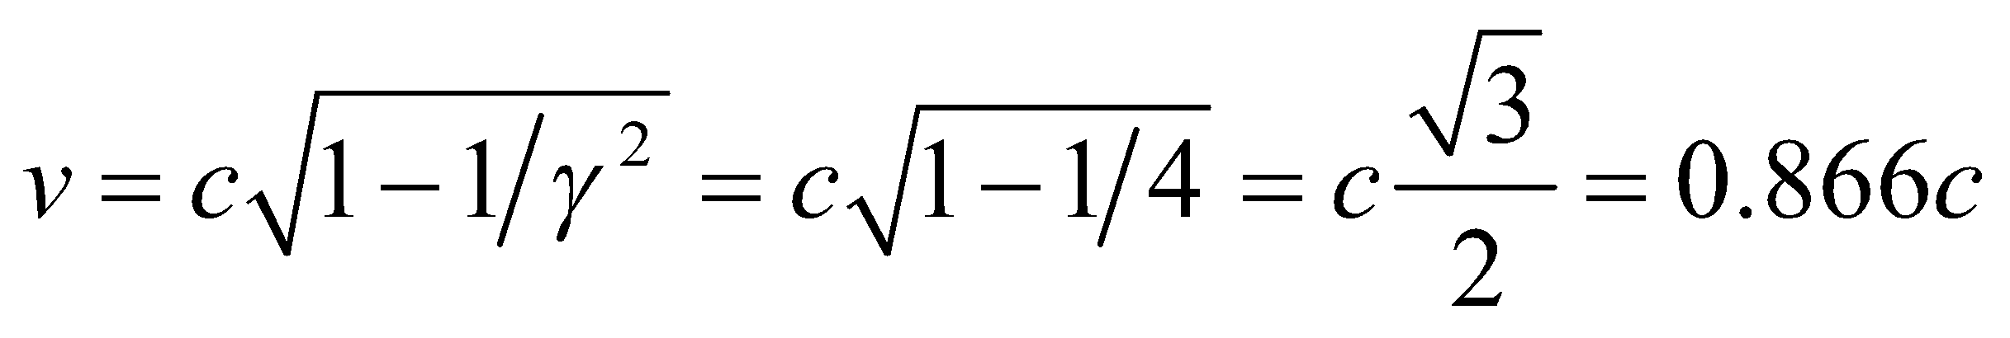

**Assess** The speed of the particle is about 0.866*c* when *K* = *mc*2. This is in the relativistic regime.

**64.** **Interpret** This problem involves length contraction. We know the Earth’s diameter in its rest frame *S* (from Appendix E) and are asked to find its diameter in the frame  of the proton.

**Develop** The phenomenon of Lorentz contraction makes the Earth’s diameter, along the direction of motion of the proton, appear to be  in the proton’s frame. For a proton with a total energy of 20 TeV (and rest energy *m*p = 938 MeV/*c*2) we can use Equation 33.9 to find *γ*:



which allows us to find the Earth’s diameter in the proton’s frame.

**Evaluate** Inserting the result for *γ*  into the expression for the Earth’s diameter gives



to two significant figures.

**Assess** The Earth’s diameter measured perpendicular to the proton’s velocity would still be *R*E. Note that, at this high energy, it makes little difference whether 20 TeV is the kinetic or total energy.

**65. Interpret** This problem explores the change in momentum when the speed of an object is changed.

**Develop** The expression for momentum valid at any speed is given by Equation 33.7:



Since  and 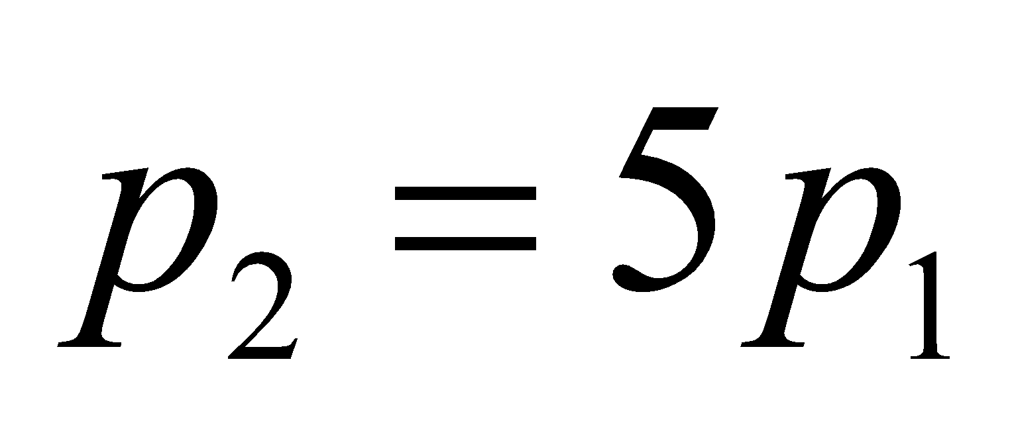, we write



**Evaluate** To find the original speed, we rewrite the above equation as



which yields



**Assess** The particle must be moving at a relativistic speed. In the Newtonian limit where  when the speed increases by 5%, the corresponding momentum also must increase by 5%.

**66.** **Interpret** We are to show that if a light signal cannot travel from event A to event B, then there exists a frame of reference for which the two events are simultaneous. In addition, we are to show that if a light signal can travel between events then no frame of reference exists in which the events are simultaneous.

**Develop** Let the first event in system *S* have coordinates *x*A = 0 and *t*A = 0 and the second *x*B and *t*B. If a light signal leaving A cannot reach B, then 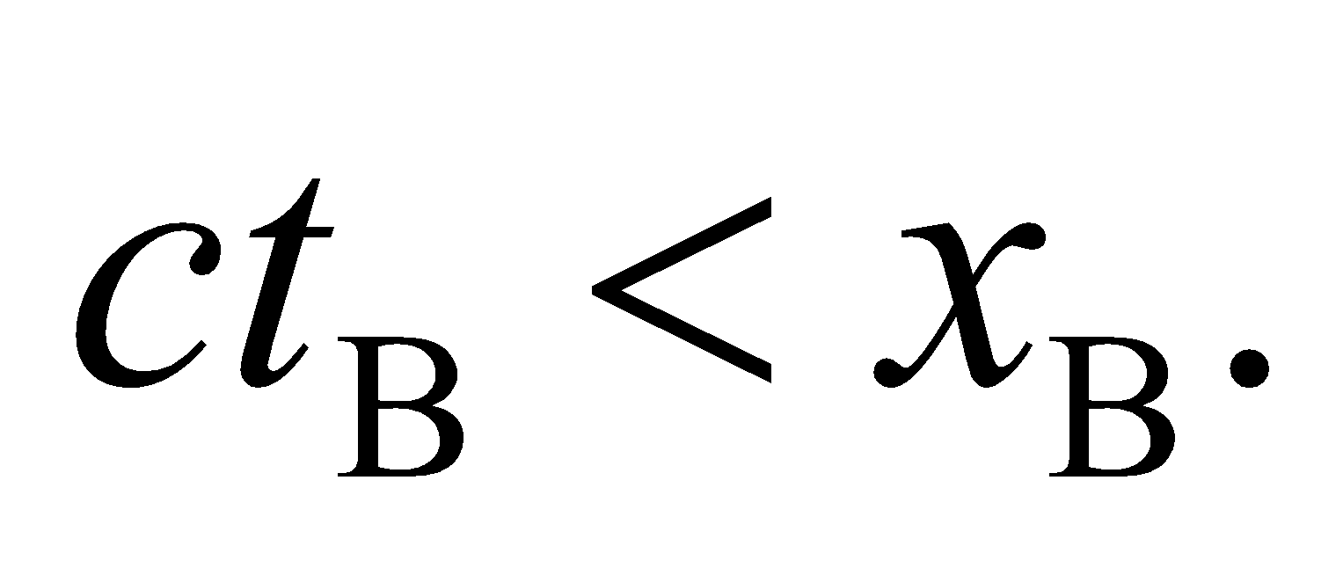

**Evaluate** The events are simultaneous in system *S*′ (with origin  and which moves along the *x*-*x*′ axes with speed *v* relative to *S*) if



Then  describes a real Lorentz transformation, which confirms the possibility of the events being simultaneous in *S*′. On the other hand, if a light signal could reach *x*B before *t*B, then  and there is no system with  in which the events are simultaneous.

**Assess** The frame of reference influences the simultaneity of events.

**67. Interpret** This problem is about the Doppler shift for light. Given a source moving toward us at a given speed, we are to derive the given expression for the Doppler-shifted frequency. For a source speed much, much less than the speed of light, we are to show that this result simplifies to the classical result (Equation 14.13).

**Develop** Consider the sketch below. Let *S* be the rest system of a source of light waves (with frequency and wavelength *λf* = *c*) that moves with speed *u* towards an observer in *S*′ (who measures ). Suppose that *N* waves are emitted in *S* in a time interval *Δt*. The first wavefront has traveled a distance *cΔt* in *S*, so the wavelength (i.e., the distance between surfaces of constant phase) is  In *S*′, however, the wavefronts are “piled up” in a smaller distance due to the motion of *S* so the wavelength is



which gives



Now, *Δt* (the proper time interval in the source’s rest system) is related to *Δt′* (the time interval measured in a system where the source is moving) by time dilation, 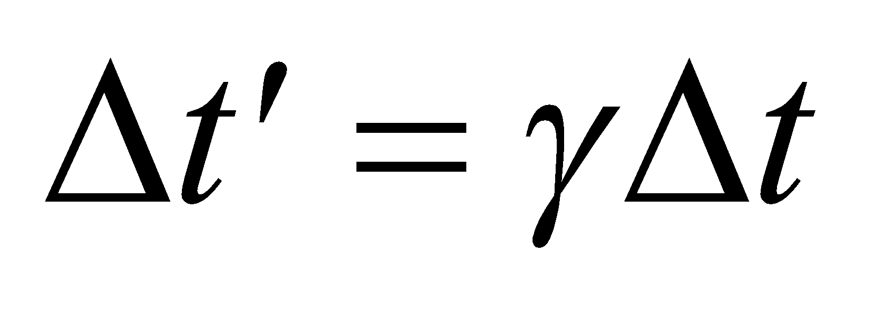 (Equation 33.3 with altered notation), so  or, in terms of frequency, 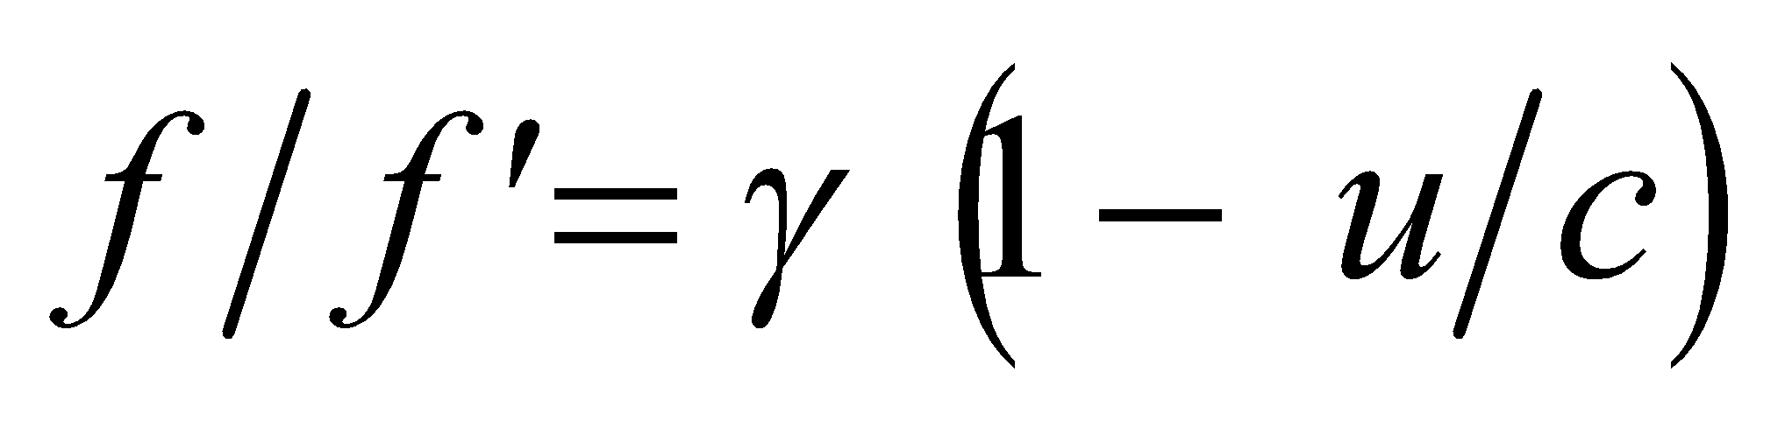.



**Evaluate** Since 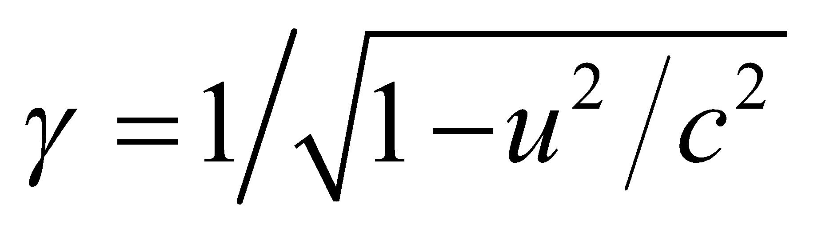, this can be written as



which is the radial Doppler shift (i.e., along the line of sight) in special relativity, with *u* positive for approach and negative for recession (note the difference in signs with Equation 14.13). For 



which, allowing for the difference in signs, is the same as the limit of Equation 14.13 for 

**Assess**  Note that it is more customary to write this limit as



The relativistic Doppler effect has been used to measure the shifts in frequency of light emitted by other moving galaxies. The observation of “red shift” suggests that galaxies are receding from us and that the Universe is still expanding.

**68. Interpret** We are to derive the velocity transformation formula for a situation where the velocity being transformed is *not* parallel to the frame velocity.

**Develop** The velocity in the *y*-direction is the distance covered per unit time, or



We know from the Lorentz transformations that *y* = *y*′ and 

**Evaluate** Substituting *y*′ and *t*′ for *y* and *t* gives



Multiply top and bottom by *t*′ to obtain

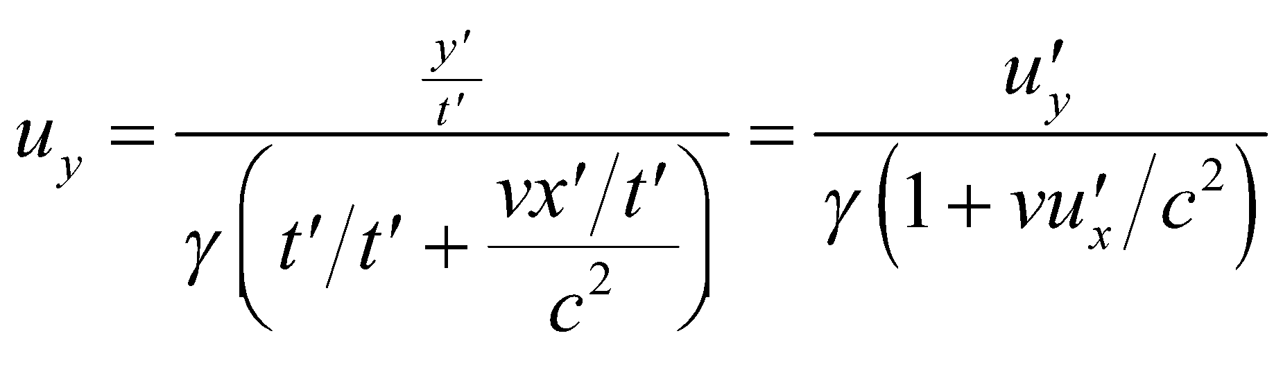

**Assess** The *x* velocity affects the *y* velocity transformation.

**69. Interpret** We shall use the relativistic momentum, and Newton’s second law (*F* = *dp*/*dt*), to find an equation for the force on a particle in terms of its acceleration. We limit ourselves to acceleration parallel to the velocity.

**Develop** Equation 33.7 gives the relativistic momentum as  and Newton’s second law is *F* = *dp*/*dt*. Thus, we shall differentiate the relativistic momentum to find an expression for the force.

**Evaluate** Differentiating the momentum gives



**Assess** This is quite a bit more complicated than *F* = *ma*, but for *u*  *c*, *γ* = 1 and the term in square brackets reduces to unity, which gives *F* = *ma*, as expected.

**70. Interpret** Newtonian mechanics is a low-speed approximation to relativistic mechanics. We are to find how fast something has to move before the relativistic kinetic energy is 50% greater than the Newtonian kinetic energy.

**Develop** Relativistic kinetic energy (Equation 33.8) is  where  Newtonian kinetic energy is 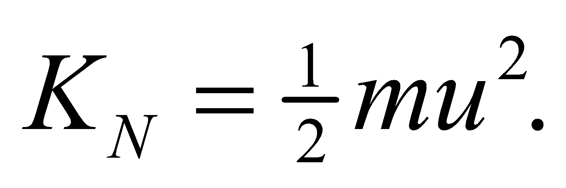 We are asked to find when , which allows us to solve for the speed *u*.

**Evaluate** The speed at which the relativistic energy is 50% greater than the classical energy is



**Assess** The kinetic energy actually goes up with speed faster than predicted by Newtonian mechanics (see Figure 33.17).

**71. Interpret** You're trying to understand a television tube by the relativistic effects on the electrons that travel through it.

**Develop** You're given the length of the tube in the electrons' reference frame, which is shorter than what you measure in the rest-frame due to length contraction:  From this you can determine the electrons' speed, as well as the kinetic energy:  (Equation 33.8), where the relativistic factor is  To achieve this kinetic energy, you'll need a voltage difference given by 

**Evaluate** Solving for the speed from the provided lengths gives



The required voltage difference is



**Assess** The voltage difference is typical for a television tube. Transformers (recall Chapter 28) are needed to increase the voltage from the wall outlet to several tens of kilovolts.

**72. Interpret** You consider possible relativistic effects on a high-speed interstellar voyage.

**Develop** Your ship is moving fast enough that time dilation should be occurring. But this effect is only evident when you compare time as measured onboard to time measured in some other reference frame.

**Evaluate** Since you are measuring your own heart rate in your own reference frame, there is no time dilation. You simply measure the pulse that you would if you were standing at rest on Earth.

The answer is (b).

**Assess** If a doctor on Earth was somehow able to measure your pulse as you were moving in the spacecraft, he would observe a slower than normal heart rate.

**73. Interpret** You consider possible relativistic effects on a high-speed interstellar voyage.

**Develop** From the Earth's perspective, the voyage will be completed in a time of  where  is the distance to Proxima Centauri as measured from Earth. On the spacecraft, this time will be dilated: 

**Evaluate** By journey's end, you will have aged by

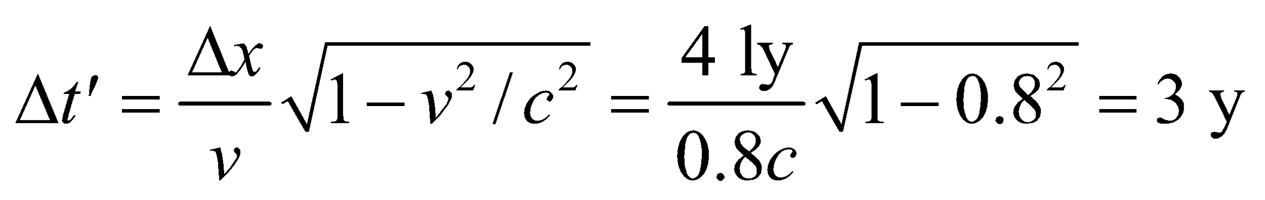

The answer is (a).

**Assess** From Earth's perspective, you will have aged 5 years.

**74. Interpret** You consider possible relativistic effects on a high-speed interstellar voyage.

**Develop** "Moving clocks run slow." From the Earth's perspective, the clocks on your ship are moving, so "one second" for Earth will correspond to 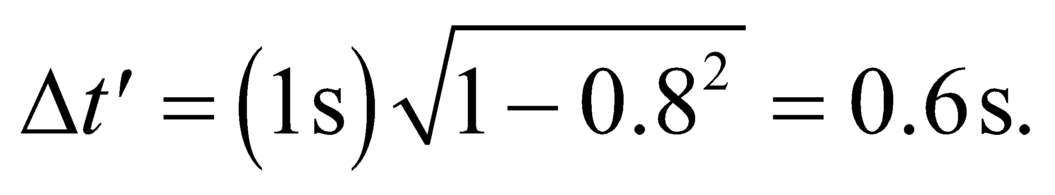

**Evaluate** However, the same argument applies to Earth from your perspective. You see Earth moving away from you at  so you will judge that Earth's clocks are moving and that they run slow compared to the stationary clocks on your ship.

The answer is (c).

**Assess** This is not a contradiction, since there is no absolute time by which to judge the "true" slowness of a clock. Each observer measures time with the clocks that are stationary in their reference frame, but there is no clock that is stationary in all reference frames.

**75. Interpret** You consider possible relativistic effects on a high-speed interstellar voyage.

**Develop** The distance from Earth to the star will be length contracted in your reference frame: 

**Evaluate** Plugging in the values, you find



The answer is (a).

**Assess** This agrees with the result from Problem 33.73, since this is the distance your ship will have traveled in 3 years time.